

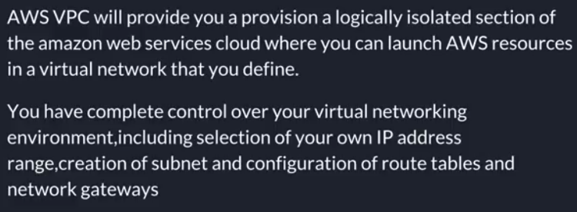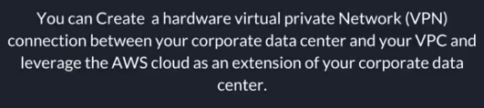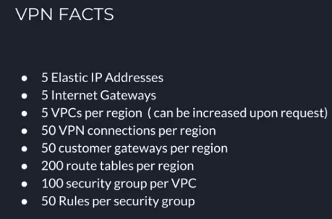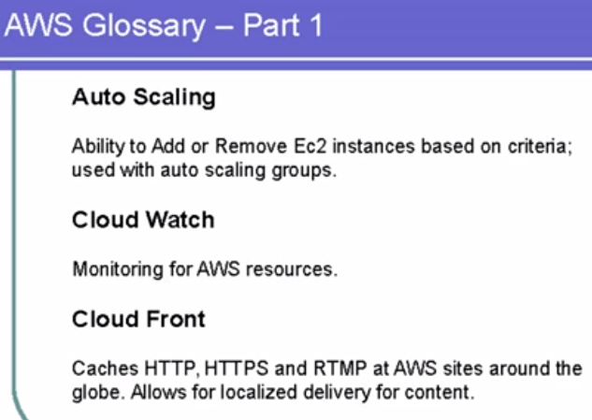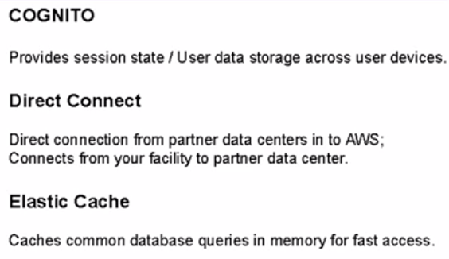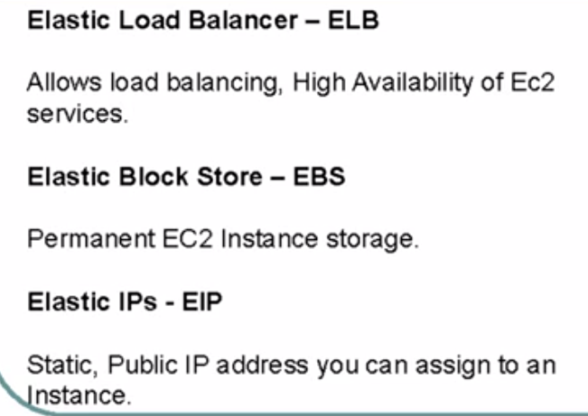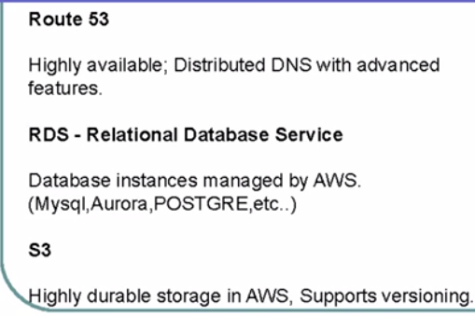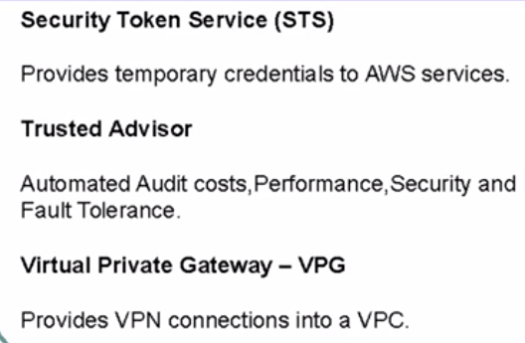

Amazon AWS VPC Introduction and Features

# What is AWS VPC?

AWS VPC or Virtual Private Cloud is an Amazon service that allows you to create you own virtual network inside Amazon cloud and to use this virtual network to launch amazon resources.

This virtual network closely resembles a traditional network that you'd operate in your own data center, with **the benefits of using the scalable infrastructure of AWS.**

You can think of a VPC as your own network of machines and databases that live completely inside Amazon’s infrastructure but can be managed as if they were in your own data center. Here’s a diagram of a how a typical VPC setup looks like

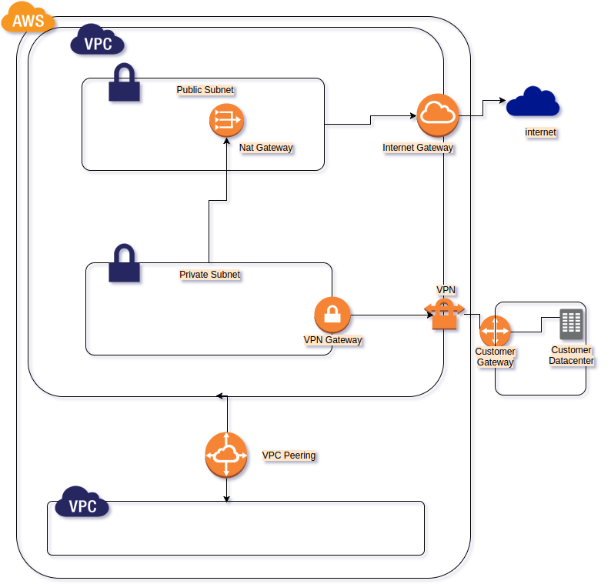

As you get started with Amazon VPC, you should understand the key concepts of this virtual network, and how it is similar to or different from your own networks.

Amazon VPC is the networking layer for Amazon EC2.

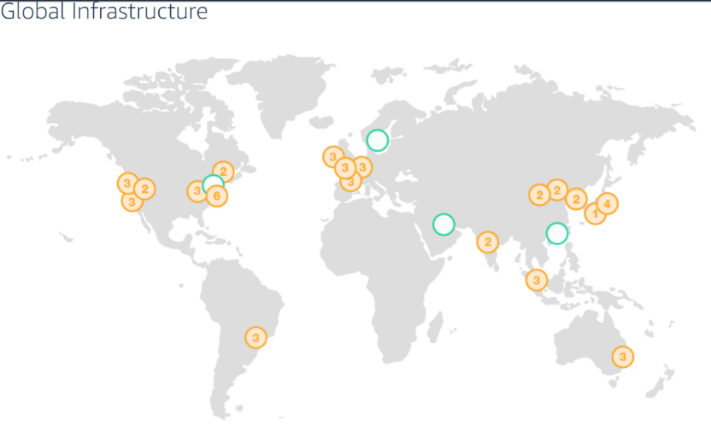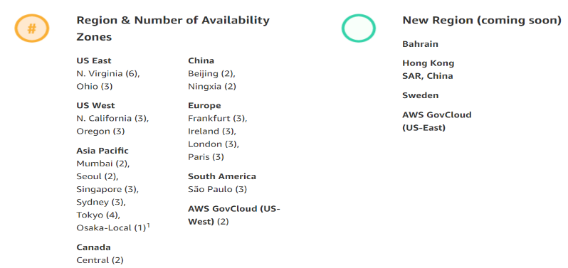

Orange Region(city)…In India…Mumbai.. Region lo (Number)🡪AZ-🡪Datacenter🡪ap-south-1a, ap-south-1b..

In North America..US_EAST-1--Have Max—6 AZ(Noth virginia)..If there is nay udate, Amazon will release first here..

In Region, there will be atleast 1 AZ..If one goes down, other should be there.. for HA

Start With Network, Ec2, S3, Database, Management tools, IAM, CloudFront, Route53

Ap-south-1 (Asia pacific )-- ap-south-1a, ap-south-1b..If Demand increases, Amazon creates new ap-south-1c simply..

US-East-1 Us-East-2, ..US-WEST-1.. 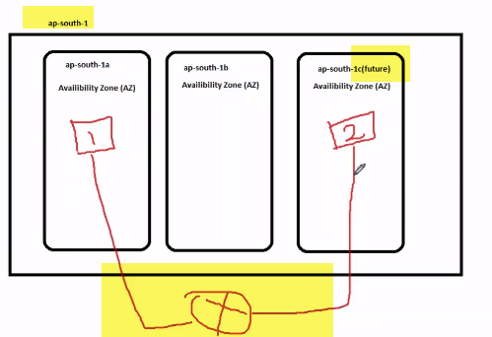

What difference b/w our own DC and Amazon DC??

**Our DC:** Ex; If I have server1 in AZ-ap-south-1a and other server2 in ap-south-1c…What if want to connect these 2 servers???.

We need to talk with N/w Team, and ask to connect these servers physically and configure routing, firewall .

**In AWS:** All AZ will be by default connected ..There is no need to configure by ourselves..

Amazon wont give direct access to their Hardware.. We can create virtual servers on their Hardware ..By you and also others (shared…Cloud means shared ) ..

By default server1,2,3 communicate by default without doing anything..

AZ in regions are inter- communicated…Between region and region no communication Ex: Virginia and Mumbai.. 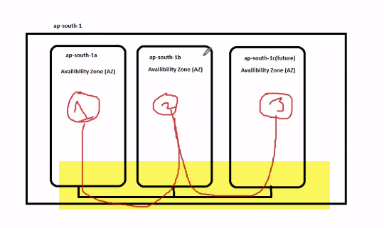

There are 2 problems here…Cloud is shared, and different companies will be hosting their servers..

Ex: TCS and infy rivals.

**SECURITY:**Suppose TCS and hoost server-1, and Infy server-3..IF both AZ are connected.. There will be problem they can access each others data

**IP ADDRESS:** TCS say will use ip: 10.1…Infy also want to use same..Ip management is very difficult..

So Amazon wants to come with solution of isolation.

Ex; there are 2 colleges. Who would be different project and work differently.They dodnt know of each other..

**Amazon created logically boundaries….1 for TCs(RED), other for INFY(Green) ..these boundaries is called VPC..**

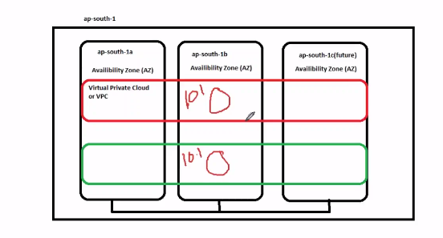

1.)If I have 1 Ec2 in TCS , and other EC2 in INFY in SAME AZ.. They won’t be able to communicate.. Because of logical boundary…SO SECURITY IS OUT NOW..

2.)in VPC of infy, TCS both can use 10.1..There will be problem only IF both VPC are connected..As long as not connected ..NO PROBLEM..CAN USE SAME IPS---**IP PROBLEM SOLVED** .

How to communicate with severs outside 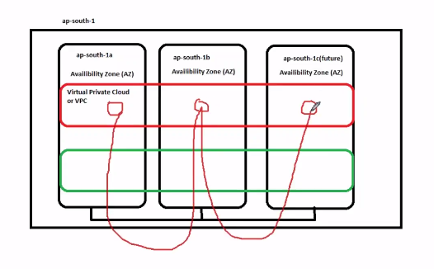

Each of these servers can communicate with each other. But how to connect from outside (from office) ..

We wont be sitting in Amazon office right☺..We will be sitting in our office.

If 2 computer need to communicate at home, we can simply use cable..

But if I want to access gmail, we need to connect to router for accessing internet,commicating outside..

So if I want our servers to communicate outside, we will add gateway(internet gateway) called as IGW..

IGW is like our WIFI Router.. It will send tafiic outside, and gets traffic to us.. 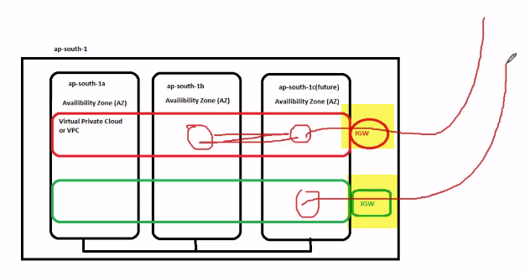

**Summary:**

Servers inside AZ-2, AZ-3 will easily communicate with eachother..But to communicate with outside world , through internet gateway ONLY..(i**f I have instance on AZ-2, and want to communicate from my office is through IGW ONLY)..**

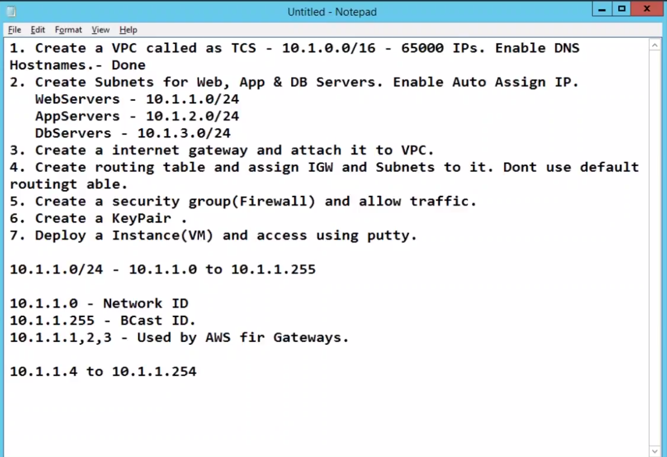

1. **10.1.0.16(main Network) -🡪255. 255..255.0.0 Subnet-🡪65,000 IPs**
2. **Create subnets for web, DB, APP**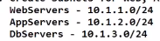

**Any Ip address will be from 1.0.0.0 to 255.255.255.255**

**IP address is divided into 5 classes (A ,B,C,D,E)….A,B,C-🡪only these 3 used.**

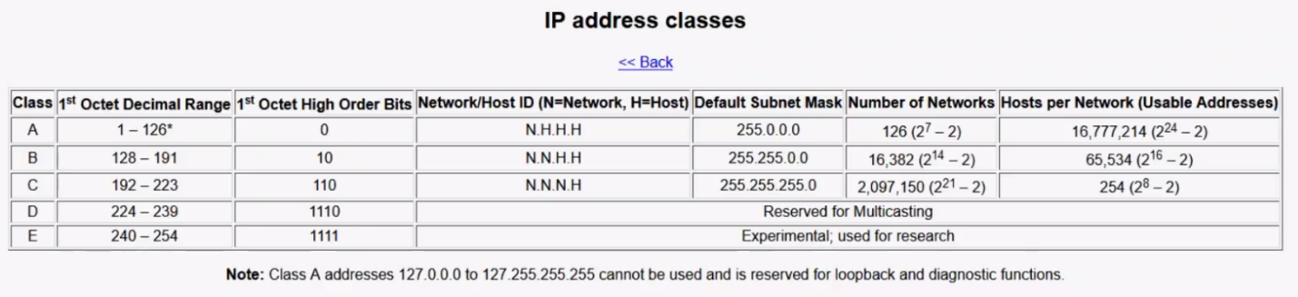

**As IP address re getting exhausted easily... They bought this.. Networks on class A ,B, C**

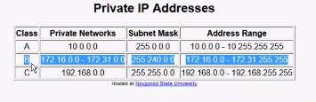

In office, we have either 10. Or 172. Network

At home, we have 192 address... Public address

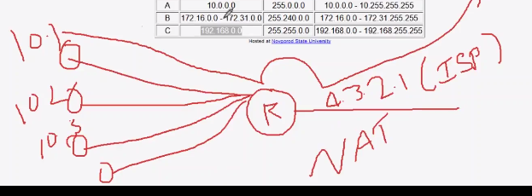

Let say we have Router R, and have Public IP at one END like 4.3.2.1.his is provided by ISP(Internet Service Provider).

On other side, we have multiple clients,--10.1, 10.2, 10.3…All these clients can internally communicate with each other…

But when they want to communicate outside..Client (10.1) will send packet to Router, Router will convert packet to 4.3 and sends over internet ..This is called NAT(Network Address Translate).

**SO ONLY on 1st STEP mentioned VPC CALLED AS TCS—10.1.0.0.**

/8--🡪255.0.0.0

/9🡪255.128.0.0

/10🡪255.(128+64)=192.0.0.

/16🡪255.255.0.0.

/24🡪255.255.255.0

Amazon will support from /16…So we took 10.1.0.0/16 in step-1.

2.) This 10.1.0.0/16 is main Building like...Which we have to divide into SMALL PARTS—WEB, APP, DB.

**We can create Up to max.. 5 VPCs**

1. 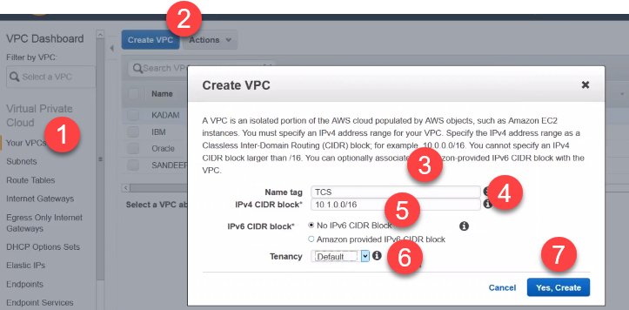

Tenancy: Default Shared... Not Dedicated.

Enable DNS hostname: If we don’t enable this, servers wont be assigned with Default hostnames 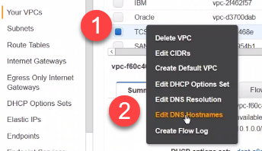

2.)Create subnet for Web, App, DB servers.

We have created VPC already in N.Virginia..But in Virginia, there are 6 AZ already.

In which AZ is this VPC created???.

We haven’t mentioned(VPC ni ee AZ zone lo athi kinchaledu) any AZ till now.

**VPC span across three AZ in fig,..**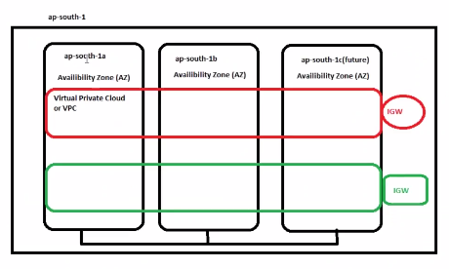

**We will do this now…**

**Go to subnet🡪Create Subnet**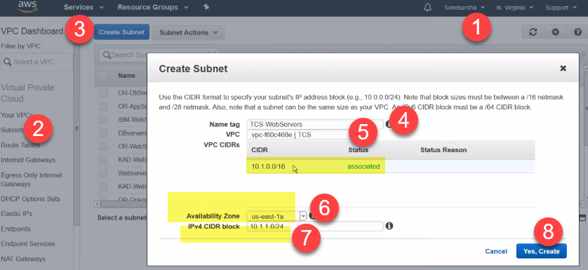

**We cant create server in direcly 16..We have to divide 16 into Parts like 24 and put servers in it..**

**AZ🡪US-EAST-1a..We are putting our TCS VPC on this AZ**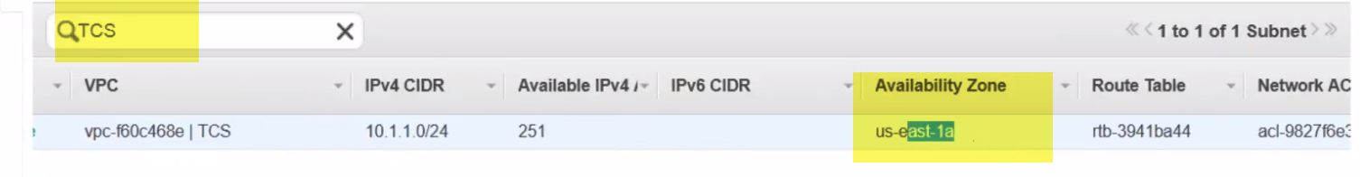

**This TCS VPC is on US-EAST-1a AZ**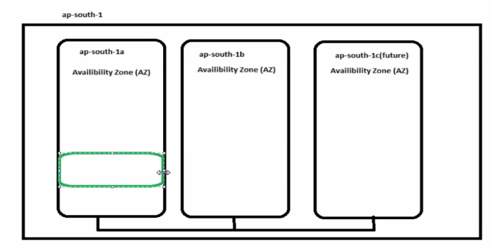

**Our VPC is in 1a only(Webserver).**

**When we create APP server SUBNET in 1b, VPC will be expanded to 1b AZ**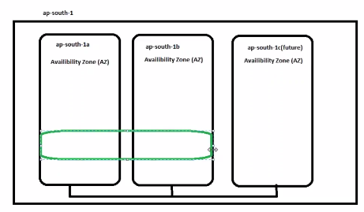

**When we create DB Servers Subnet in 1c, VPC will be expanded in 1c AZ.**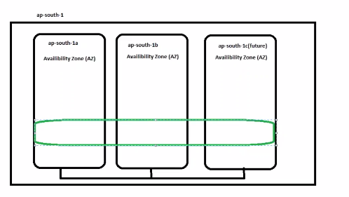

**Creating subnet for APP SERVER** 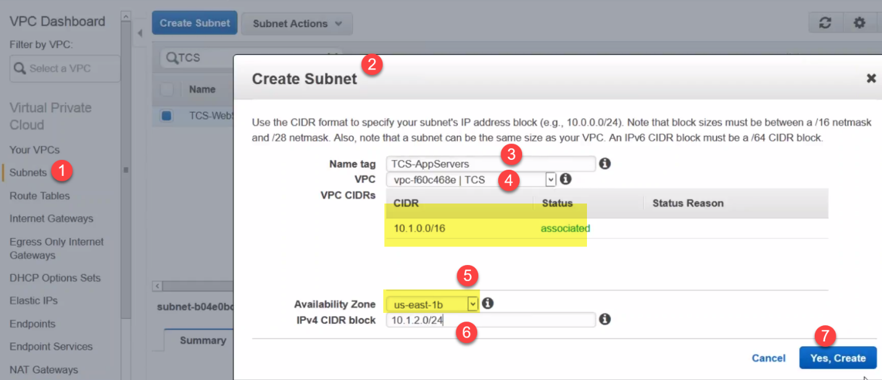

Now VPC is extended to 1b AZ.

**Creating subnet for DB SERVER**

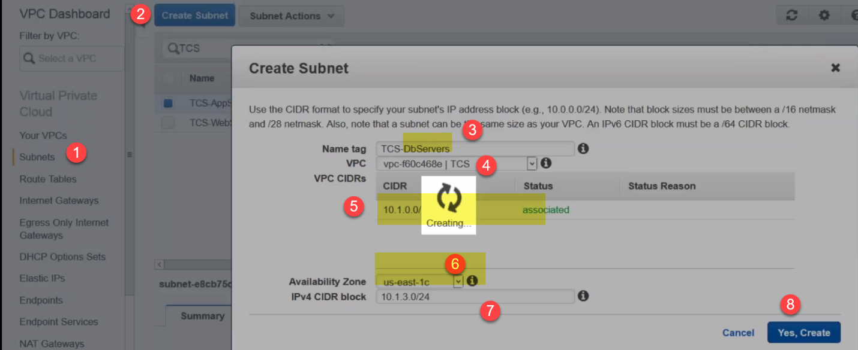 Now VPC is extended to 1c AZ.

**TCS VPC is now in AZ-1a,1b,1c of N.Virgina.Note: there are 6 AZ in virginia**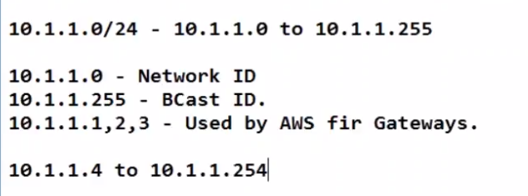

What does 10.1.1.0/24 mean??

1.)10.1.1.0 to 10.1.1.255.So totally 256 IP address.

1. In this, 10.1.1.0 is called N/w ID..And 10.1.1.255 is called Broadcast ID..These 2 cant be given to Anyone..
2. Also 10.1.1.1,2,3 are used by AWS for Gateways .
3. So when we assign IP address to Ec2 instances, It will start from 10.1.1.4 to 10.1.1.254…These only we can use..

**We have create Subnets now…**

**Auto-Assign IP.:**

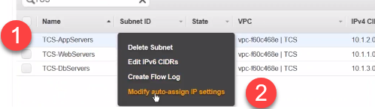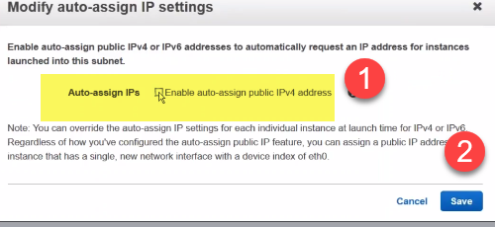

Do same for APP, DB subnets also

**Step-3:**

EC2 instances will communicate with eachother…But we cant connect from..So we create IGW.

No meaning of cloud if we cant connect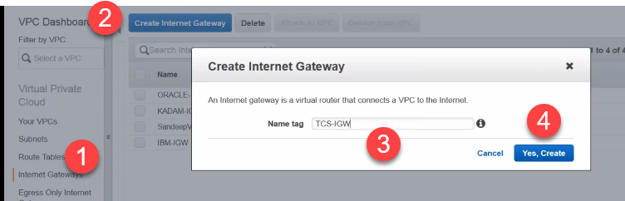

Note: **When we create IGW, it will be in Detached mode.**

**For 1 VPC, we can attach only one IGW.**

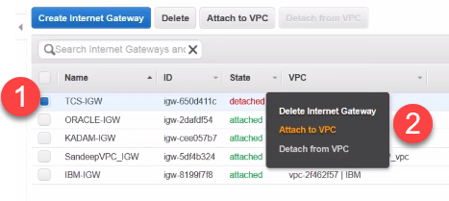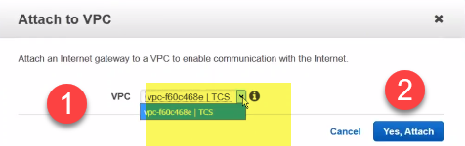

Already Other VPC are attached.. So it will show only TCS VPC Which is created now..

**Step-4: **

Suppose in Hyderabd, there is a Big Mall created.If someone closed our eyes,..Without asking anybody ..How can we comeout ???.

We can comeout..But it will take lot of time.

**Routing table:**

Servers (EC2)can easily communicate with themselves,. But When servers want to connect outside, They have to use Internet Gateway.

Somebody have to tell to go out (traffic) need to use IGW.. This is called Routing Table..

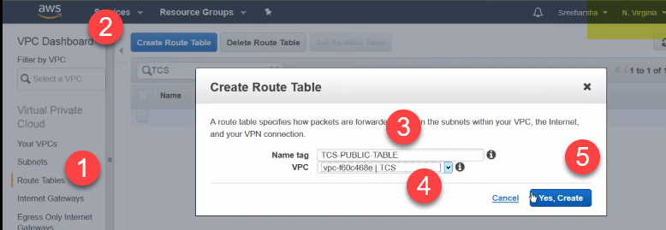

Public: All ec2 instances and routing table directly connected to internet

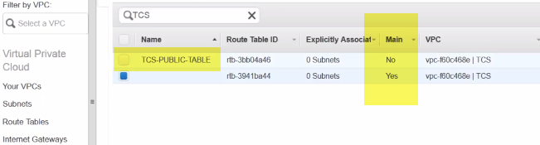

1. Routing table created which is TCS-PUBLIC.It is not main.

There is another Routing table created, which is main.

1. Also, there is **ZERO** Subnets.

When we click on Routing table, we created, and click on Subnet Associates..We can see sunets which we can associate.

We have to associate subnet 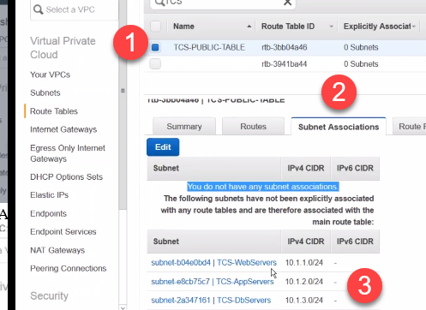

CLICK EDIT, And add 3 subnets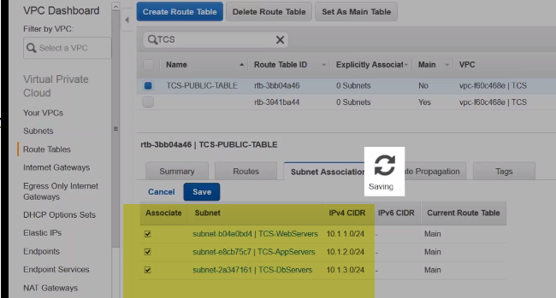

**So these 3 SUBNETS ARE ADDED TO ROUTING TABLE..**

**So If I simply add subnet to Routing Table, will they send traffic to Routing Table???.**

**Lets say in my AWS account, I have 6 IGW, we have to say which one to use..**

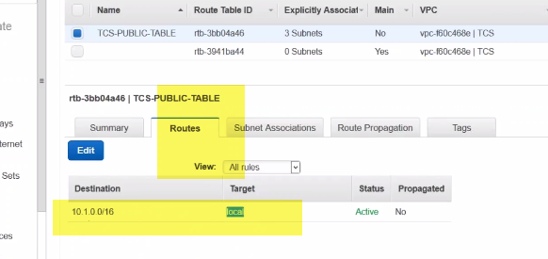

So we go to Routes…In this, we can see 10.1.0.0/16(local)

Meaning means???.

We have 3 subnets which start with 10.1 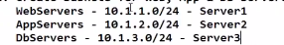

10.1.0.0/16 (local) means…Any machine which starts with 10.1 in this VPC will be local.

There is no need to goto IGW**..(Communicate locally).**

**So if we want to connect otherthan 10.1 or iGW…CLICK Edit** 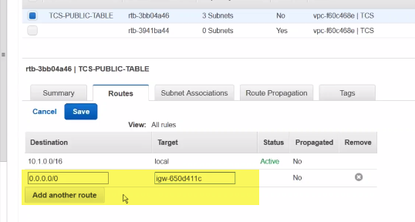

Add another route…0.0.0.0/0🡪Any other IP other than 10.1 like 10.2, 10.8 etc.. want to go any other IP don’t use than local route , use 0.0.0.0/0 with target IGW.

So, If I want to send traffic to any IP other than 10.1, use IGW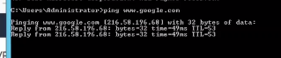

Let say ping goole.com, it is pinging to 216.. Not 10. IP..

**Step-5:**

**We cant open whatever port we want.**

Security groups will help, with what port we want to open.

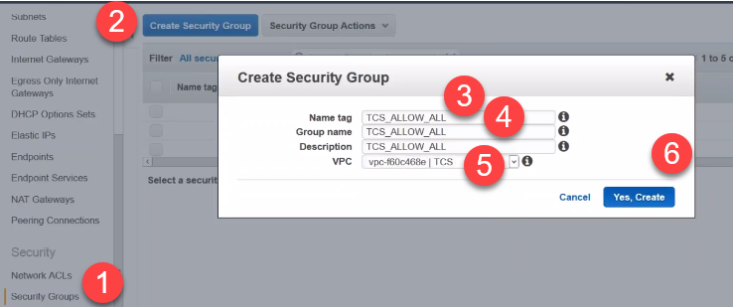

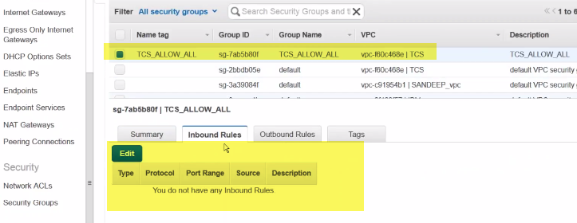

There is no Inbound rules.From outside no one can connect.

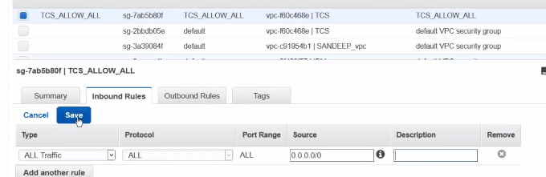

For example, I am allowing all traffic from anywhere(0.0.0.0/0)

Outbound: Not required. By default it will be open.

**Step-6: **

**Talam..Talamkappa**

When we deploying a VM, that VM wll have a Talamkappa.That is called Public key.

They will give key for us(publicKey .pem file)

Without this key, we cant connect to server.

**Got o EC2-🡪 Keypairs🡪 create Key pair…It Will create and give Public key to us, and keep private key with itslef.**

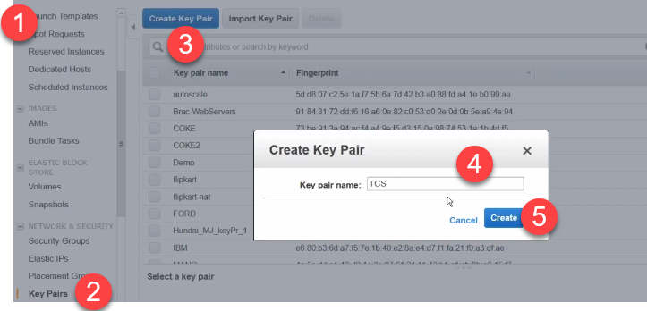

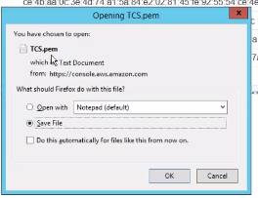It will download pem file(TALAM…Public key 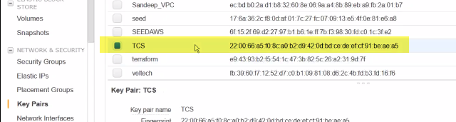

AWS will have talam kappa (private key)..

**Step-7: **

**Goto Ec2 instance and launch instance**

**I always use Amazon linux because:**

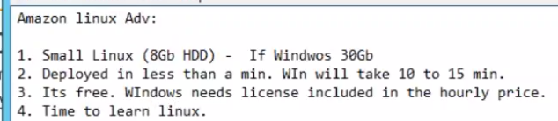

**HDD is 8 GB.**

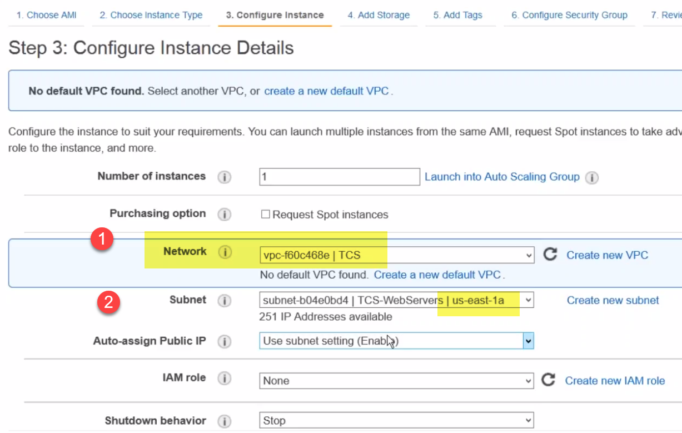

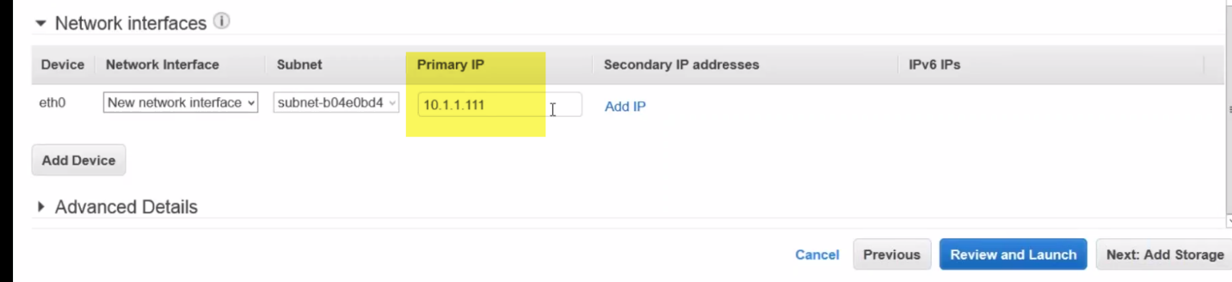 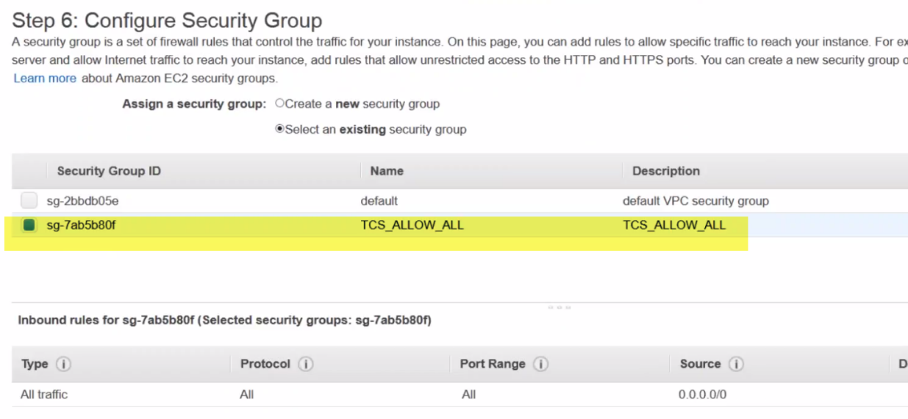

We already configured security group 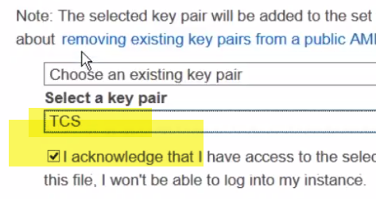

When launching Ec2, it will ask for which talam kappa to use(publickey)..Say TCS

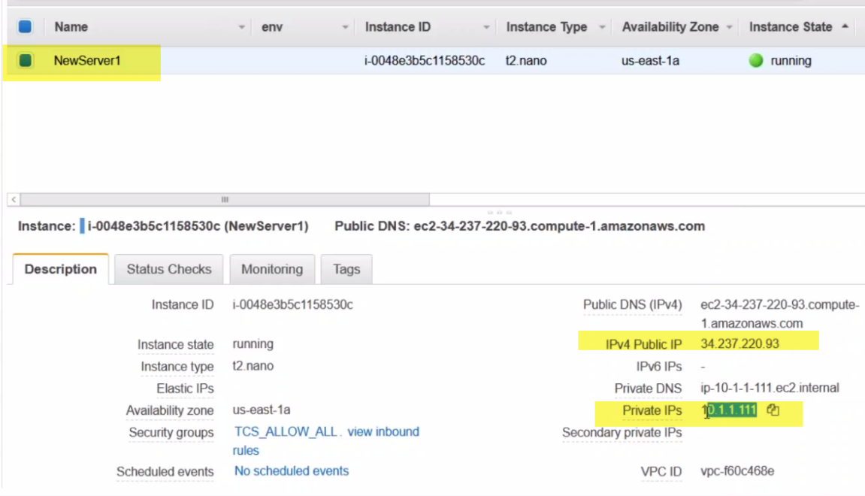

Every Ec2 instance will have 2 IPs---Privae(internal comm) and public IP(So if I want to communicate I should use PublicName or PublicIP).

**NOTE: IF I DON’T USE ENABLE DNS IN STEP-1, we will not get PublicNMae)** 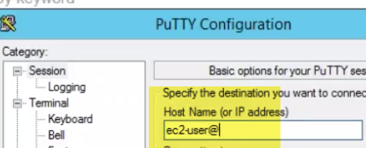 

We can use username@publicName at putty itself..

Ec2-user is default Username..

**Putty will search for PPK file…Not for PEM FILE.So we need to convert pem file to ppk** 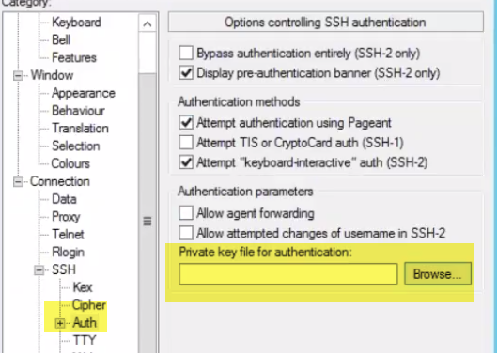 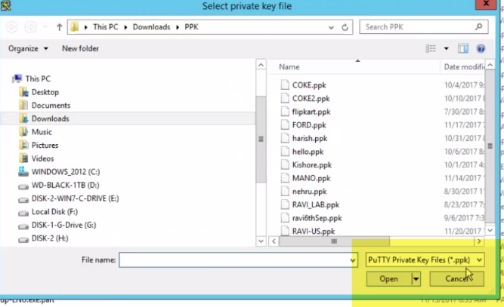

Open puttygen🡪 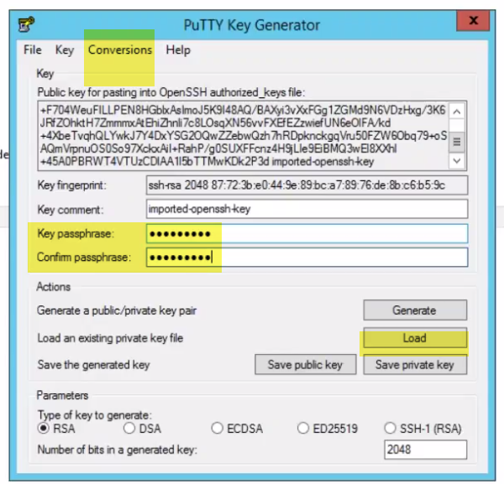

Import pem file🡪SAVE PRIVATE KEY

**Note: Don’t ever click on Generate.**

**To further protect , if someone have this pem file…We can add keyphrase** 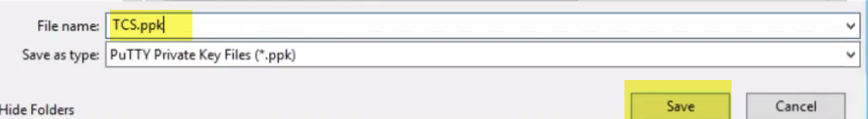

Note: Ppk is not private file…

**Ppk is just another foem of pem file..because don’t know of pem file…**

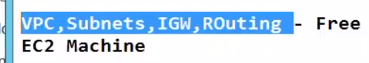

# AWS VPC NATE GATeway

# Network: VPC, Subnet, Routing Table, IGW and configured them..

We have VPC(Maruthi-10.1.0.0/16---Main address space)

1.)

# C:\Users\vebalusu\AppData\Local\Temp\SNAGHTML83667d.PNG

2.) , In that VPC we created 3 subnets MAR-SUBNET-1,2,3 in AZ-US-EAST-1a,1b,1c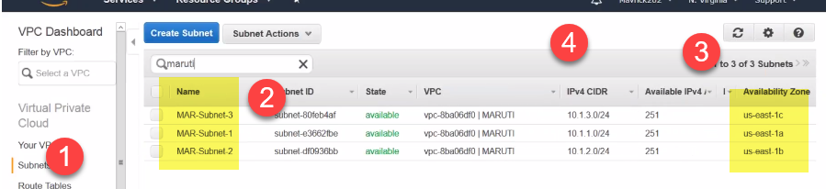

# 3.) For traffic to gout we have internet gateway IGW.

# Subnet Subnet1 is directly connected to IGW.

# 4.)If I Create instance/Server/VM inside subnet, How traffic goes outside??

# C:\Users\vebalusu\AppData\Local\Temp\SNAGHTML8a2a2d.PNG

# So VMs can connect to internet and send traffic inside or outside.

# But in Big environment, it is a big problem because VMs are directly exposed to internet.

# Ex; Suppose if I have Database server…Db server connects to internet…NOWAY it’s a security Breach.

# DB or any server shouldn’t have direct access to server..

# So Solution is???

# I will create a New Subnet Maruthi-NAT-Subnet with Ip(10.1.5.0/24).We used 1,2,3 already..

# 4 is free(if EC2 not used)..Using 10.5 IP..

# I have a VM configured in NAT Subnet..

# This DB1 is not connected to internet gateway(IGW). If it is connected in this way, Traffic C:\Users\vebalusu\AppData\Local\Temp\SNAGHTML982826.PNG

# Traffic will go out and comes in using IGW for DB1..But this is a serious threat.

# So I way, Connect to VM1 first (1) ---MANAGEMENT VM and then connect to DB1.So there is no one can access…And fully secure

# C:\Users\vebalusu\AppData\Local\Temp\SNAGHTML9a1bb8.PNG

# But when need to do updates (windows/linux updates)….I need to connect to internet...I cannot connect to internet from PATH -1(VM1) , and then 2(DB1) ..DB cant connect to internet..

# One can say this way, Directly connecting to IGW..But problem is : DB can commicate to Outside..But Someone can enter into DB here..

# SO WHAT I WANT IS: I WANT DB1 to BE CONNECTED TO INTERNET..BUT NOT OTHERS TO COMMUNICATE WITH DB1..

# Summary: We have one Main Sybnet, where we have VM1 through which we can directly connect to internet.

# But for security purpose, I don’t want internet to connect to DB1.. So I created new subnet NAT and put DB1 server in it.

# If anybody want to connect to DB1 , needs to connect to VM1 and then Db1..

# So, problem here is: DB cannot connect to internet for ANY windows/linux updates.

# This is Problem.. Solution is NAT gateway..

# I will Create new Gateway NAT GATEWAY. C:\Users\vebalusu\AppData\Local\Temp\SNAGHTMLa6bc82.PNG

# VM1 can connect to traffic easily through IGW.

# For DB1 to connect to internet, I will use Nat Gateway..

# DB1 will send traffic to NAT Gateway.. NAT GATEWAY will send traffic through IGW…Outside world.

# Traffic from outside comes though IGW and then reaches NAT gatway..

# NAT GATEWAY Traffic evarini traffic vadaladuu(BLOCKED).

# C:\Users\vebalusu\AppData\Local\Temp\SNAGHTMLac2863.PNG

# If I want to connect to traffic to DB1, it is login through VM1 and then through DB1

# So I have I have many DBs(DB1, DB2, …)..Procedure is it is through VM1 and then through DB1

# SO NAT GAEWAY ADVANTAGE IS: I CAN GO OUTSIDE..AND If o want to connect to DB1…PATH IS VM1 and then DB1

# C:\Users\vebalusu\AppData\Local\Temp\SNAGHTMLaf79c0.PNG

# Question: Performance will be slow when connecting to DB1 from VM1?

# In real envirtonmnet VM1 there will be multiple ones..All Vms will be connected to 1 DB.

# Don’t think VM1 as webserver..I want o make change in DB(create a table).So I will connect to VM1 using SSD to VM1 and then I will connect to DB1..

# VM1 is only management server/JUMP SERVER ..Not think this as webserver with tomcat or jboss installed..

# LAB

# Note: When we create NAT gateway, it will ask for select subnet.

# Nat Gateway have 2 interfaces. When we are asked to select subnet, we should select Public subnet.

# Step-2: So create a NAT Gateway and select Subnet-1(MARUTI-SUBNET-1)

# C:\Users\vebalusu\AppData\Local\Temp\SNAGHTML161d750.PNG

# Private Subnet: The subnet for which there is no direct connectivity to internet is called Private subnet

# Public Subnet: The subnet for which there is direct connectivity to internet is called Private subnet...

# C:\Users\vebalusu\AppData\Local\Temp\SNAGHTML164d5ca.PNG

# When someone deploys a VM in this subnet should get PUBLIC IP BY DEAFULT

# Note: When we are going through DB1🡪Nat Gateway🡪 VM1🡪 IGW.. What is need of public IP???

# There is no need of Public Ip for DB1..Howevr we are assigning public IP for DB1 and making sure it is NOT getting connected.. C:\Users\vebalusu\AppData\Local\Temp\SNAGHTML168b176.PNG C:\Users\vebalusu\AppData\Local\Temp\SNAGHTML168e901.PNG

# So whenever one deploys a VM, will get public IP automatically.

# Step-2:

# 

# Note: 1.) Always select Public subnet ( subnet from which we need to traffic through NAT Gateway.

# NAT gateway requires Elastic IP

# C:\Users\vebalusu\AppData\Local\Temp\SNAGHTML17390ba.PNG C:\Users\vebalusu\AppData\Local\Temp\SNAGHTML1740137.PNG

# When we click on Create New Elastic IP, it will be created

# Ex: We are using NAT gateway in real life.

# Ex: Router. We are connecting different devices like Mobiles, laptop to router.

# ISP will provide IP address to that router. SO, when we have internally 10. IP, router will automatically convert that traffic to 34.232. and sends out..

# Whenever we get response we are getting from IGW🡪 VM1🡪 Nat Gateway.

# Responds to 34. IP…Nobody know there is backend DB server..

# Nat Gateway converts 34. And provides to DB1

# 

# OUT IN

# 

# Step-3:

# Routing table are nothing but.. SIGN BOARDS.

# EX: We have created a main subnet Maruti-Main-Table already with 3 Subnets in it.

# 

# ROUTE IS TO IGW.

# 

# NOTE: Without creating New routing table, and simply coming to subnet associations, and then ADDING NAT Subnet is of no use…

# We are just red-directing NA Gateway to IGW……NO USEEEEEE

# Never add NAT gateway to Routing Table..Because it goes to IGW and public

# Solution: C:\Users\vebalusu\AppData\Local\Temp\SNAGHTMLb315b.PNG

# Create Routing Table and then add NAT Subnet to it C:\Users\vebalusu\AppData\Local\Temp\SNAGHTMLc5922.PNG

# Note: Add only NAT subnet.

# So, what we are telling is: If there are any VMs on Nat subnet, use this routing table..

# Routing table: When we are going to Hyd-Goa is through jungle..There should be signboard.If not they will go to Gujrat than Goa.. So sign-boards are needed.

# 

# TODOOOOOOOOOOOOOO

# ______________________________________-

# 

# Step-5:

# C:\Users\vebalusu\AppData\Local\Temp\SNAGHTML1ccb95.PNG

# On Subnet-1

# We are selecting NAT SUBNET

# C:\Users\vebalusu\AppData\Local\Temp\SNAGHTML1e08e7.PNG

# Every Server will have 2IPs…Public Ip (access Vm from anywhere in world) and Private IP(internal comm)..

# Elastic vs public IP:

# Technically both are same..DB or VM have one Public IPDB have this Public IP.

# Stopping this DB Vm…Default Public IP will get released..

# C:\Users\vebalusu\AppData\Local\Temp\SNAGHTML2405ae.PNG

# You can see Public Ip got released…Private IP can be seen.

# Start DB server again, it maynot get same IP again..

# C:\Users\vebalusu\AppData\Local\Temp\SNAGHTML255465.PNG

# BOTH PUBLIC IP AND PUBLIC HOSNAME CHNAGES.

# NOTE: WHEN SERVER REBOOTED, BOTH PUBLIC IP AND PUBLIC HOSNAME REMAINS SAME>

# WHEN SERVER STOPEED AND STARTED>>BOTH CHANGES.

# For IP TO BE STARTIC< WE USE ELASTIC IP(Permanent IP)..Even if server got rebooted or stopped..

# Step-6:

# Copy DB1 DNSname and

# So, traffic is through: IGW🡪 VM1🡪 NAT Gateway.

# NAT Gateway blocks everything..Any one can go out..But doesn’t allow anyone inside ..

# There is Only Return the dragon..No Enter the dragon here..

# NAT AGteway will drop packets here.

# C:\Users\vebalusu\AppData\Local\Temp\SNAGHTML2b6e97.PNG

# Lets try connecting VM1

# Connecting here..

# Step-7:

# Use private IP of DB1 only..

# 1.)Error: C:\Users\vebalusu\AppData\Local\Temp\SNAGHTML2ee7b0.PNG

# Permission denied.

# Copy Maruti.pem file

# Use this Pem file to connect to DB1

# 2.)Error-2: C:\Users\vebalusu\AppData\Local\Temp\SNAGHTML312b95.PNG

# Warning Unprotected Private file.. C:\Users\vebalusu\AppData\Local\Temp\SNAGHTML31bd37.PNGOwners can have r/W permissions…No Issue

# If Group and Others have R/W..They can copy this file, And can login..SO

# Change permissions:

# Here, Only owner have read permissions..No one have other permissions..

# Try again:

# Able to loin ..Prmopt changed form 1.100 to 5.100

# Ping from DB server..

# Traffic is going through DB1🡪 NAT🡪 VM1🡪IGW🡪Out.

# How to believe???

# Let say I go to routing table, and give incorerect in NAT Gateway.. C:\Users\vebalusu\AppData\Local\Temp\SNAGHTML377a93.PNG

# Some thing wrong here..0.0.0.0/24..WRONG..

# Ping will stop now…

# Change back C:\Users\vebalusu\AppData\Local\Temp\SNAGHTML3925e2.PNG

# Ping happens

# C:\Users\vebalusu\AppData\Local\Temp\SNAGHTML3a5a7a.PNG

# You can see between 1(48) and 2(70) .. About 22 pcakets got dropped.., when we changed routing table.

# This proves that traffic goes through DB1🡪 NAT🡪 VM1🡪IGW🡪OUT.

# BILL

# 

# For VM(1) , NAT GAEWAY(2) , ELASTICIP(3)…About 20 rs

# Questions: IPV4 and IPV6 diff:

# IPv4(32 bit), IPV6(128bit)

# IPV4: IP address is of rage –0.0.0.0 to 255.255.255.255. So private and public addressing will be different in this..

# IPV6(128bit)..Heavy addressing

# IPV6 addressing will be of form.. Very large addressing.

# 

# There is no concept of public and private IP>Every IP is unique in this

# On 4 AZ, we hosted 4 servers..Through putty using public Ip we are able to login.

# But can lo connect to Gateway and ping local ip??

# How to connect to IGW..?? ☺

# C:\Users\vebalusu\AppData\Local\Temp\SNAGHTML453f0d.PNG

# This is IGW.. There is no IP we can see here.. AWS will not give access to Gateway.

# If we make changes it will be down

# Q-3)If there si no NAT, We can directly connect using Public IP

# Q-4) Is NAT IP is public IP?

# Yes.. We give elastic IP.Aws buy some IPs from ISP.. When we request, they assign them

# Q-5) Through IGW, we are connecting to VM1. Lets say we are considering Windows.

# After login to VM1 windows, and want to connect to DB1..Through RDP??.

# Should we take DB1 private Address?or NAT private address??

# --1.)If we are taking NAT public Ip, traffic will be from VM1 to NAT( Traffic dropped as NAT doesn’t allow incoming)

# --2.) When VMs are communicating internally, Always uses private IPS..RDP to 10.1.5.0 C:\Users\vebalusu\AppData\Local\Temp\SNAGHTML51479e.PNG

# 

# When I say traffic, what I mean is ping google.com.I am sending packets and receiving packets

# 

# 

# Private vs Public IP:

# 

# Suppose James Taylor is name of person.

# In his family(taylor surname) have members…James, King, Peter..They know each other And can simply call themselevs by their names.

# Simpley James without James Taulor ..James is unique, so No need to call with surname..

# 2.)Let say I have ISP (internet Provider) AT&T.

# They are givinf internet connetion.Connection comes to us using WIFI router..(WIFI router is our family).

# Now, ISP defines one public IP for router.For router, we can have multiples devices connected. EX: laptop, mobiles, Desktop.So many devices, we can use in this public IP..

# 

# Laptop will have one privateIp, mobile will have private IP,Desktop will have private IP..

# Now,this Private IP is valid within this family itself..Each of these devices can communicate with each other easily..

# PUBLIC IP IS IP Which is shared with each one of them. ANY of the device will get same Public IP because all going through this wifi router/..

# If I type ipconfig, It will give me the IP defined by router..

# This IP is defined by rouer(private IP), where as public IP is defined on router by ISP…

# 

# Public changes from time to time..If I want static public one, need to purchase from ISP.If I connect to home router, we will get IPs..

# CIDR: Classless Inter Domain Routing

# Defines what range of IP, we should get from router, when we connect a device..

# IP Is nothing without subnet mask…This combination is called CIDR

# CIDR

# 

# CIDR block range is

# I am gonna use this as different waay, call it as 24-🡪8.8.8.0=24 8 means fixed…Nothing can be changed…Total=256 IPs.

# Why 192.156.0.123 is not valid IP??

# In this first 3 blocks are fixed, and cannot be chnaaged…Second block cannot bech changed

# 

# First 3 octlets should be SAME

# 

# Which will give me more IPs

# 2 fixed 2.) 3 fixed 3.) 1 fixed

# Lower Block number …Higher is BlockSize---More IPs…

# 1.)

# 

# 

# Create VPC in Ohio Region C:\Users\vebalusu\AppData\Local\Temp\SNAGHTML1562173.PNG Create SUBNETC:\Users\vebalusu\AppData\Local\Temp\SNAGHTML15889b8.PNG



# Create Routing Table

# C:\Users\vebalusu\AppData\Local\Temp\SNAGHTML15952d5.PNG

# Associate Subnet to routing table C:\Users\vebalusu\AppData\Local\Temp\SNAGHTML15c84f2.PNG

# Launch Instance in Ohio region C:\Users\vebalusu\AppData\Local\Temp\SNAGHTML15ed2e9.PNG

# AWS Networking Deep Dive: Virtual Private Cloud (VPC)

# Amazon AWS is the world's most popular public cloud provider. As organizations move more of their workloads to AWS, it becomes more important for them to design their VPCs to adapt to ever-changing security and connectivity requirements.

# NIGEL POULTON

# using AWS and VPCs you can literally build yourself your own world class data center for virtual machines in the cloud and it's so flipping' easy and cheap.

# VPC- data center in the cloud

# So, we'll build multiple networks or subnets in different locations for high availability. We'll configure high speed, highly available internet access, and we'll build load balancers and VPN connections, and we'll play around with virtual machines

# C:\Users\vebalusu\AppData\Local\Temp\SNAGHTML7784bd.PNG

# Amazon was running probably the biggest online retail website in the world and that website itself was the crux of their business...And they invested on it... It was high performance, highly available, all that stuff, and it had spare capacity.

# 

# one day folks at Amazon had brilliant and game changing idea, hey why don't we sell some of this spare capacity to customers. Oh my goodness....

# The idea, yeah, that there's this mahoosive web scale infrastructure out there that's highly available, high performing, and whatever else, and you can buy or actually, I should say, rent, slices of it.

# I mean, who wouldn't want some of that?

# Let's say you're a startup or in fact you're any business that needs to grow, but you don't want to lay down a bunch of capital to build your own data center and buy your own servers and storage, instead you can just go and rent some of it from Amazon. They'll be more than happy to sell you a bunch of compute and storage, the full shebang, and guess what? They probably build and manage it better than you do.

# Okay, well let's say business is good and you're expecting a spike in business next month and you think maybe you need to double or triple or quadruple your needs, but then you're projecting that maybe a month or so after that you don't need it anymore. No sweat. That's what this stuff is all about. It's elastic.

# You can just spin up more virtual machines or consume more storage space or whatever and pay for what you use and then if you stop using it, you stop paying. Don’t forget is is built on Top world class infra..

# AWS as a cloud platform, is architected into regions and availability zones. So, at a global level AWS has got data centers in strategic locations around the world.

# Regions closer to where you are going to be faster... Every region is fully independent, so fully isolated from all other regions. Meaning, if a service in a region or in fact if the entire region itself goes down, other regions shouldn't be impacted.

# within each region we've got two or more availability zones.

# every region Amazon offers certain AWS services. I live in the UK, so my closest AWS region is Ireland EU West. If I lived in Chicago, then it would be Northern Virginia, US East.

# If we use Ireland, EU-West as an example, it's got three availability zones. Each connected, yeah, by a high speed, low latency network links.

# 

# Now then, each availability zone is physically isolated from the rest, meaning if one of them goes down, I don't know a power issue or rock falls from space onto it, whatever, other availability zones in that region won't be affected.

# But, even AWS has buts, there have been plenty of services outages, okay, where issues have started in one availability zone and rippled over into other availability zones, causing the effected service to choke and become unavailable across the entire region.

# So that's why I was careful to say, right, availability zones are highly available and isolated from a physical perspective.

# So, I guess then, for like uber high availability, you might want to be spreading your services across regions, though actually I'm saying that, that's a bit of a two-edged sword because we don't have these nice low latency links between regions.

**What Is a VPC?**

* Well when Amazon was first launched, like back in the mid 2000s, there was just the S3 object store and the EC2 virtual machine platform and it's like, oh yeah.
* a lot of potential customers, especially, right, established businesses and enterprises. You see, most established companies were used to their own data centers where they owned the service, storage, and networking and they were in full control of the lot.

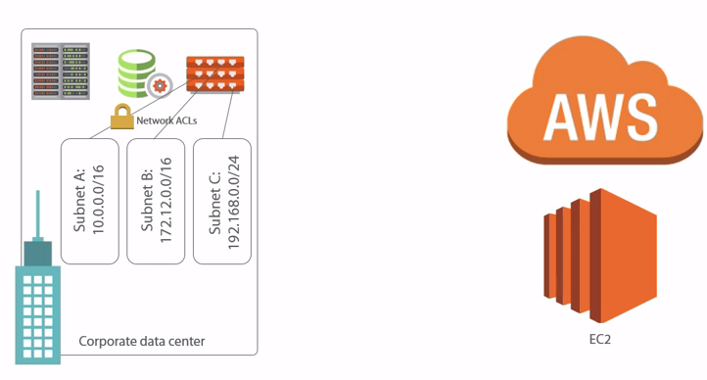

* Then enter EC2 as a virtual machine computing platform and suddenly not only were the servers and the likes not theirs, but they **had precious little control over them too**, especially in the networking space.

-🡪So it was like, spin up an EC2 instance, a virtual machine, yeah, question, **what's it's IP address going to be?** Answer, uh, well, look that's just not a good answer okay. So very cool, yeah. **Lots of shortcomings also, yeah.** 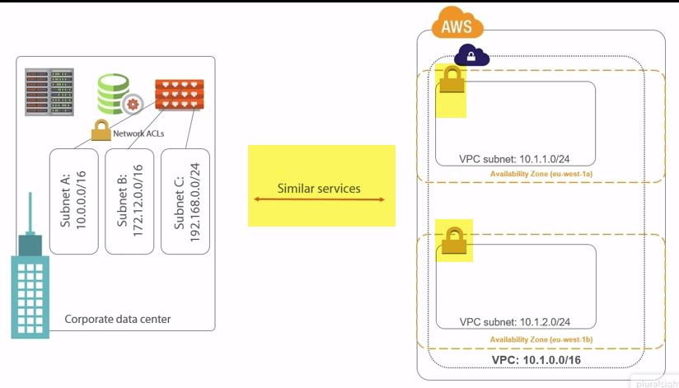

* Well here entereth VPCs. These let us build **pretty much our own virtual data center in AWS** and we'll see all of this in just a sec, right.
* But for instance, we get to choose the network range for our entire VPC and then we're free to carve that up into as many subnets as we want**. But not only that, we can put these subnets in whichever availability zones we want and that is massive, right.**
* It means we can say things like, okay I want a couple of web servers for performance and availability and then choose to deploy one into a subnet that let's say in availability zone 1A and the other into a subnet that's in availability zone 1B.
* Then if 1A goes away, so like the whole availability zone or maybe just the EC2 service, yeah, who cares, we're cool. 1B is still up and we're still in business.
* **But it's not just that, on each of these subnets, we can lash network access control lists just like we do on routers and firewalls in our corporate data center networks** and before long, this is starting to look a whole lot like a regular corporate or data center network, which is a huge driver for adoption.

**A Couple of Warnings**

* First up, right this stuff is addictive. So beware of the drug dealer model and I'm not making light of drug dealing here, nor am I calling Amazon drug dealers, I'm just trying to warn you, as is often the case with drug dealers, the first hit is free, then once you're hooked that's when it starts to cost and genuinely best of luck pulling yourself free. Well the same can potentially happen with AWS.
* Initial upfront costs can be so low as to be almost insignificant, but then if you're not careful before you know it, you're going to find yourself running a shed load of stuff on there and that's when you're going to start to feel the cost. 
* Also, man, be careful not to do a Code Spaces. So if you don't know, there was this company called Code Spaces that I think was essentially a **cloud based version control system or something like that,** and like a lot of startups, they built their infrastructure, an entire business actually, on AWS.
* The problem being, actually, I should be careful about pointing the blame here, but the issue okay, was **they were hosting everything on AWS, so their production environment and all its backups.** Okay, I get that, it makes life easy, yeah. A single AWS account and you've got access to everything, makes day to day ops nice and easy, right. 
* Though, I'm sure you've probably twigged, it also makes it dead, dead simple to trash the entire thing. **So in the case of Code Spaces, someone malicious got access to that AWS account, it doesn't matter who, right, could be a disgruntled employee, an external hacker, whatever, right. The point is, they gained access to the Code Spaces AWS account and well, basically deleted the company production services and all of its backups**. Yeah, not a great story.
* **And don't get me wrong, okay, multifactor authentication, separate accounts for different roles, proper identity and access management, maybe even hosting backups or copies of backups elsewhere.** There are a ton of things that can be done to mitigate disasters like this and in truth, it's not massively different to any other cloud providers or even on-prem non-cloud solutions where you have your own kit and your own data center. You can still totally be hacked and owned or have a disgruntled employee wreak havoc.

**Building Our First VPC**

I say magic quite a lot, but honestly, I reckon magic and technology go really well together.



As Arthur C. Clarke's third law states, "Any sufficiently advanced technology is indistinguishable from magic." Well, my humble aim for this course is to peel back the mysteries behind AWS virtual private clouds and show that after all it's not really magic, but indeed mere technology or be it totally cool technology.

**Starting the Wizard**

under Network🡪Start VPC Wizard. We've got four options, only it's pretty much two options with just a slight variation on each. 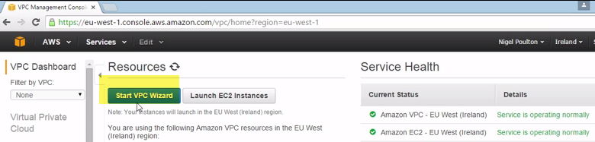 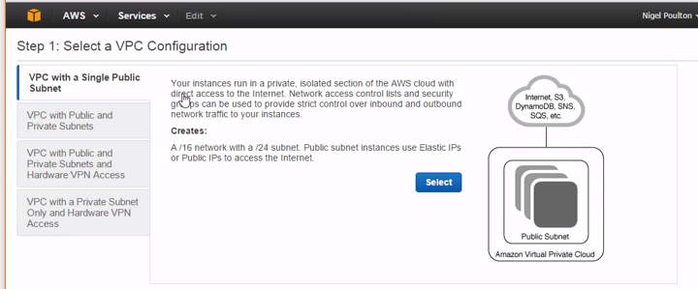

1. VPC with a Single Subnet
2. VPC with Public and Private Subnets.
3. VPN with Public and Private Subnet and Hardware VPN access.
4. VPC with Private Subnet ONLY and hardware VPN access

And then the two options below down here, these are just the same, but with a VPN bolted on.

**Right now, though we're going to rock and roll with option 2. We'll have a public and a private Subnet**

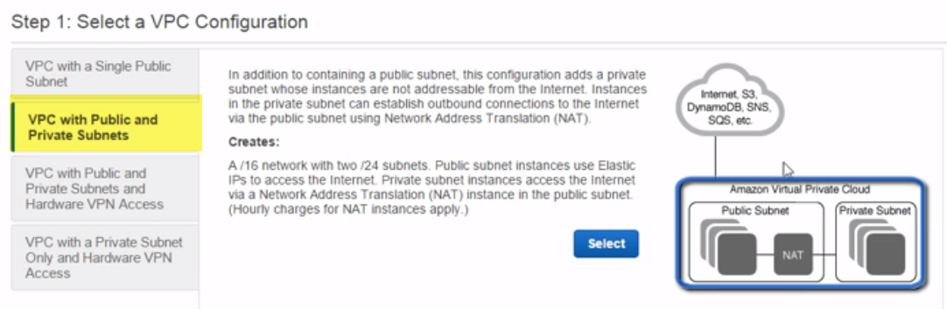

this outer rectangle, this is our entire VPC, our entire virtual data center that we're building, then within it we're creating two subnets, a public one, and a private one.

Now the major difference or the only difference, **to be honest,** is that **a public subnet** is going to have direct access to the internet. We're going to be able to connect out to the wider world as well as accept unsolicited incoming connections.

**The private subnet** on the other hand isn't. Well, yeah, actually that'll do for now.

Oh, scary screen. Well, not really. Up here at the top, okay, this is the VPC stuff, subnet specific stuff is below. 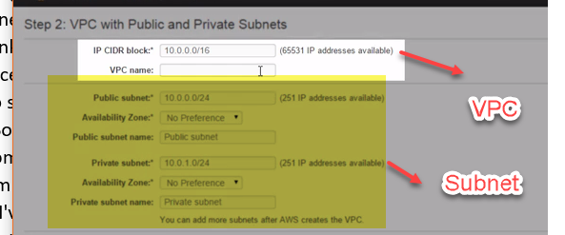

1. First up, the easy stuff though,
2. **VPC name.** I'm going to call this one podcast.
3. Now then, **the CIDR block**: this is where we define the network or the network addresses from which all of our subnets will take their addresses from.

**It’s like a master network, like a pool of addresses that all of our subnets will then be a slice of** and I know, okay, for the network savvy who are watching, I'm sure I butchered that, but suffice to say, okay, **whatever we choose here at the VPC definition level, our subnets have to draw from.** S

So we can't do something like 10.0.0.0 up here and then try and pick subnet address ranges down here from let's just say 192.168.whatever, yeah.

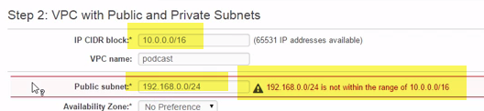

IPv4 addresses like these are broken down into 4 octets.

4 sets of 8 bits, 8, 16, 24, and 32... And then by slapping /16 onto the end here... 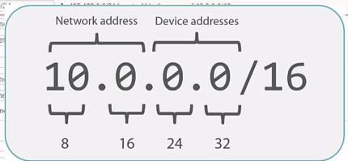

a.) We're basically saying the first 16 bits or the first 2 octets, so the numbers before the first 2 periods, these are network address. I don't know, maybe like the city name in our postal address. In this case then we'd be in the 10.0 city.

b.) then the remaining 2 octets are for street and house numbers of any devices that we put onto the network.

c.) So the number after the **/16 here is telling us how many bits constitute the network portion of the address,** then we're free to play with any bits that are left over to the right of that. .In this case the last 2 octets..

**Configuring VPC and Public Subnet Options**

1.)I'm going to go with 10.1 as the network for my VPC here.

2.)Then down in our subnet we're going to have 10.1.0 and 10.1.1. Okay, still loads of red text.

3.)So, if we **stick /24** onto the end of it, what we're basically saying okay is that the **network portion of the addresses for our subnets is actually the first 24 bits, so 10.1.0 and 10.1.1 and then because they're both slices of the bigger 10.1 network** that we've got up here in our VPC, the scary red text goes away and everything looks good again.

4.)But…any network address starting with 10. Is not a public network.

10.anything addresses are like full on RFC 1918 addresses, which is technical uber jargon meaning they're just not publicly routable on the internet. In proper layman's terms here, right, any internet router that sees packets with addresses like this is just going to drop those packets.

5.) But trying to talk to a device with a 10. address over the public internet, that's a bit like **trying to send internal office mail via the national postal service.** So just think, I don't know, an internal mail address to Mike in accounts on the 7th floor or Mia in facilities on the 5th floor, right.

The national post man or post woman, they're going to take one look at that address and probably the lack of a stamp, yeah, and just say, what? I can't deliver that. And they're just going to bin it. But I'm waffling, right? **If our 10. public network here isn't publicly routable, so not routable on the internet, then how the chuff is it going to work as a public subnet?** I mean public subnets are all about communicating directly with the internet, right?

6.) I'm going to unfold this mystery in just a second. For now, let's just put it down to AWS magic, okay. I mean it's not and we'll see exactly how it's done in all of its simplistic glory in just a second, but let's not get side tracked yet. I just brought it up now, okay, in case there are any networking uber lords there rolling their eyes here like I don't know what it is, 10 minutes into the course and saying, oh this joker hasn't got a clue, doesn't even know what a publically routable network address is. Well stick with me okay.

7.) VPCs, okay, are per region. So an entire VPC exists inside of one region and only one region.

8.)Then on the subnet name I'm going to go pub-podcast.

9.) Definitely recommend to name everything that you can in AWS, else long cryptic names that AWS assigns resources. 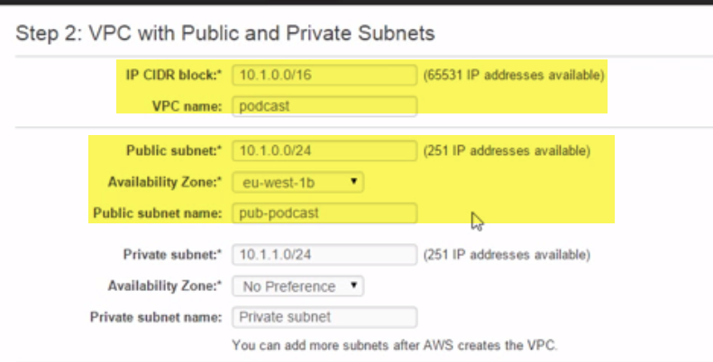

**Configuring Private Subnet, NAT, and DNS Options**

subnet or a sub network is a slice of the wider address range up here in the VPC network.

But it is slightly different to the public subnet we just created. 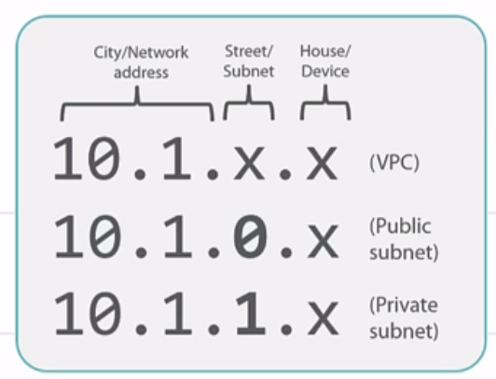

a.) we're in the city called 10.1, we take that from our VPC definition at the top, and

b.) our public subnet is on a street called 0 and

c . ) our private subnet a street called 1.

Then any devices that we put into these subnets, so containers and EC2 instances, they get house numbers in the last octet after the final period, yeah.

**For now we'll stick it in the same availability zone and we'll call it priv-podcast.** 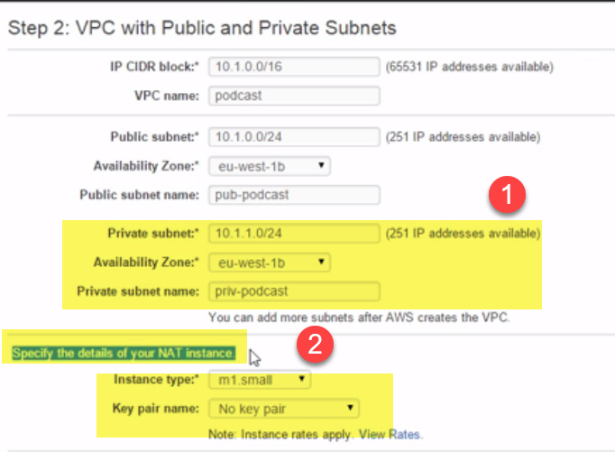

Now the NAT instance: this is basically a specialized EC2 instance that's going to live in our public subnet, but it lets instances in our private subnet talk to the wider world, the internet.

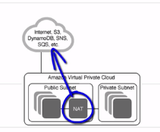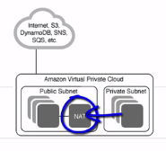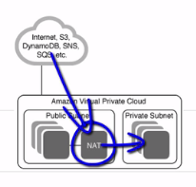

**IMP-1:** Now real quick, okay, it works by getting itself a public IP address, so not a 10. address, yeah, that means it can talk directly with the internet.

**IMP-2:** and then we just create a route in our private network that says, hey you know what, for any traffic whose IP address we don't know where to send it to, send it over to the NAT instance. The NAT instance then does some networking magic, there I go with magic again, but anyway, it does some networking magic so that that traffic gets sent over to the internet.

**IMP-3:** Any replies, well they get routed back to the appropriate host on the private subnet.

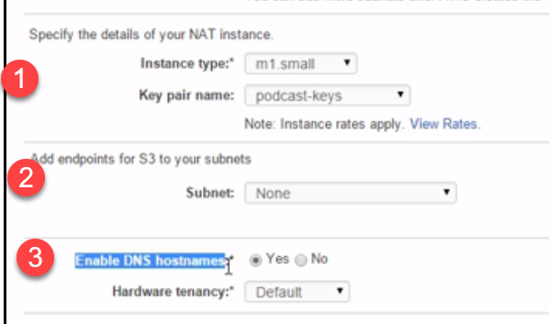

Instance type: m1 small

Keys: podcast-keys (meaningful name).

I'm not bothered about S3 endpoints for now, but yeah I do want to **enable DNS host names..**

* It is just to make sure that any instances that we spin up in this VPC, okay, are going to get DNS names that are resolvable internally within AWS and externally on the public internet (the latter of course only being if we're putting them in a public subnet and giving them public IPs, but the idea is, right)
* if we want name resolution rather than just working with IP addresses, we want to say yes to this.

**hardware tenancy option,** default 🡪share actual server hardware and the likes with other folks, to the other option.

dedicated where we pay for dedicated physical servers that we don't share with anyone else. But that's going to cost a ton more than the default shared tenancy.

**A World Class Data Center**

We have literally built ourselves a world class data center here. We've got world class physical data center facilities behind everything that we've just created, so stuff like world class air con, world class power and power management, world class cabling, world class internet access, you name it, the whole shebang is backed by Amazon's world class data center infrastructures.

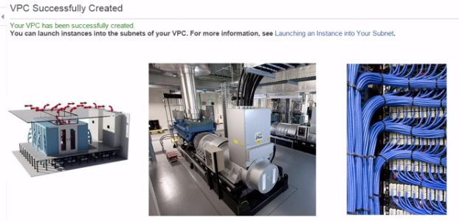

**It's not like you've just carved out for yourself some resources from the machines in my home lab, no, no, no, you have got a virtual data center sitting on top of world class highly available physical infrastructure**

How much has it cost us so far? Zilch, nothing, well, okay so that NAT instance is probably costing us a penny or so, right, but you grock, right.

I need to calm down, but it's pretty impressive in my book. I mean, I remember back in the day, right, racking and stacking physical equipment, having contractors in to pull cabling, test AC equipment, pulling up floor tiles, cutting my fingers and hands on like ridiculous server rails, and patching cables behind a bunch of servers and switches that were pumping out hot air into my face like I stood beneath a space shuttle during a take-off.

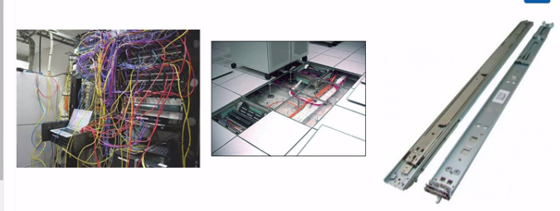

we can't walk up to an Amazon data center and say, hey don't mind me, I'm just coming in to inspect the kit that my stuff is running on.

annual power maintenance tests, UPS tests, all of that kind of jazz, yeah.

Give yourselves a well deserved pat on the back while we review just exactly what we've built for ourselves.

**Reviewing Your VPC**

We can see we've got our new VPC, podcast, yeah.

1.)Note:the three VPCs that I've currently got, they've all got different network addresses and this'll be really important later on when we try and connect them to each other.

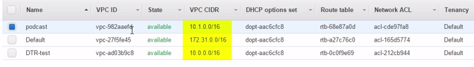 2.)**default VPC is** one/region., AWS automatically creates one default VPC for you in each region.

And all it is, right is the VPC that any instances and the likes get deployed into unless we specifically choose to drop them into a different VPC.

**3.)SUBNETS:**

we see straight away the value of naming them. I mean we can instantly pick out our private and public subnets that we just created, right..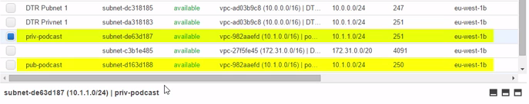

but who the heck knows what those ones that I've not bothered to label are for.

**4.)Moral of the story, remember label your stuff.**

**5.)Time to reveal the mystery of this public subnet business.** 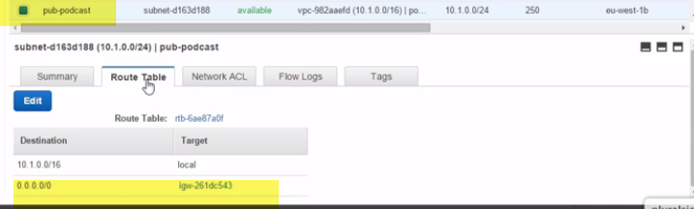

6.) Take a look at the route table down here associated with our public subnet.

This rule here, **0.0.0.0/0,** well this is like the default route for the subnet, so the catchall route that gets used when there's no better matches. And this device here that that traffic gets sent to, starting with igw, is an internet gateway**, a router that routes traffic to the internet.**

**7.)And you know what? If we compare it to our private subnet up here** 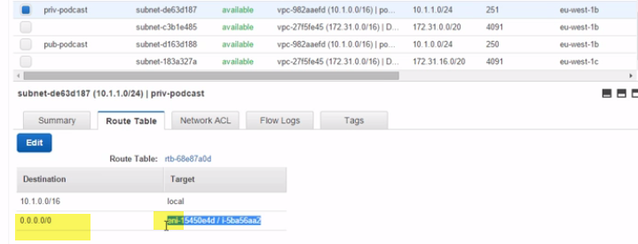

yeah, see how that **doesn't send traffic to an igw or to an internet gateway**? Well, that there, at least at the time or recording, is the major difference between public and private subnets.

**8.)A public subnet has got a route to the internet via an internet gateway and a private subnet doesn't.** This other route (10.1.0.1/16) , this one here, oop, well both subnets have got this. And what it does is it lets traffic flow locally between subnets without our VPC. Okay, cool and all…

9.) But it doesn't throw any light onto the mystery **of why our public subnet here, why it's got a private network that's not even routable on the internet. Well, let's unravel this mystery.** You know what right?

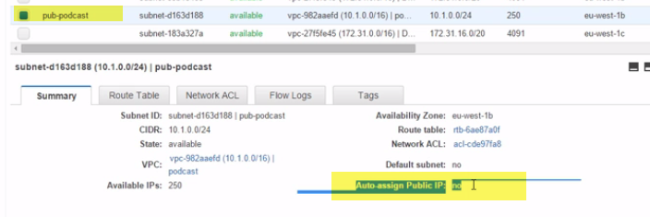

We're going to be coming back to all of this in more detail later, but this old boy here, okay, **auto-assign public IP, this is where the magic happens or actually this is where we turn the magic on** because the magic actually happens on the internet gateway.

10.) But this setting, right, it's a subnet wide setting, okay, and if we enable it. 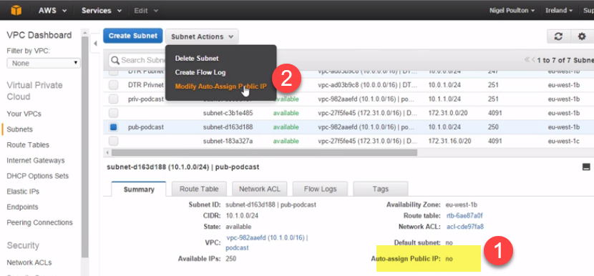 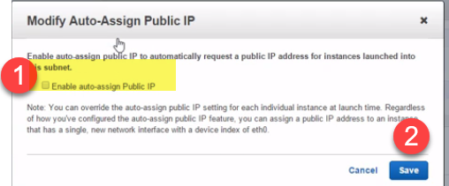

So we go up here and then we hit this modify auto-assign public IP option, **what this is going to do is** anytime we launch an instance into this subnet, it's going to get a public IP.

IMP: So a proper, bonafide publically routable address, none of this RFC 1918 internal only, not publically routable stuff, no every instance is then going to get its very own public IP address, only the way it works, right..

but the way it works is that each instance still only gets a private IP address from the RFC 1918 CIDR block range down here. But then the internet gateway performs some NATting magic where it maps a public IP address to a private IP address.

You get what I'm saying or at least I hope you do, right?

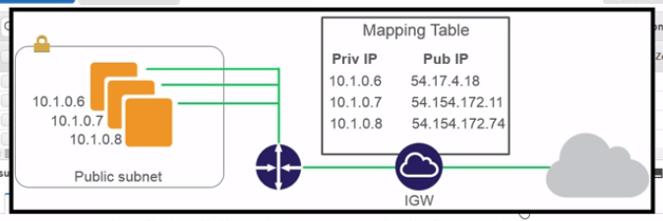

Every instance will then a public IP address associated with its private IP address on the internet gateway. So the internet gateway holds a mapping, making it look and feel like the instances have their own public IPs.

For now, right, we know that public subnets 1) have a route to an internet gateway, meaning they can get out to the internet and if we want instances in that subnet to be directly addressable on the internet with public IPs, we can do that too, thanks to a bit of **NAT magic done by the VPC's internet gateway. Wowzers.**

**Network Access Controls and Launching an Instance**

We can easily change a subnet that we've labeled as private to public and public to private.

The only real difference between a public and a private subnet is what we just said, right? A public subnet has got a route to an internet gateway.

So if we change our private subnet routing table so that it sends all of its unknown traffic to an internet gateway, well that private subnet for all intents and purposes, becomes a public subnet.

(IMP)-🡪What I'm saying is, there's like no special hidden setting or anything that says once we've created something as a public subnet though shalt always be a public subnet or a private subnet thou shalt always be a private subnet, no. It really is just whether or not it's logically hooked up to the VPC's internet gateway and all that takes is the creation of a route within the subnet. I mean our private subby here, okay, oh that's not good, oh right, maybe my session timed out or something, at least that's what I hope. Right, where were we? Oh yeah and we look good, okay. Anyway we can see, okay, that it's possible for our private subnet here to auto-assign public, yes public,IPs to its instances, no sweat. It's totally doable. But even if we configure it to do that it's not really a public subnet. To be a public subnet, like we've said, I'm rattling on about this too much now, I get that okay, but it's got to have a route to the VPCs internet gateway. So keep that in mind, right. Just because the subnet started out its life as a private subnet, we can tweak its settings and make it public and vice versa of course. Anyway, another thing we need to know. We can see that our subnets have got access control lists too. Now as things stand, okay, all traffic is allowed, so about as much use as a chocolate fire-guard. But these ACLs are totally editable, meaning we can tweak them to lock things down and obviously we will as we crack on with the course, but the point is, as we can see here, we've got the ability to create inbound and outbound, allow and deny rules and that is pretty darn flexible. Now I suppose, right, we should mention the whole point of VPCs, yeah, that is to run applications. Well, in AWS we run apps in either containers or EC2 instances, and just to keep the learning curve of this courseas unsteep as possible, I'm pretty sure unsteep isn't really a word, but to keep the learning curve of the courses properly, I'm having a brain freeze here, maybe keep it as shallows as possible, anyway to keep things simple, yeah, we're just going to stick with EC2 instances, AWS virtual machines if you will. So let's go and fire one up (Loading). Now I'm going to go with Ubuntu and free tier is good. Now importantly actually, we're going to need to configure our instance details, otherwise AWS is just going to launch it into our account default VPC. But we don't want that, we actually want to stick it in the VPC that we just created. So here we can choose our podcast VPC and in a second we're going to see if we can access it from the internet, so we'll stick it in the public subnet. See again, right, the importance of naming our stuff. Next, we get the chance to override the subnet setting of whether or not the instance gets assigned a public IP, but see how our subnet setting is already enabled? Well seeing as how that's the case, we'll just stick with the default, and you know what? That's enough for now. We don't need to bother about anything on this screen for now, well, I mean that big old scary warning up there is just telling us that the security group config is wide open. Store that one for later, right, we'll tackle it in due course. Let's spin her up. Oh yeah, we need to associate the instance with a key pair. It doesn't really matter which set as long as you're in possession of them. Podcast keys will do for me. Now we can launch.

**Connecting with PuTTY**

if we've got a bunch of instances and we've not named them, we're going to have to do a bunch of digging around to work out which instance is which, so let's name it now

PuTTY doesn't like the .PEM key format that AWS provides. So I'm going to fire up PuTTY Gen. I'm going to import a key, this one's ours, and hit Save private key

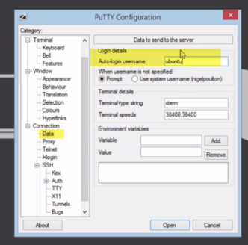Default user for ec2 instance for ubuntu

**aws-vpc-operations-m3-09 - Summary - Building Our First VPC**

we pretty much started out with this, yeah, that's right, a blank sheet of paper. No infrastructure to run our apps on. Then purely by having an AWS account, boom, we instantly got a whole bunch of this kind of stuff behind us..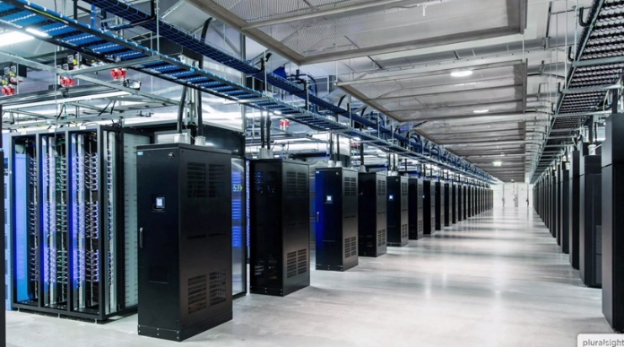

and what that is is world class data center infrastructure and we could start building on it and thanks to Amazon all of that physical stuff is their problem now.

we started off by building a VPC, which is like the logical boundary of the virtual private cloud or the virtual private data center that we were going to build in AWS. 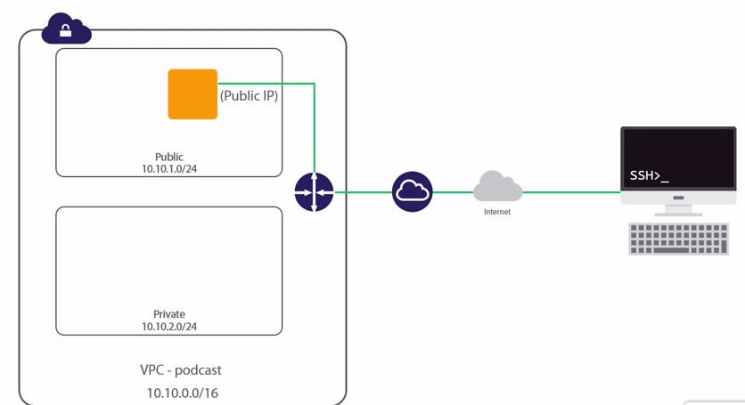

we gave that VPC a network and a name, then we carved that network into two subnets.

We made one of them public and the other one private

difference is the existence of a route from the public subnet to the internet via an internet gateway. Then, we spun up an instance in the public subnet and we made sure that it got assigned a public IP address. Then we initiated an inbound SSH connection to the instance using that public IP.

It's just insane, honestly it is. With a few clicks of a mouse and a pathetically small incursion on our credit card, we've effectively built a data center.

But we've bought or leased no land. We've built or leased no building, put up no security perimeter, connected no power, connected no Telco communications, we've racked no servers, ran no cables, nothing. Amazon has done it all for us.

All we had to do was to find a few networks and even that was a walk in the park. Internet gateways were built for us, network routes were configured, access control lists, so much stuff, and we never even broke a sweat.

I want to give a big old warning here. 

You might be tempted to think, hey now I can go and build a private data center in Amazon and the world is my oyster and yeah it is, but don't go running straight off and deploying your apps into what we just built there. There's actually a ton more that you're going to want to learn before you start hosting your prime time on Amazon.

And I'm not just talking fancy stuff like high availability and auto-scaling, I'm talking critical fundamental stuff like making sure that **public IP just gave to you instance doesn't change when you reboot your instance because the way that we built the VPC in this module here, as soon as you reboot that instance, it's going to lose that public IP and get a shiny new one.**

**Building Subnets and Configuring Routing**

we're going to start from a clean slate, and then we'll manually build a VPC from the ground up. So we'll define a VPC and we'll carve it into a couple of subnets. We'll make one of them public and one of them private and along the way we'll introduce routing, but as we're putting it all together, we are going to make sure that we explain how it all works.

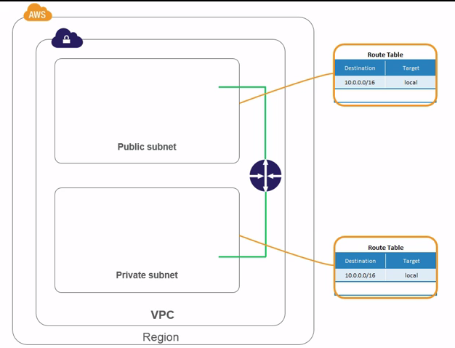

I'd never intentionally cause a P1, okay, but when I worked in operations, man, those were the best days, action packed, loads of people involved, loads of pressure, never a dull moment, man. I mean the time literally flew.. It's all about being prepared. But I'm getting carried away, okay, just take this, right, bad stuff like this happens.

Poulton's first law of IT, stuff just breaks all the time, right. Don't say you weren't told. So, diving gear on, oxygen checks, let's dive in.

**Creating a VPC - Building Subnets and Configuring Routing**

1. First things first okay, create the VPC. Now we're going to see that a VPC itself is not much more than a name and a range of IP addresses or at least that's all that we need to worry about.
2. Remember, right, behind the scenes we are carving out for ourselves a portion of Amazon's world class data center infrastructure.
3. Anyway okay, we're going to call ours podcast again. I deleted the one that we used in the last module and I did a bit of cleaning up.
4. Then we'll go with a **10.0 network** again. **Remember, this /16 means that the first 2 octets are the network address and the last 2 octets here are for device addresses.** We'll get this bit right, okay, because you know what? Like most network hocus pocus, once it's done it is like way to complicated to change. **So get your CIDR block right because there's no way to come back and change it later.**
5. make sure that you're not already using this CIDR block somewhere else in your corporate network, even outside of AWS, okay. Because if you are and then at some time in the future you come and try and hook that network up to AWS file, like a VPN or something, well you're going to have problems.

So, the **moral of the story:** make sure that this CIDR block is unique within your organization

1. Then tenancy here, yeah, this is just whether or not we want to pay for our own dedicated physical servers on the back end or whether we're happy to share. I'm happy to share.
2. remember, a VPC only exists within a region. So, here's our VPC and up here, I'm in Ireland, true that be. ..but if I go to let's say Asia Pac Sydney, good day mate, well we can see here how there's just the default VPC in this region.

So, when building a VPC, make sure that you're in the right region, oh, and if at some time in the future you're looking around for your VPC and you can't fine it and you're like sweating..

**The Default VPC**

1.)VPC that we just created is not a default VPC and there's actually no way that we can make it a default VPC. Well, at least there's not at the time of recording, right.

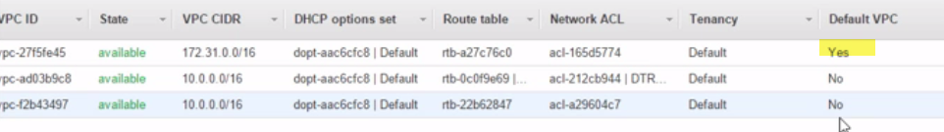

2.)Now what this basically means is if we want to launch instances into our new VPC, we've got to manually select it when launching the instance.

3.) A new instance is automatically going to get launched into the region's default VPC, they call it network over here, yeah, but really they're named VPC. Well, I guess VPC basically is a network. 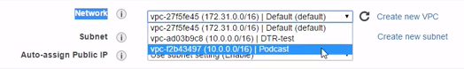

4.) But the point is, if we want to launch the instance into our VPC, then we need to manually go in here and pick it from the drop down.

5.) every regions got one default VPC and that gets automatically created for us by AWS and there's no way to change that. So even if we delete it, which we absolutely can, well then our region just ends up with no default VPC. Then later on if we suddenly decide, uh that was a mistake and we really do want one, well we need to go with our begging bowl and go and beg to Amazon to recreate it for us.

**Major VPC Options**

**It have VPC ID—Cryptic..,Name(Always name your staff), Status,VPC CIRD..**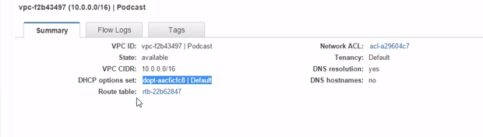

**DHCP options set:** what DHCP is most famous for is dynamically assigning IP addresses to devices on a network, so every machine on an IP network needs an IP address in order to communicate. 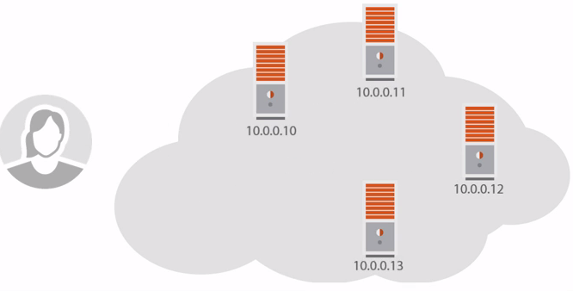 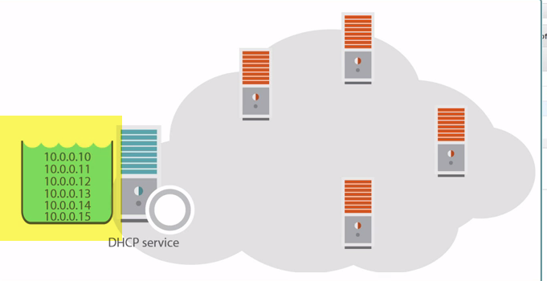

Well, instead of ours manually assigning every machine a unique address, most of the time we just conscript DHCP into managing all of that for us.

So, we give DHCP a pool of IP addresses and pretty much say, hey any time a new system appears on the network and asks for an address, go ahead and lease it one. Bingo. And it takes care of a bunch of other stuff too like making sure that we don't assign the same address to two devices and all of that jazz.

DHCP( dynamic host configuration protocol).. it can do much other than assign a bunch of IP addresses.

Click on DHCP options…(hyperlink)

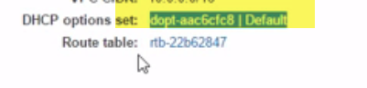 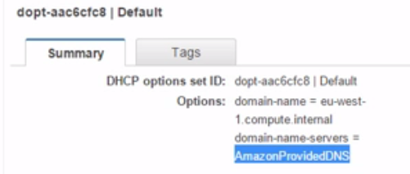

Well, we can see how this options set is also going to **assign a domain name of eu-west-1.compute.internal and it's going to tell the instances to use Amazon's own DNS servers.**

In fact, Amazon provided DNS is actually a DNS server that sits on the second address in your VPC's network, so in our VPC with 10.0.0.0/16, it's going to be sitting on 10.0.0.2.

let's see DHCP options available… by clicking on Create DHCP options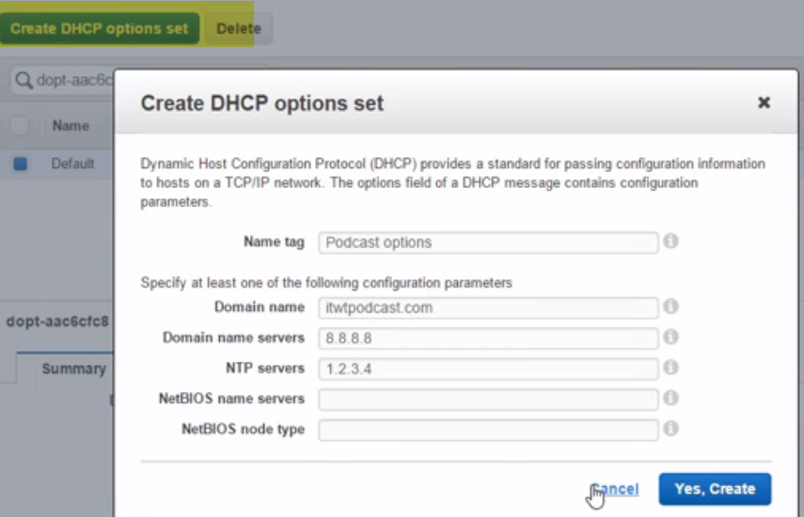

Domiain: intechwetrustpodcast.com, so that all of our instances get a host name in the intechwetrustpodcast.com domain, try saying that.

We could point it to Google's famous DNS server and we can point it to an NTP server for accurate time too, and I totally just made that address up, right. And seriously, right, if you need to configure nasty old NetBIOS stuff, oh man, you really want to drag yourself out of the 90's. So a bunch of stuff that they can manage and configure, okay, but it's worth knowing.

--🡪 (1)**DHCP options sets are associated with your AWS account. 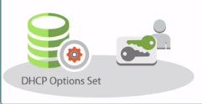 (1)**

**So they're not limited to the scope of let's say a VPC or a region or anything like that, no, and it's 2)totally possible to have multiple sets of DHCP options set, try saying that, good grief, but any VPC can only have one assigned to it. (3)**

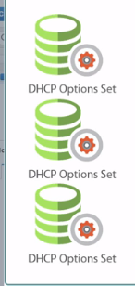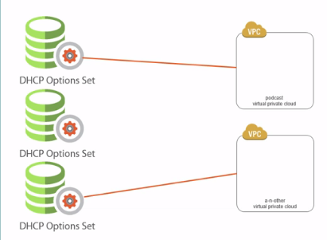**(3)**

**(2)**

**(4)So I can't assign two DHCP options sets to this new podcast VPC, but I totally can assign this single, I'm just going to call it a set this time, to multiple VPCs. (5) 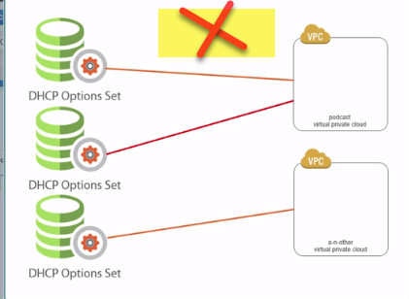 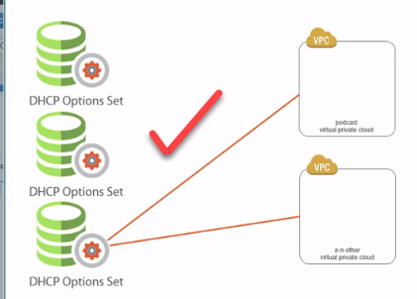(5)**

(4)

**once you create a DHCP options set, you can't modify it. In fact, look, there's no modify option, just delete**. 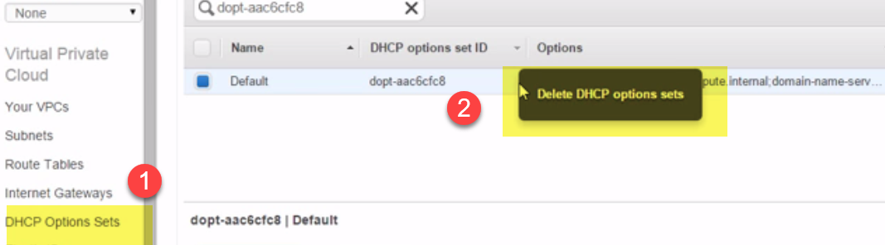

. If we change the DHCP options set that we've got associated with a VPC, we don't necessarily need to reboot our instances. **So what happens is, right, when an instance gets its IP config from a DHCP option set it gets it on a lease and then every so often it needs to renew that lease.** Well, when that time comes to renew the lease, any instance is going to pick up the new options.

There we go, DHCP options sets.

-🡪 Now route table: Route tables basically tell us how to navigate around our VPC and after the internet as well. Think of them as kind of like maps or directions, yeah.

🡪Then we've got **network ACL**: it's basically a list of what traffic gets allowed and what traffic gets blocked.

🡪Tenancy, we already know about that.

🡪And then finally, **DNS resolution :**Do we want our hosts to be able to look up DNS names and resolve them to IP addresses?

🡪 **and DNS host names**:And then do we want instances in this VPC to get assigned DNS host names? So map their IP addresses to friendlier, more readable DNS names? Well, we want yes on both of these counts. So if we go up to Actions up here, Edit DNS Hostnames…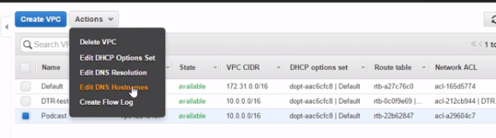

**Building Two Subnets**

1.)Okay then, if we hit subnets over here, then jump straight into creating a new one, now, I strongly suggest that you give it some kind of name, okay, that makes it easy for you to tell if it's going to be public or private.

2.)This one's going to be public and our first public subnet in this VPC, yeah.

3.) Make it part of our new VPC and 4.) choose an availability zone(1b)

**Note:** Now, okay, **don't forget how each availability zone within a region is like its own isolated data center,** so that means let's say one of those snazzy flying delivery drones that Amazon is working with, yeah, well let's say one of them does like divide by 0 midflight and it comes crashing down on an AWS data center, taking the entire availability zone out with it, right. Okay, pretty funny news story, assuming nobody's hurt. But it's no big deal for us, right? As long as we've deployed our apps in a highly available fashion across multiple availability zones because the thing to grock here, right, is that an availability zone being taken out, even in style like that, right, isn't going to impact any AWS services running in other availability zones.

1. **CIDR block**: this is a slice of addresses taken from the pool of addresses that the VPC holds.

The VPC has got like this big old pool of addresses and then each subnet that we create as part of the VPC takes a slice of those addresses for itself. 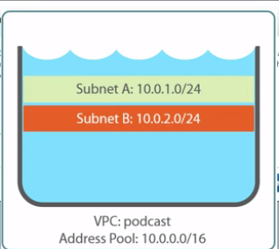

**6.)Okay, so our VPC was 10.0.0.0, 10 and 3 zeros, right, with a /16 subnet mask. So for simplicity, we'll say this subnet's going to be 10.0.1.0/24 and yes we'd like to create that.**

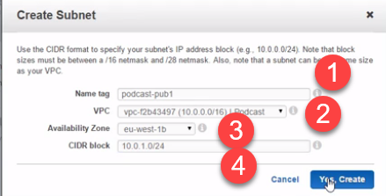

1. And that's a very basic subnet for us, but we're going to want 2 for later on okay. One public for accessing the internet directly and the other one for private without direct internet access.
2. This time for a private subnet. Same VPC, same availability zone, and this'll do for the CIDR block. 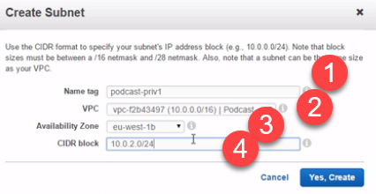
3. **Summary:** We've created our VPC, yeah, we called it podcast and we assigned it a big old range of addresses. Then, from within that range of addresses, we sliced ourselves out two subnets, podcast-pub1 and podcast-priv1. Both in a single availability zone, right? 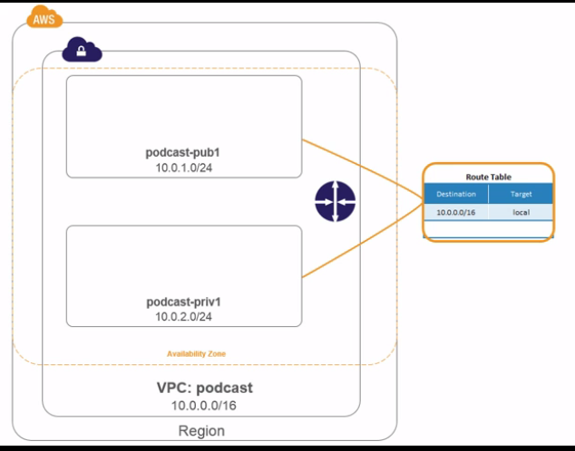
4. Now then, that's what we've explicitly built, yeah. But behind the scenes, AWS has thrown in some extra stuff without us knowing, ...Mainly what it's added is a router and some routing tables.

**Introducing Routing and Route Tables**

1.) **Routing, routing, routing:** The first thing to note is exactly where the route is drawn on the diagram. **It's at the VPC level, so one per VPC.** 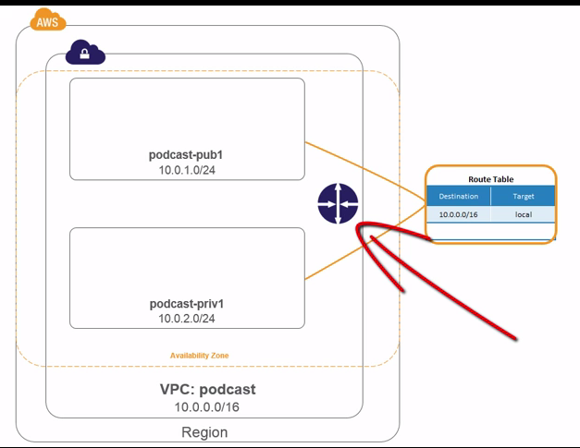

2.) And if we add a couple of lines to it, yeah, we can see how it **routes** traffic between our two subnets. That's the job of the router, right…to let instances or containers on one subnet talk with other subnets, conceptually it's mega simple.

3.) Then, in each subnet we have a routing table. 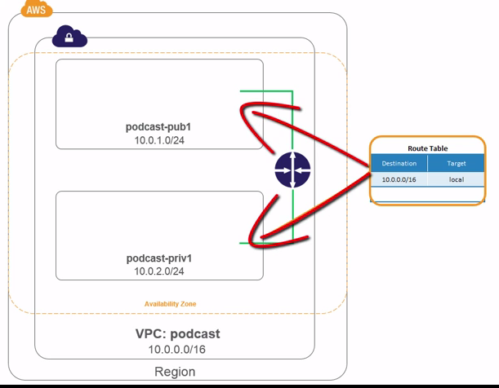These tell us how to get traffic from one subnet to another.

4.) I suppose we could **say that the routing tables are a bit like directions, maybe road signs or something, yeah, and the routers themselves are the roads.**

5.)For now though, route tables are like directions, where do I want to go? Another subnet? Okay, hit this router. I want to go to the internet, okay, hit another router.

6.) The routers themselves being like roads.

7.) Next thing to point out is that our **AWS router is like 100% totally hip software defined goodness.** I can guarantee **they're not giving you some Juniper or Cisco router** in there, no way. This is bona fide software defined networking.

We don't need to worry about the state of the router, so is it up, it is down? How are the power supply units? What's the temperature? All of that kind of stuff, no concern of ours. We don't need to think about how to configure it for high availability, we don't need to manage port counts, nothing like that.

8.) **We just need to care about the rules that tell it where to send packets, that's the route table entries, the directions, yeah**.

9.) I mean, look here in the UI, there ain't no option for routers or router configs, just this route tables option here. 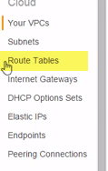

10.) go over to subnets here and our public subnet and hit the Route Table tab, right, we can see our route table's ID, rtb-22b whatever, yeah, 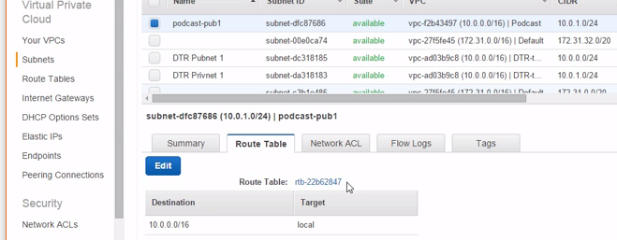

right now our route table has only got a single lonely entry and that 10.0.0.0/16 address... It's the network we assigned to our VPC. **Now, this combo here of the VPC CIDR block plus the target called local, this is the route or the direction if we keep with our analogy, that traffic needs to take if it wants to talk to another device within** our VPC. **Should be pretty easy to remember since the target says local.**

11.) And you know what? Every route table gets this entry and I don't think we can even delete it, so from a routing perspective, every device that we spin up in any subnet has got access to directions telling it how to get to every other device in our VPC. **And I stress, okay, this is from a routing perspective because, yeah, we can use things like network access control lists or security groups to lock things downand disallow traffic and the likes, but as far as network routing goes, this route table entry here means we're all family within our VPC.**

**Creating a New Route Table**

1.) Now every VPC gets an implied router, it's just there. It can neither be created nor can it be destroyed, a bit like NRG app, that's how fundamental this AWS stuff is.. 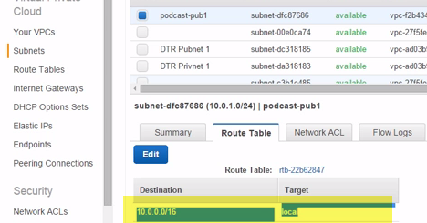

2.) Also, every subnet needs a route table. So if we've got three subnets here, they all need a subnet. They all need a subnet, I mean they all need a route table. But each subnet can only have one route table. So we can't say, hey subnet 1 over here, he or she can have 3 route tables...

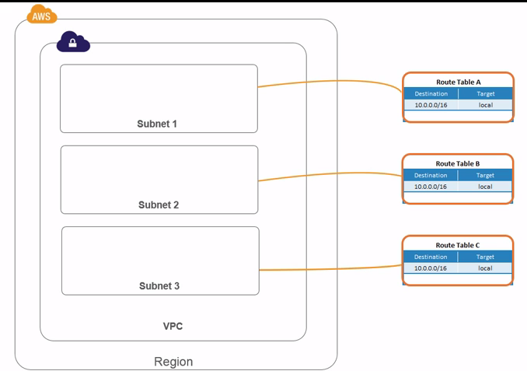 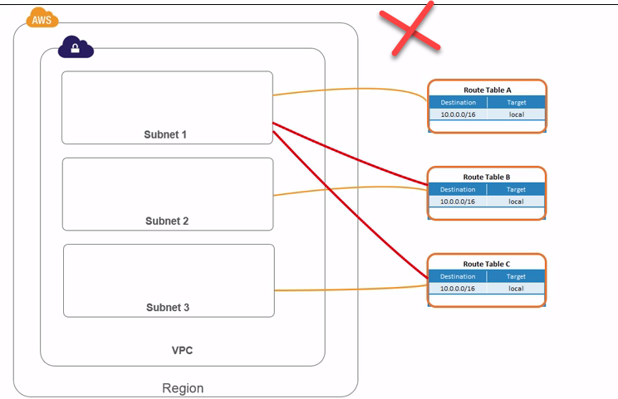

3.) uh-uh, our survey says uh-uh, but a single route table on the other hand, totally possible for that to be associated with multiple subnets. 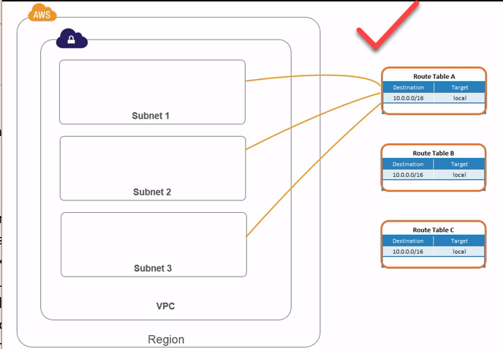

4.) when a VPC gets created it automatically gets a main route table. 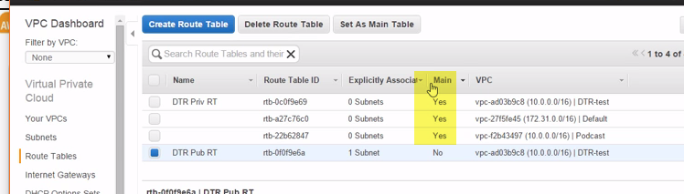

5.)It's dead easy to flip back and forth between being a main route table and being a non-main route table. We just right click the one that's not the main, this one, and we say set as main table. 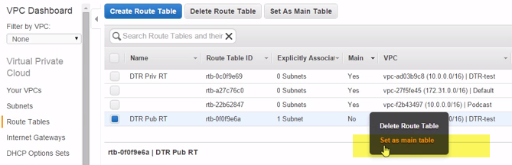

6.) Now I'm not going to do that because this one's actually an alive VPC where I'm doing some testing on Docker Trusted Registry, but if I did click set as main table, then this one up here, which is currently the main table for that VPC, it's going to get demoted to being a non-main table.

You know, not that it's actually a demotion, but you get, right **how a VPC can only have one main table.** They should have probably called **it the default route table or something,** I don't know.

7.) But what does a **main table mean?** Well it just means that anytime a new subnet gets created it automatically gets linked to the VPC's main route table. 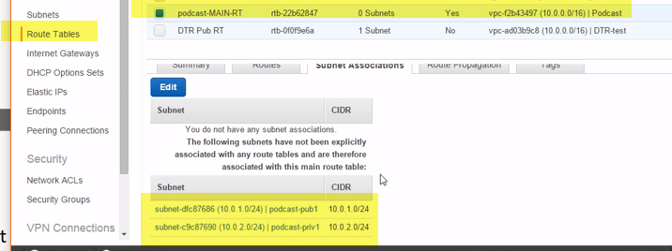

So if we pick our podcast one again, and I'm going to name it actually while we're here (Typing), okay, then if I hit Subnet Associations down here, see how it's got two associations? Our public and our private subnets. But look, see how they're not explicit associations? That means we didn't manually create them.

**They just got associated by default because this is the VPC's main route table, yeah.**

8.) Well I'm not a fan of that, okay. Mainly because see **up here the 0 subnets,** this could be misleading. I mean, not massively so, right, because we can **see here it says explicitly associated subnets,** so there are 0 explicitly associated subnets.

But I don't know, it's entirely possible that someone comes along and thinks, ah, this route table is not associated with any subnets, so let me go and mess with it. Not ideal, no.

9.)So let's edit here, select our public and private, save that. 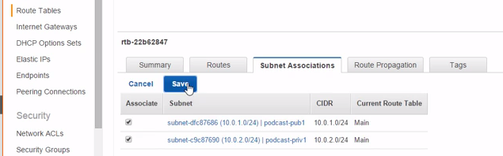

Look that's tons better, well in my opinion it is.

**1o.) Anyway, every subnet needs a route table and every new subnet gets the VPC's main route table.** And that's okay and we are free to modify and tweak the main route table. There's nothing super special about it that stops us doing that and you know what? You might choose to do that, but again, I'm not a fan.

I prefer to leave the main table as it is and then to create a new one and put my funky new custom rules in the new one. This way, right, anything funky that I do, it doesn't get automatically applied to new subnets and that's probably a good idea.

11.)So I'd create a new one, give it a meaningful name obviously, 10 lashes for anybody not naming their stuff, put it in the podcast VPC, and create (Loading).

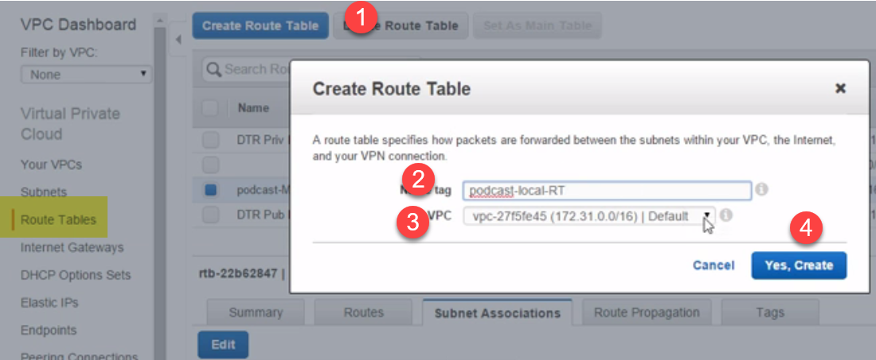12.) And if we find it now, yeah, see how it's got a default local route, in fact, yeah,… 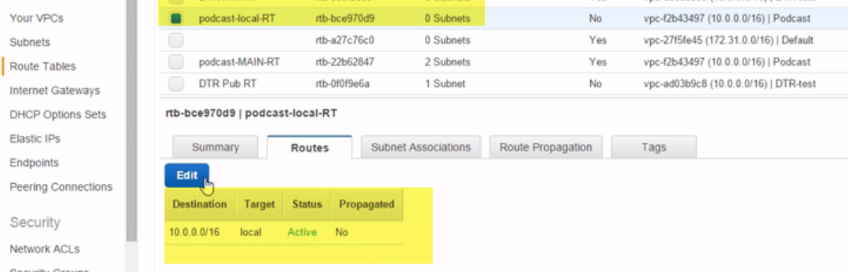

see how you can't even delete that route? It's etched in stone. **THERE IS NO DELETE OPTION**

**13.)Then if we go and associate it with a subnet, we'll pick our two, save them, lovely. 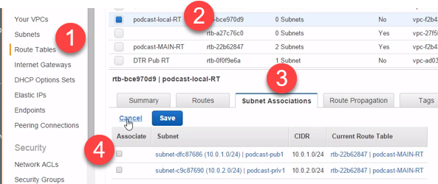So, a new route table in our VPC, not the main table, meaning any changes we make to it don't get automatically associated with any new subnets that we create, but it is associated with our two subnets.**

**Module Summary**

1.)We kicked things off by building a new VPC again, but this time without the help of the wizard. We called it podcast and we gave it a /16 CIDR block of addresses.

2.)be careful when choosing the CIDR block because if you want to go hook your VPC up to let's say your corporate network over a VPN at some time in the future or maybe you want to create a pairing connection to another VPC, these are probably only going to work if the CIDR blocks of the two networks don't overlap.

3.)Ex: So make sure they're not both, for instance, 10.0.0.0, I keep running out of zeros here, 10, 3 zeros, /16. If they're both the same, you're going to have problems when you try and connect them.

4.) And we also pointed out stuff like VPCs are per region, yeah. Yes, they span multiple availability zones, but those availability zones all need to be in the same region. We can't have a single VPC spanning multiple regions, at least not at the time of recording.

5.) Then we covered off some of the VPC related options. DHCP options sets was one of them, right. Now we said these are tied to our AWS account so we can attach them to any of our VPCs. And they let us manage whether or not our instances will be able to, let's say, resolve DNS names to IP addresses..

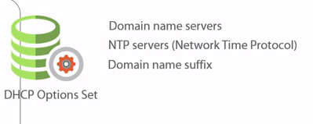

we can use DHCP options sets to configure things like NTP servers, yes, and the DNS name suffix that gets applied to our instance host names.

6.) Then after all of that, we finally got around to creating a couple of subnets, just a **nice little way of carving up our larger VPC network into smaller, more discrete, and more manageable sub-networks.** And like we just inferred a second ago, these exist within a single VPC, so within a single region.

**But the important thing is, right, they are tied to a single availability zone and that's important because subnets are a great way for us to pin services down to a particular availability zone.** So, want to spin up an instance or a service in a particular availability zone? No worries. What we do is we spin it up in a subnet that's in that zone, dead simple.

1. then we looked at routers and route tables. We said that **every VPC automatically gets an implied router.** Implied, implying, or suggesting it's just there. We don't need to create it, indeed we can't create it nor can we delete it. It really is just there.
2. All we need to do is manage the route table entries that get associated with each of our subnets. Remember we said these route tables are like the directions or the road signs that point traffic down the different routes.
3. , hey, I want to talk to a device with an address somewhere in this VPC, so on 10.0.0.0/16, hit the local route, anything else, that's what the all zeros here means, go and use this igw router here instead.

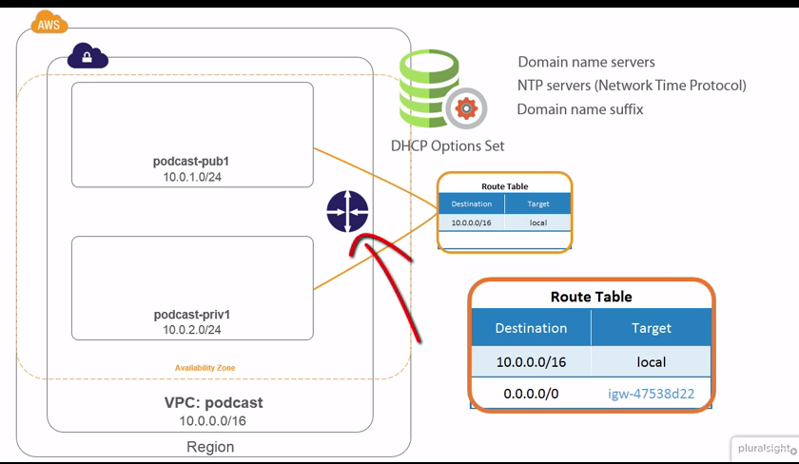

1. And Amazon promises, those are my words actually not theirs, that this router is always going to be there and that it's not going to be a bottle neck.
2. **Cool, okay, but on the flip side, it's pretty much invisible to us, we've got zero insight into how it actually works or how it's performing.** We've just got to trust Amazon and that's a sticky point for a lot of people. I mean I don't even like it personally, but it's just the way it is.
3. Oh yeah, we said **every VPC has got a main route table, which is just like a default route table for that VPC.** We can tweak it if we want and we can even change which table is the main table.

**Configuring Internet Access**

**Module Intro**

1.) We'll take our existing public subnet that we've created and we'll configure it for direct access to the internet.

--- We'll be configuring our public subnet for direct inbound and outbound internet access. So any instances that we run in there will be directly addressable on the internet, so they'll have their own public IP addresses

2.) we'll configure our private subnet for internet access.

---Our private subby on the other hand, well while we're going to grant it internet access, it's not going to be direct, it's going to be via a proxy of sorts, something that will allow outbound access.

So, you know, the old classic use cases where you need access to the internet for updates and patches and the likes, but at the same time, not allowing unsolicited inbound connections.

**Creating an Internet Gateway**

1.) we're going to kick this baby off by making our public subnet, well public. Now according to the Amazon docs and the likes, in order for a subnet to be public, it needs to be connected to an internet gateway.

(it needs to have a route to the internet and then there's the small matter of having a public IP address.)

2. )For now, let's just create an internet gateway ..if we hit Internet Gateways over here, 🡪create a new one.. well check that out. All it needs is a name. 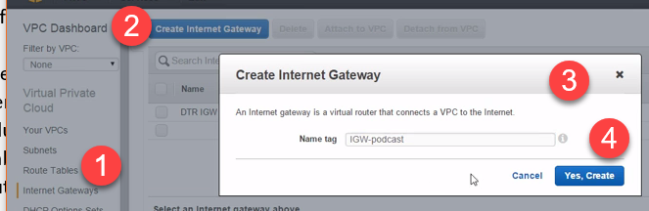

(Talk about a simple setup. I mean step back for just a second and really think about that. Life back in the day, right, when I was cutting my infrastructure teeth. You know what, and cutting my fingers racking and stacking servers in small coms rooms, back in the 90's. Well, I remember when we got our first ever 1 MB internet connection. I mean, this was like a huge deal, not just the fact that it cost an arm and a leg and 1 MB was like mahoosive, but the effort that we went to to make it as redundant as possible and the likes, wow, I mean I remember we had a couple of our own routers hooked up to it, and although I was definitely a trusted member of IT, I was nowhere near senior enough to go anywhere near it. I mean it was a huge deal. We practically had the queen come and ceremoniously commission the thing. It was a big deal and it was a ton of effort and money. Well you know what?)

With a click of a button, and well let's give it a name here and as simple as that, we've created for ourselves..**We've just created for ourselves a horizontally scaled, redundant, highly available internet connection.** Talk about buzz word bingo.

Let me run that by you again, a horizontally scaled, redundant, highly available internet connection, so posing no availability risks and no bandwidth or scalability constraints.

I mean is somebody pulling my chain here or what? I've just clicked maybe like three buttons and supposedly I've got what sounds like the ultimate in high speed, never goes down, internet connections. Seriously, sounds the bizzo, right?

3.)But here's I suppose the frustrating part, yeah. Amazon doesn't tell us anything about how it actually is all that stuff..

4.) Creating a potentially awesome internet connection for your VPC and its subnets is like a Sunday afternoon stroll in the park. **All we need to do now is attach it to our VPC. Oh and notice the drop down, it's only giving us VPCs that don't already have one.** 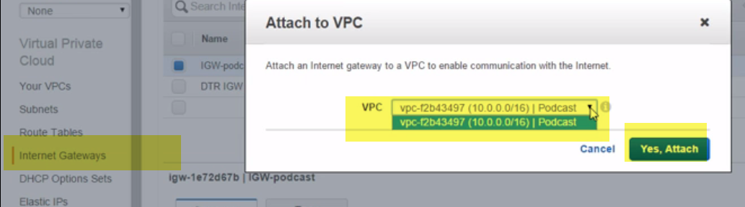

**So** it's a one internet gateway to one VPC mapping. I suppose what else would it be, right? I mean, why you would want two of them when they're indestructible and never tire, makes sense right?.. Okay, anyway, that's our uber high performance, uber available internet gateway created. Even my mom could have done it. **But notice, okay, that it got associated with our VPC, not a specific subnet. So it's available to all of our subnets,** we just need to create entries in a subnet's route table to enable that subnet to use it.

**Updating the Route Table**

1.)So let's hit our public subnet and let's add some internet gateway action to its route table. Ah, right, see how it's currently using the podcast local-RT route table, 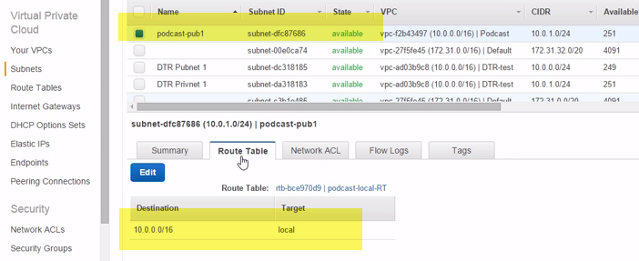

2.)in fact, yeah, it's associated with two subnets, so our public and our private subnets. 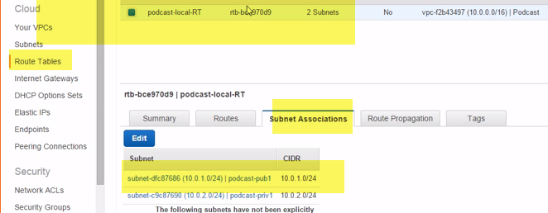

3.)What we want to do then is create a new route table. And we'll call this one podcast-public-RT and what we'll do is we'll use this one for any subnets that need access to the internet and we'll keep the local one for private subnets that don't need hooking directly up to the internet.

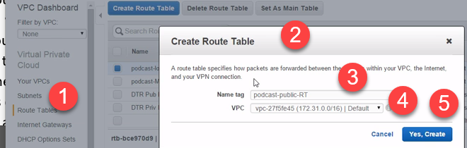

1. we'll add a new route first. Now the easiest way to add a route pointing to our internet gateway is to add a default route like this.
2. **So that's what all of those zeros is, a catchall route that will get taken if there's not a more specific route.**

when an instance comes to send packets to a destination, and this is the high level, right, it looks at the route table and it says, okay which route do I need to take? If there's a match on the route table it sends the packets to whatever is listed in the target here, but if there's no match then it sends data to whatever's listed as the target for the 0.0.0.0/0 default route, kind of if there aren't any matches then send it this way, the all other routes or all other directions that you often get on road signs.

1. **So, all these zeros represent our all other destinations default route.** So, we want to point this to the internet gateway and see how it suggests that for us and it even includes our friendly name that we gave it, cool.

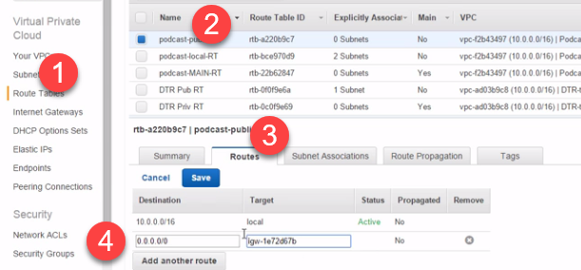

And that's pretty much it. That's our road sign right there. Local traffic, so anything that matches our 10.0 network, hit the local route. Anything and everything else, head for the internet gateway. Magic, super simple.

6.)So we've created an internet gateway for our VPC, that superman style internet gateway to end all internet gateways. Well, that's our road or our route to the internet. Then, inside our public subnet we updated the road signs. We created a route table entry that said, hey for anything that you don't see above, so anything that doesn't match our 10.0 network, head over to the internet gateway. But we only added that rule to the route table of our public subnet. Our private subnet still knows nothing about it. Not hard at all, right?

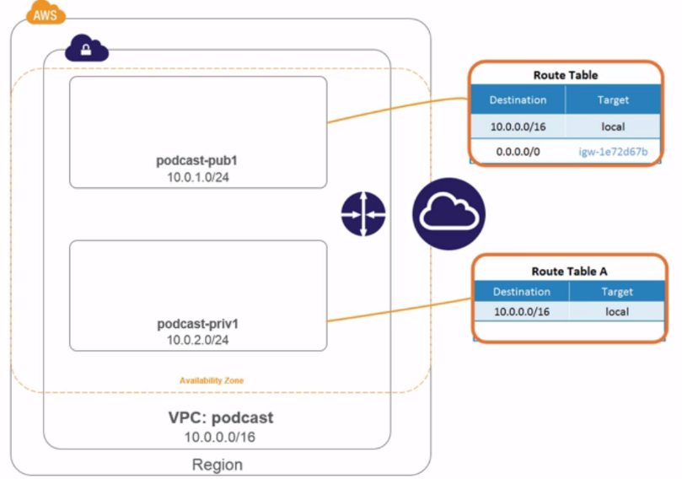

7.)Now hopefully not flogging a dead horse here, but **how this routing table stuff works is the most specific routes get precedence over the less specific ones.** Any by specific I suppose I mean the subnet mask bit, right. So let's say we had two routes that were similar, 10.0.0.0/16 and 10.0.0.0/24. Well the /24 route is the most specific because it includes more bits in the mask, 24 rather than 16, right. Well what this means, our default route here is as unspecific as it gets, right. So that route is only ever going to get picked if there's literally nothing else that even comes close to matching.

8.) Good stuff and all and it really is, but even that's not enough to give our instances direct access to the internet. We've one more thing to configure, public IPs.

**Configuring Subnets to Assign Public IPs**

1.)So we've got all of the VPC and subnetty type infrastructure in place to get us out onto the internet, but in order for any instances to actually make it out there, they need a public IP and I know it's probably not needed, but just in case, okay.

2.)Let's build out our analogy of roads and road signs. So if our routers and internet gateways are our actual roads, and our route table entries are like our road signs, then public IPs, I suppose, are a bit like cars.

3.)In order to get out there on the internet or onto the motorway or highway, yeah, our instance needs a public IP or a car

4.) we have a couple of ways to accomplish that. We can either assign an instance of public IP when we create the instance or we can set an attribute on the subnet so that every time we launch an instance into that subnet it's going to get one automatically ..Right

5.)So if we head over to our public subnet and then see here in the Summary tab 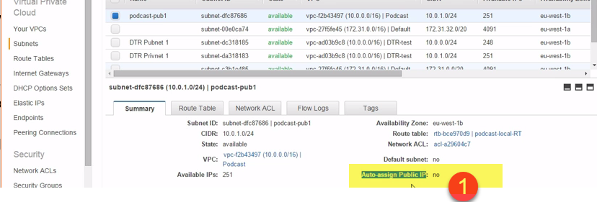 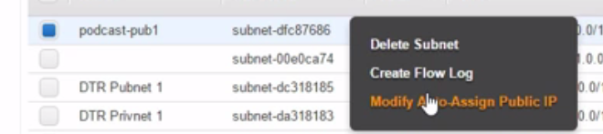

Auto-assign public to yes.

However, we've no way of controlling what IP address gets assigned..

**Spinning up an Instance**

1.)We'll have our podcast VPC thanks and obviously we want our public subnet and then see here, auto-assign public IP, we can either go with the subnet's default setting, which is the bit in parens, obviously that's enabled since we just set that, or we can manually override the setting. **Well the subnet's default of enable is fine with us, but just remember this is where we can override it if we need to.**

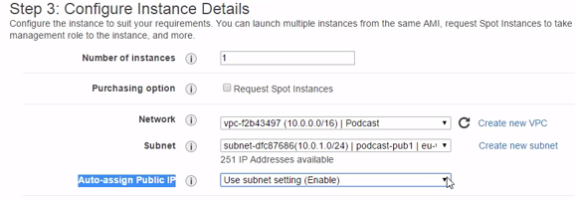

2.)security group 🡪SSH …Now while this spins itself up, let's go see it's public IP. There it is, 52.18.112.214. IP address. Well let's grab a copy of it, in fact, no, let's go with the public DNS name.

3.)We'll open up a command prompt and let's see if we can ping it. Bingo. Well, okay it's not accepting pings, but we can see that we can resolve the DNS name to its public IP address.



4.)Okay, well let's configure PuTTY here…

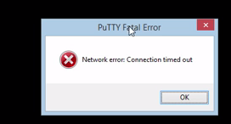

Let's check the security group, yep,(22) SSH allowed. Let's go look at the NACL, Inbound, yes to all.

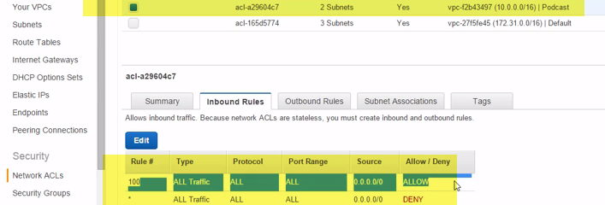

5.)I wonder if we've got a route to the internet, yep. **Oh, look, no subnet associations.** 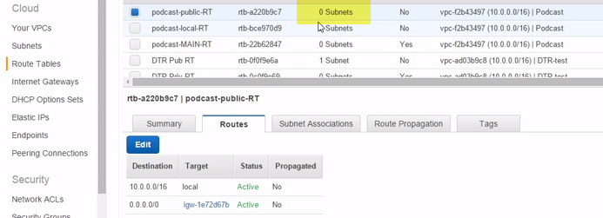

let's associate it with our public subnet. 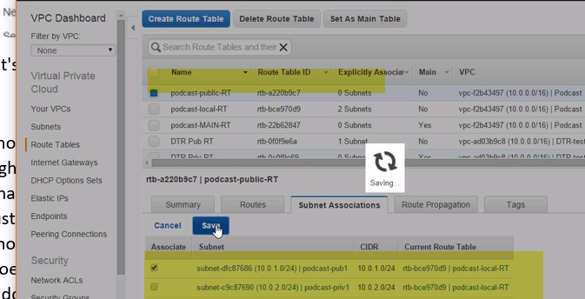

6.) Should we try this again (Loading)? Ah, that's miles better. Whooo wee,

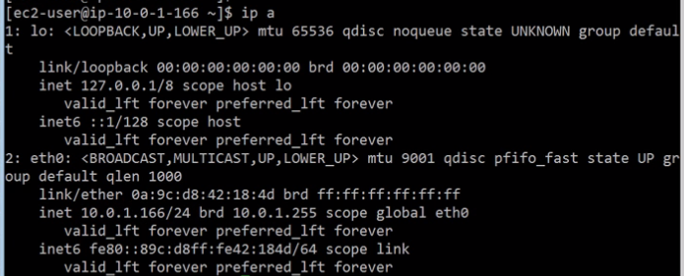

IP addresses. Oh, hang on a second. **Where's the public IP?** That's just the loopback in the private addresses there. Are we missing something? **No, same again here, just the loopback and the private address. So Linux knows nothing about the public IP address.**

**But we know it works, right? I mean we've just SSH'ed into the thing using its public IP.**

7.) **So what's going on? Does it have a public IP or doesn't it? Well, we're witnessing a little bit of AWS magic here**, but not hidden dark magic. So not like the secret source of the internet gateway we talked about earlier, although this is actually internet gateway magic, it's just not secret this time.

**So what is going on here?** Our Linux instance, and it could just as easily be a Windows instance, right? But it knows nothing about any public IP address, we just saw that. All it knows about is its private IP.

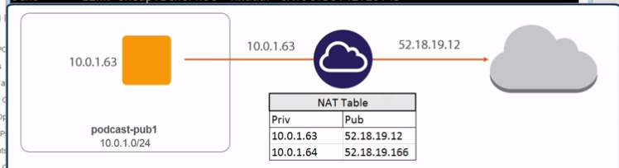

Then on the internet gateway we've got a bit of NAT magic going on, network address translation. So basically, the internet gateway is holding a mapping of private IPs to public IPs. So every time our instance here sends a packet to the internet, the internet gateway, yeah, it sends the packet out to the internet, but stamped with the public IP of the instance. Then any replies that come back, well they get converted back to the instance's private IP before they getdelivered back onto the VPC. Dead simple, but dead effective too. The internet gateway just takes care of making sure that any internet bound requests in or out get mapped to the appropriate public IP for that instance.

8.)So just in case you weren't already impressed at the horizontal scalableness and super nitroglycerin enhanced performance of the internet gateway, well guess what? It performs a bunch of NAT magic too.

9.) I don't know, next it'll be making you coffee. But the sweet thing, remember, we created it with like a couple of mouse clicks, unbelievable. But there we go, a public subnet in all of its wonder and glory. Internet gateways, route table entries, and public IP addresses. **The only problem we're left with now, when we reboot the instance it's going to lose that public IP and get a totally new one. What? You heard that right. Totally non-persistent. Here today, gone tomorrow. No good for anything permanent. What? Well, no big deal, it's easily fixable.**

**Elastic IPs**

1.)So I'm guessing right, for most production apps and the likes you're going to want persistent public IPs, at least for some of your internet facing systems. Maybe you need some of your clients to internally white list some public IPs so that when you come talking to them they can trust you.

2.) Well public IPs, like we've just been working with, are definitely not the answer to that. They don't belong to you and they change every time an instance reboots. So what we really want are what Amazon calls elastic IPs.

3.)Now these puppies are the same as public IPs in that obviously they're kosher publically routable addresses and we've still no control over which particular addresses we get, but they are ours to keep. And bouncing an instance isn't going to cause it's elastic IP address to change. In fact, the only time that an elastic IP gets released back to Amazon is if we explicitly say so.

4.) I've obviously had them in the past, but once I'm done with them and I've trashed the instances they map to I give them back. 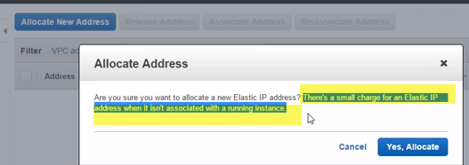

Because while they're in use you don't get charged, although actually, I think you do if you've got maybe more than one per instance or something like that, but I'd check the latest pricing info. But once they're not in use there is a small charge to pay.

1. Now all we need to do is go associate it with an instance or an elastic network interface.

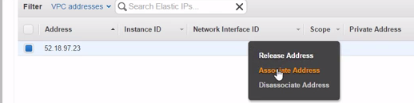

For simplicity sake, okay, we're going to attach it to the instance that we just fired up a second ago. 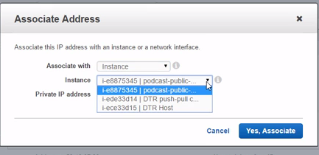 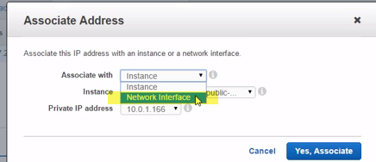

**But normally, not normally, but certainly the more powerful option is to associate it with an elastic network interface** and all that is is well, a network card, but one that we can associate and re-associate with pretty much any instance we want.

**7.)So if we were to associate an elastic IP with an ENI, that's an elastic network interface, we can attach and detach that interface from different instances easy** as pie, though stating the obvious I hope, it can only be attached to one instance at a time.

8.)If we jump back over to EC2, see I told you that shortcut would save us some time, and we select our instance, well see here how the public IP and the elastic IP are both populated with the same address.

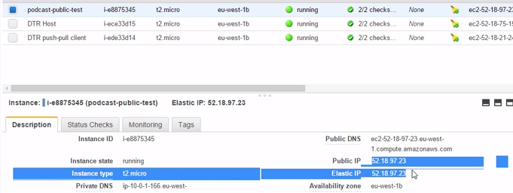So, for reliable, persistent, public IP addresses we need elastic IPs.

**These get assigned to our VPC and then we can assign them to instances or elastic network interfaces.** And again, as far as our instances are concerned, they work the same as public IPs, meaning Linux or Windows or whatever knows nothing about them. It's all magically and invisibly mapped on the internet gateway.

9.)So let's say, okay, generally speaking, elastic IPs are where it's at for publically routable IPs. **Definitely what you want if you need something persistent and reliable.** I've got a little note here as well saying, at the time of recording at least, **there is a limit of five per VPC.**

**Private Subnets and NAT Instances**

1.)In this lesson we'll configure things so that instances in our private subnet can get access to the internet. But we're going to do it in a way that's totally different to how we just did it with our public subnet, the reason, right, we don't want our private subnet to have full on access to the internet.

2.)So what we're going to build here is going to be a bit more restricted, you know, a bit lower performance and no public IPs for any instances. I mean it's still going to work of course, it's just for a different sort of requirements.

3.)This use case is going to be a bit more suited for things like hosts that need access to the internet for let's say patches and software updates.

4.) First up, we're going to spin up what's called a NAT instance and we're going to spin it up in our public subnet. We'll use an Amazon provided AMI for that and although it's just a Linux instance, it is a bit special. We're going to use it like a router. So kind of a proxy middle man, right, where we send it packets and it in turn delivers those packets to the internet.

5.) So we'll spin the instance up and then we'll configure it to disable source and destination checks and this is vital, right. Because this is what lets it act like a router, receiving packets from our private subnet and passing them onto the internet or the internet gateway, I should say.

4.)Now, all instances have got this attribute called source and destination checks and by default it's set to enable, and all that does, right, is say, **hey anytime you receive a packet on the network, check it and see if it's either from your or to you, if it's not, drop it.** So don't pass it onto anyone else. Well obviously that's not good behavior for a router whose raison d'être is obviously to forward packets on that are not addressed to it. So we're going to need to disable that check.

5.)Also, we're going to manually update the routing table in our private subnet so that it's got a default route that throws packets to the NAT instance. This way, anything that's not matched by the local route gets thrown over to the NAT instance, which then in turn is going to throw them over to the internet gateway, which is then going to throw them onto, well the internet. Magic…

6.) Now a couple of quick points before we go and configure it. This config of using a NAT instance here as a router is going to act a bit like a stateful firewall of sorts, right. So, yes, while we can send traffic out to the internet, the only traffic that's going to be allowed back in is going to be bona fide responses to stuff we've already sent out.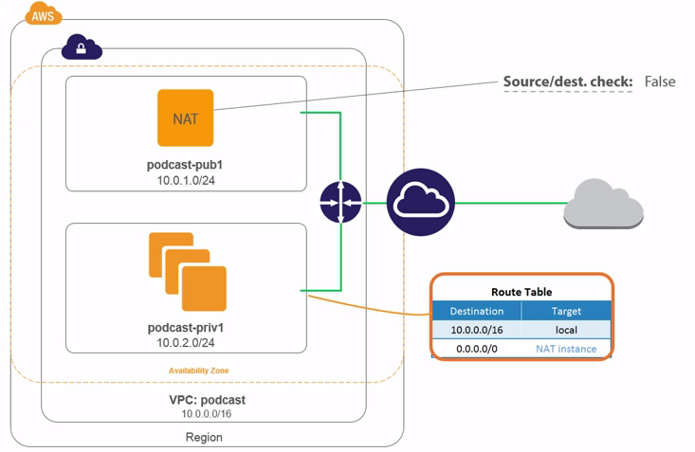

7.) So, unsolicited incoming traffic, so stuff that's not in response to something we've already sent, it's going to get dropped. **In technical speak, that means our NAT instance is going to allow stateful responses**. Also, right, what's going on under the cover in the NAT instance is actually PAT, port address translation, it's not NAT.

8.)So remember how we said earlier that our instances in a public subnet, we assign each instance a publically routable IP address and then the internet gateway maintains that mapping table between public and private IPs? Well that can't be the case for this setup, right?

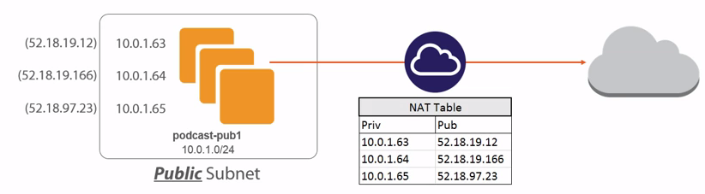

9.)Because the only instance that's part of this party, with a public IP, is going to be the NAT instance itself. So we'll end up in a situation where we've got multiple instances in our private subnet here all trying to get out to the internet via a single public IP on the NAT.

So what happens is the NAT instance, sure, it's got its own public IP to get to the internet, but it maintains a mapping table that maps private IP addresses of instances on the private subnet to its own public IP plus a unique port number.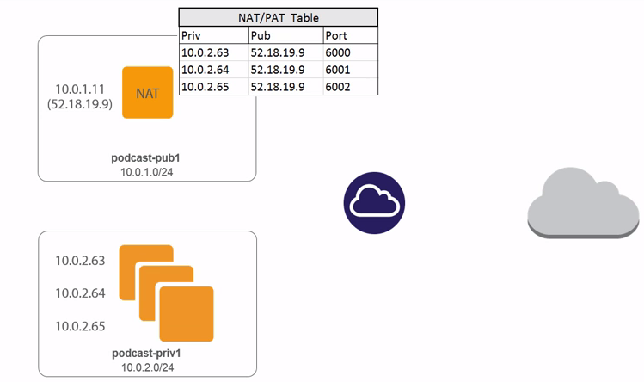

1. So let's say we've got two instances down here, right, with a single private IP each. This particular one might be associated with port 6000 and then this one with port 6001. So, any traffic that comes back to the NAT, so a bona fide response, as long as it comes back on port 6000 it's going to get forwarded onto this instance. Okay, theory, theory, theory, should we actually go and do it?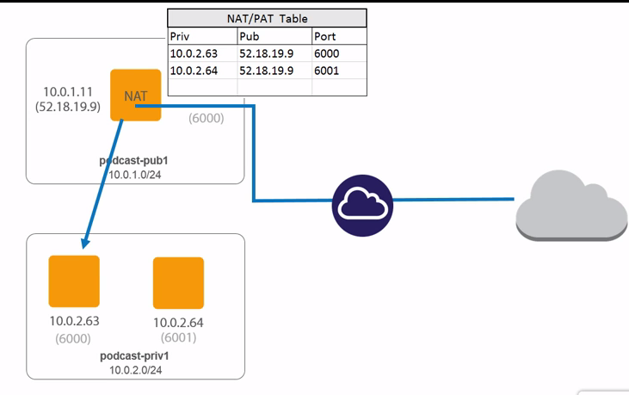

**Configuring a Private Subnet with a NAT Instance**

1.)Okay, so from our EC2 console here, let's launch a new instance.

2.)And we want Community AMIs here, then search for something with **NAT in it.** This HVM bit here, just make sure that I don't get an old style pair of virtual instance, because we want the full on hardware virtual machine version, right? And **then 2018 just filters it so that I only see recent versions.**

3.)The difference being, right, this GP2 bit here, this is telling us that this one's going to be based on super flashy SSD rather than magnetic rotating _____ for it's disk.

4.)podcast VPC up here and **importantly, right, it's got to go in the public subnet.** Now if you stick it in the wrong subnet here, you might as well just destroy the thing and build a new one from scratch **because migrating instances between subnets is just, well I was going to say hard, it's not actually that it's hard, it's just hmm, it's more manual than it should be.** Anyway, it needs to go in the public subnet, okay. And it definitely needs a public IP. Right. 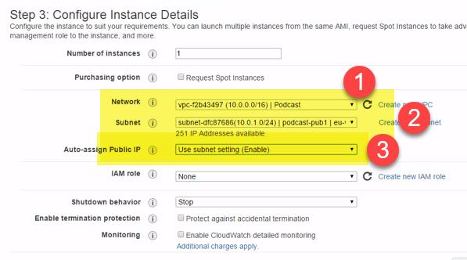

5.) SSH rule, that's going to be fine for now**. In the real world, yeah, you're probably going to want to lock the source bit down so that it just accepts connections from IPs on your management network or something like that.** But the thing is, right, the thing to do here is add rules for the type of traffic you want to allow out.

Well, we'll add a rule here for HTTP and then we'll add another one for HTTPS.

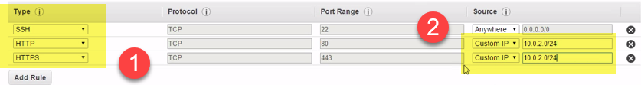 But what we want to do is lock the source addresses down to our private subnet so that only instances in the private subnet, right, are going to be allowed, so that's going to be 10.0.2.0/24 and same again here .

1. Now to disable those source and destination checks.

Networking🡪 Change Source/Dest Checks 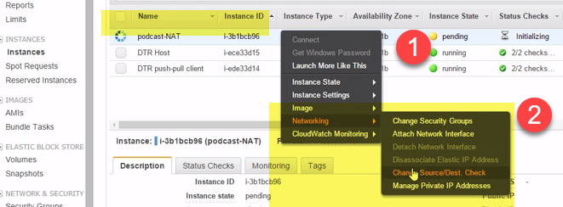 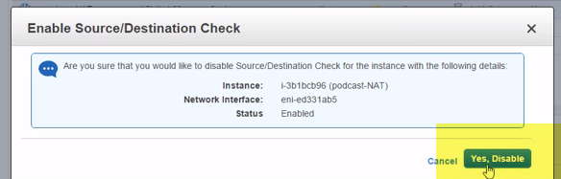 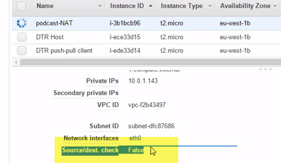

**And I think we should be able to see it somewhere down here, yeah, there. False, so disabled.**

1. Now to update the route table for our private subnet …podcast-priv 1 here. So let's give it a new default route And the target, nice, we want this one, the NAT instance rather than the internet gateway. 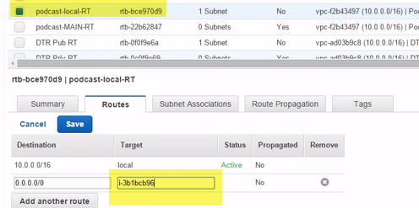

And I reckon we're good. That's our private subnet all set up and ready. So **the instances that we launch in there can get out to the internet via the NAT proxy instance that we put in the public subnet**.

**Module Summary**

1.)Starting out from a base of a VPC and a couple of subnets in a single availability zone, first up we created an internet gateway, effectively a router with an interface into our VPC and another one facing the internet. And it only took like a couple of clicks to create, thanks for that Amazon. Anyway the fact is it gives us a reliable way out to the internet. 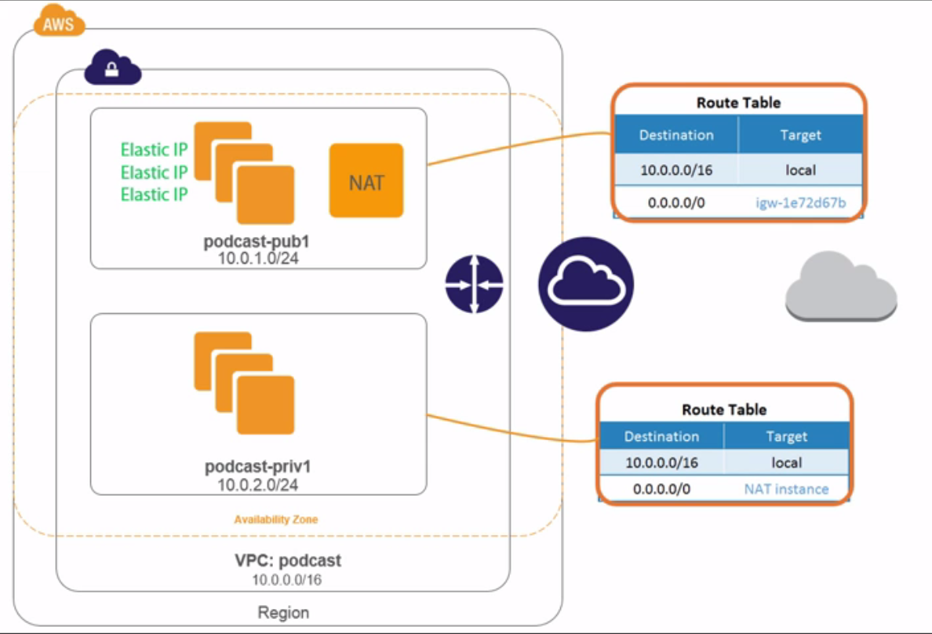

2.)Then we updated the route table associated with our public subnet so that it knew about the internet gateway, yeah, we used 0.0.0.0/0 plus the internet gateway as a default route for the subnet. So the route to take when nothing else matches what you want.

3.)Then after that we saw how to assign public IPs to instances, either manually when launching the instance or by setting the auto-assign public IP property of the subnet. But don't forget, you don't own those types of public addresses, so they don't stick around after reboot, making them no good for any time where you might need a persistent IP address that maybe you publish to your clients and the likes.

4.)For reliable IPs that you do own and that you pay for when they're not in use, you want to go with elastic IPs. These are still full of public routable goodness, but they belong to you so they're not going to bail out on you when the goes gets tough. And that pretty there is public subnets in the internet.

5.)So after we were done with that, we switched our attention to our private subnet and we gave it the gift of internet access, but through a proxy host in the form of NAT instance that we stuck in the public subnet. This is just like a Linux instance, right, that forwards packets onto the internet for us and it wasn't even hard to build.

6.)We grabbed one from the community marketplace. Sure we have to disable source and destination checks and we added a default route to the route table in the private subnet, so an entry that sent all unmatched traffic over to the NAT instance, but that wasn't hard.

7.) You know what? I reckon that's pretty much what we did in this module. Cracking stuff, right? I mean, that diagram is starting to look pretty decent now, don't you think? Almost like a real data center.

**Securing Your VPC**

**Module Intro**

AWS defensive technologies: Security groups and

network access control lists.

the theory first and then we'll put them into practice and once we're done, well I was going to say, we'll be experts, but that's not true, right. Experts is a strong term and I don't like throwing it around casually, so while we won't be experts, we will be well up to speed and we'll be at a decent level. So let's crack on.

**The Big Picture**

1.)let's say then we've got a couple of subnets, 1 and 2, with a couple of instances in each. And the up top here, we've got our VPC's router. Now the normal flow of traffic is that traffic comes into the router, so could be from the internet or from another subnet or from another VPC even, the point being traffic comes into our router, then depending on the routes in the route table, the router sends the traffic on. So, if it's intended for one of our subnets it gets sent on there. And that's it really.

2.)So where security groups and network ACLs come into play, it's like this, as traffic gets routed to a subnet the network A-C-L or ACL or whatever you want to call it, associated with that subnet inspects the traffic and then based on the rules in the ACL, it decides whether or not to allow the traffic. So maybe the ACL says web traffic from the internet is allowed, but SSH traffic isn't unless it comes from a machine with an IP address from our management network.

3.)Well then, anytime any SSH traffic comes in from anywhere other than the management network it's going to get dropped, not allowed through.

3.) **the network ACL lives and works at the subnet level, so it gets applied to subnets and therefore protects any instances in those subnets.**

4.)Security groups, on the other hand, get associated with individual instances, a bit like instance firewalls, well a lot like them actually. So, you know, like the Windows firewall or IP tables or maybe some third party software, yeah. The point being, they're local to the instance. But actually, right, a bit like public and elastic IPs, our instances don't actually know anything about them, so they get applied or kind of wrapped around the instance.

5.) So we manage and we configure them at the AWS level from the AWS console. If we were to log onto our instances and look at local firewalls and the likes, they know nothing about them. Anyway, as we can see, right, two layers of security.

6.) So any traffic that gets past the network ACL has got another hurdle to jump before it makes it to the instance, and that's good stuff, defense in-depth, layered security, all of that goodness.

7.)We've got two layers, two complimentary layers. I think I'm going to say this a lot, right**, defense in-depth.** Well that's the view from like 50,000 light years. 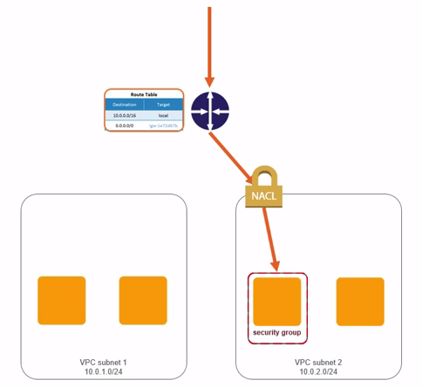

**Security Group Theory**

1.)first thing to say is that all instances need a security group. It's a bit like a tax code, right, you've just got to have one though and like tax codes, security groups are a good thing. In fact actually, instances are not limited to having just a **single security group, they can have more, up to five actually**.

**2.) security groups actually get assigned to NICs, network interfaces on our instances and not the instances themselves. So, me saying each instance can have up to five security groups associated with it, well that's really five per network interface.**

3.)So an instance with 2 network interfaces, well it can obviously have 10 security groups, 3 network interfaces that would be 15, yeah.

4.) If we click the instance in the EC2 console and we modify its security groups, we're actually working with the Eth0 NIC, the first NIC in the instance and I don't want to get like massively side tracked by this, okay, because for all intents and purposes we are associating with the instance because we can't remove the Eth0 network interface from an instance.

5.)Now as much as I don't want us to get side tracked by this, I do think it's worth knowing, so security groups are actually associated with network interfaces on an instance and not directly with the instance itself and I'll try and show that when we come to the demo in a sec, right.

6.) **Now though, for how they actually work??.** So they're pretty much personal firewalls for our instances. They allow or deny traffic. Okay, that's only like half true, okay. What am I saying? Well, security groups, okay, can only actually be configured to allow traffic, so we can only create rules that say things like, yeah allow this traffic or yes allow that traffic, we can't explicitly say deny this traffic or deny that traffic.

7.)But okay, in reality if we don't specifically allow a type of traffic, then it's going to get denied. So, once we create a security group and start populating it with rules to allow traffic, any traffic then, I suppose we could say, whose name isn't on the list, gets denied, yeah. So we create explicit allow rules and then anything not explicitly allowed is implicitly denied.

8.) First up though, they can allow inbound and outbound traffic. Inbound being traffic that's coming into our instance and outbound being traffic that's leaving the instance.

**Then, for each we create a list of rules, each rule being a protocol, a port, and then depending on whether it's inbound or outbound, it needs a source or a destination.** 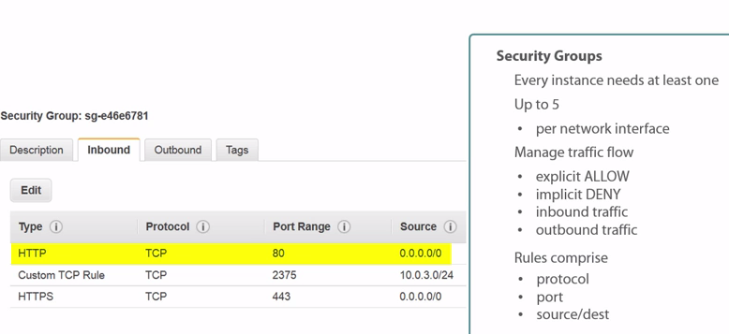

a.)So looking at the first line here, this one's nice and easy, it's allowing unencrypted web traffic from any source.Okay, well, how do I know that? Well by convention, unencrypted web traffic operates over TCP port 80 and by specifying 0.0.0.0/0 as the source, **we're saying allow this traffic from any source, so a pretty standard rule, yeah, one that you might legitimately apply to internet facing web servers.**

**b.)** Then there's this bad boy in the middle. This guy is going to allow Docker traffic over TCP port 2375, but only from devices in the 10.0.3 network. . And the way this all works, right, is that when evaluating traffic, right, so anytime traffic comes in, all rules get processed and checked, then if when we've processed all the rules and we've not found a match, the traffic gets dropped, denied.

c.)The rule down at the bottom here, it's pretty much the same, only this time it's allowing encrypted web traffic…And outbound looks the same. Okay, a different rule, yeah, but the structure is the same, protocol, port or port group, yeah, and a destination this time instead of a source.

1. we say that security groups are stateful, they act like a stateful firewall, so for example, any responses to traffic that we send out are automatically allowed back in.Think of it maybe like this, the security group, I guess we could say, remembers hey yeah, I allowed that traffic out before and I can see that this is a legit response, so I'm going to let it back in. And vice versa too, so if it's just allowed some traffic in via an inbound rule this time, it's going to remember that too and it's going to let responses back out even if there's no explicit outbound rule saying so. So security groups are of a sort stateful firewalls.
2. Also, right, if you modify a security group, so maybe add or remove a rule, no probs, it gets automatically applied and becomes effective on any instance that the security group is associated with. It's totally dynamic, so on the fly, yeah, while the instances are hot.
3. We can have 100 security groups per region and each security group can have 50 rules.

**Oh, and they don't filter traffic, okay, from the reserved addresses in your subnet. So I think we mentioned this earlier, but every subnet's got 5 reserved addresses, the first 4 addresses in the subnet and the last address in the subnet and these get used for DNS, DHCP, EC2 metadata, key management server, and routing.**

**Implementing Security Groups**

1. within our VPC console, Security Groups is down here under Security. You can get to it from the EC2 dashboard as well, but if we hit it here we see our existing security groups..ah, none of which are named. Slap across the face for me for laziness.
2. Name tag : podcast Docker Hosts …podcast VPC 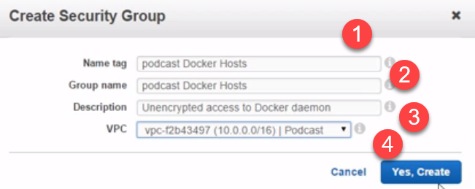

it's creating an empty shell for us. So if we see down here, yeah, currently no inbound rules, so nothing has been allowed in yet, but everything is being allowed out.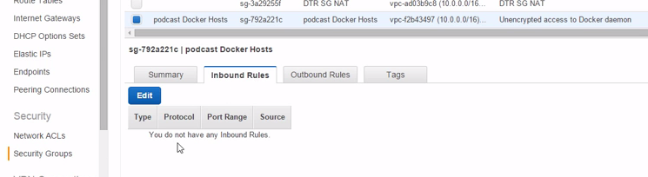

3.) So back here we're going to add a rule to allow TCP port 2375. 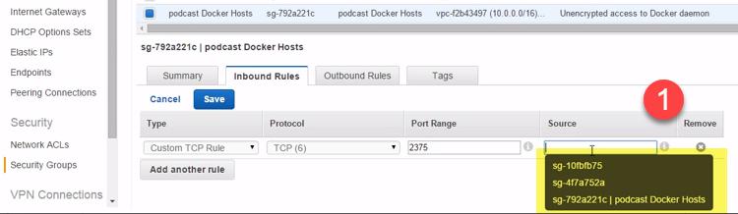

I'm going to put in a CIDR block here, but as we can see, we can totally pick another security group if we want. Pretty much that would be saying allow TCP 2375 access from any host that happens to be a member of whichever of these security groups we choose. Nifty and all, but we'll go with 10.0.2.0/24. Restricting access, yeah, to instances in our private subnet.

4.)And let's do another one. Call this one podcast web traffic, copy and paste that down here, choose our VPC podcast 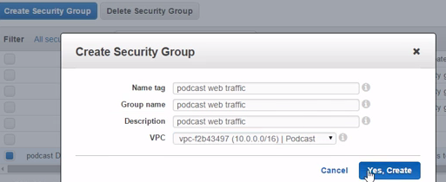

This time, okay, we'll add HTTP and HTTPS and we'll do both of them from anywhere

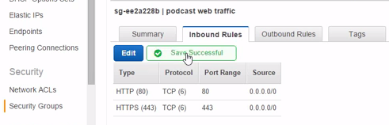

1. Two new security groups, each with some inbound rules and both, right, allowing all outbound traffic. Not the most secure in the world, this outbound bit here, I know, but you know what?
2. Now if we jump over to our EC2 console, and what have we got here? Hmm, not a lot really, especially in our podcast VPC.
3. So let's go fire another EC2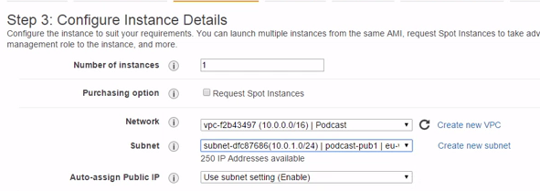 up. This'll do, yep, podcast VPC, public subnet, yeah it's going to get a public IP, **storage is good, podcast-test is good.** Ah, now if we click up here, right, see how we can select from existing security groups? 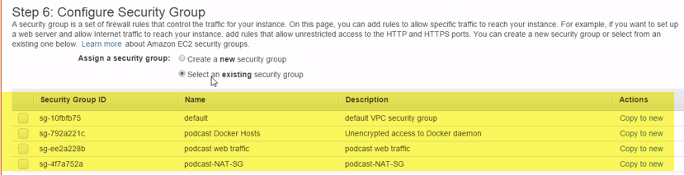

Lovely and all, but this time we're going to let the wizard create one for us. Now by default, okay, with this being a Linux instance, it's only going to allow SSH traffic in. So that's just the bare minimum, right, so that we can get in and manage our instance.

1. give it an elastic IP from over here. Okay, just got the one for right now. Let's associate it. We'll pick our instance from here…If we go back here, there we go, elastic IP.

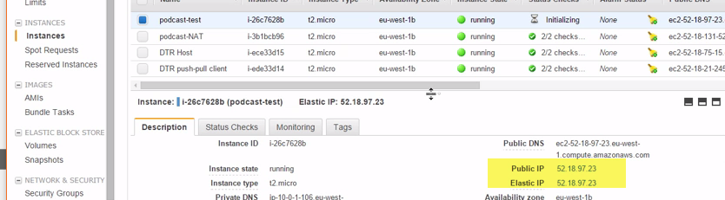

Now then, right now it's just got the one security group, yeah.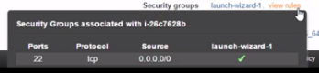 The one we created when launching the instance to allow SSH.

8.)We've just SSH'ed in using the instance's public IP or its elastic IP and we're only being allowed in because the security group associated with the instance is allowing SSH traffic from anywhere.

install the Apache web server..But obviously if we go try to connect to it over here, give it a second or so, dah-dah-dah, no joy. Reason, its security group is dropping any packets that are not SSH. So to fix that edit the security group so that it's got a rule in that allows web traffic or we can add another security group that's already got a rule allowing web traffic.

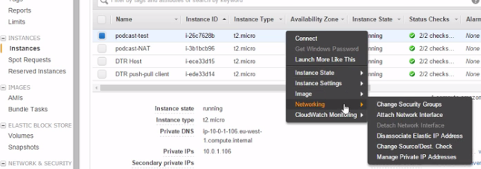

9.)Networking 🡪 Change Security Groups here, we want to add this podcast web traffic one here, and notice as well, see how we've got both security groups listed now.. 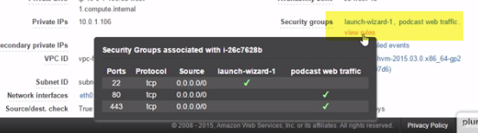

Web traffic now allowed. Totally dynamic, yeah, totally on the fly, and totally cool.

**10.)how network interfaces and security groups go together.**

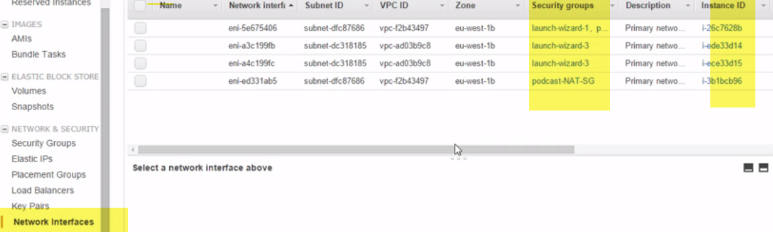

**Network ACL Theory**

1.)Network access control lists or even Network ACLs or Network A-C-Ls or whatever, right.

2.)NACLs are to subnets what security groups are to instances, firewalls of sorts, yeah. So very similar to security groups, but totally different as well.

3.)remember back to our picture from earlier, how we've got traffic coming in and it's been expected by security groups with their inbound and outbound rules and only allowing explicit allow rules, but anything not explicitly allowed is implicitly denied and how they maintain state.

4.)Well first up, NACLs apply up here at the subnet level and they've got separate rule sets for inbound and outbound traffic. But, these guys let us explicitly deny traffic as well as explicitly allowing it.

5.) And they're stateless, meaning they don't care if a packet is a legit reply to something already allowed, if there's no rule specifically allowing it, then it ain't getting passed. So the two things I reckon that are of note here are the things that make them different to security groups, sure okay, they operate at the subnet level instead of the instance, but it's these abilities to create deny rules and the stateless behavior that you really want to note. And you know what? Amazon might change this in the future. But personally, I think it's a pretty good approach, you know, it's good to have similar but slightly different technologies at different layers in the stack. These guys, in my opinion, really complement each other. 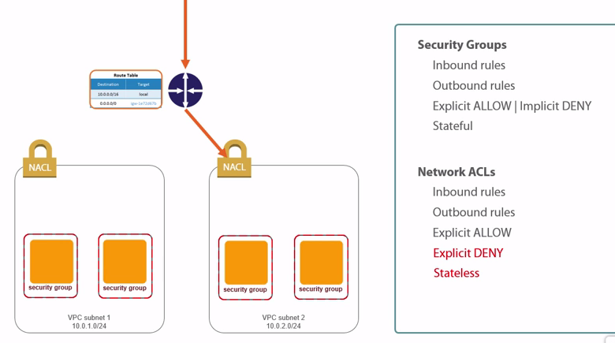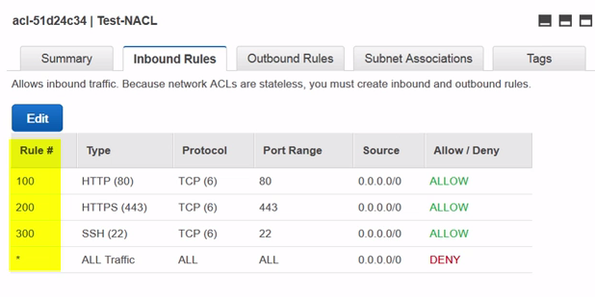

The combination of the two being a pretty solid mix. Anyway, they look like this, kind of similar to security groups, yeah, but a couple of big old differences, oh, well, first off up here it's reminding us, **yeah that they're stateless, but it's this rule number column here where I want you to notice because when traffic hits a NACL rules start getting checked in order, so in numeric order. That means rule #100 here gets checked first, and I don't know, let's say that the traffic we're inspecting is encrypted web traffic, well rule 100 here doesn't match, so the next rule gets checked, rule #200, that's TCP 443, you know what?**

6.)Looks like encrypted web traffic to me. So that's a match. And processing of the rules stops. No need to check anymore, we've hit a match, so we can make a decision. Well this rule here says allow here at the end, so we let the traffic on through. And that is totally different to security groups where all rules always get processed.

But let's do another example, let's say the traffic coming in and being expected was aimed at the Docker remote API on TCP 2375, okay, we check rule 100, no match, 200, no match, 300, still no match, and then this funny looking fellow down here with the asterisk. 

Well that says all traffic, all protocols, on all ports, from anywhere. Well that sure as hell matches and it says deny, so the packet would get dropped. The asterisk rule being the default catchall rule for when none of the other rules apply or match I suppose should say. You know what? You might hear it referred to as the default deny all rule.

7.)And NACLs are stateless, so they couldn't care less, right, whether a packet is part of a legit conversation. If there's no rule specifically allowing the traffic, then big red down here is going to grab it and toss it over the wall. Now this behavior of rules being processed in strict numeric order and then as soon as a match is hit we say we're good, we don't need to bother checking anymore rules, well let me tell you, knowing something like that is pure gold when you're troubleshooting network problems and you've got like a shed load of NACL and security group rules to wade through.

8.) Seriously, pure gold. Ah, that reminds me of something else, remember we said, in fact we showed it actually, that multiple security groups can be associated with a single instance. Well not so with NACLs, right? Each subnet can only have a single NACL attached to it, though a single NACL can be attached to multiple subnets. And you know what? If you've ever administered routers on network firewalls in the past, or even written good old basic programs where ever line had to be numbered and the number automated, well you'll already know the power of sticking to a numbering style like this where we go up in either 10s or 100s.

It just means if you need to stick a rule in between, let's say 200 and 300, well we can just name it 250 and it'll automatically get inserted in between the two, whereas if we'd named them 2 and 3, well, good luck with that, yeah, because while we can delete rules in a NACL we can't modify them in place.

1. Okay, well rounding out our NACL theory, we can have 200 NACLs per VPC, but only 20 rules per NACL and you know what? If you're new to this, 20 rules might seem like a lot, but many seasoned networking pros out there will tell, it ain't. Though, taking a ridiculously positive outlook on things, keeping this number of rules in the NACL small is really quite a good thing. For one it's going to make troubleshooting a relative walk in the park compared to something with hundreds of rules. But it's also going to help performance because processing hundreds of rules, that takes time.

**Configuring Load Balancing**

1.) load balancing can be a dark and a difficult art. It's certainly not something that you just configure with a few clicks of the mouse and away you go. Well, not unless that is you're in AWS.

2.) Amazon has done an absolutely outstanding job here. They've take a key technology and they've made it simple, so simple

3.) elastic load balancer, is going to be scalable, resilient, high performance

**The High Level View**

1.) Two availability zones, eu-west 1b and eu-west 1a. 2 availability zones, so two data centers, yeah, with a bunch of instances in each. Now let's say for arguments sake, okay, these are internet facing web servers and they're all serving up the same web front end for an app, well what we love to do, right, is balance incoming traffic from the internet across all of these instances and have it rigged up in a way so that if an instance goes down or even a whole availability zone, so a major incident, yeah, we don't skip a beat. We've have it so that the surviving infrastructure just carries on.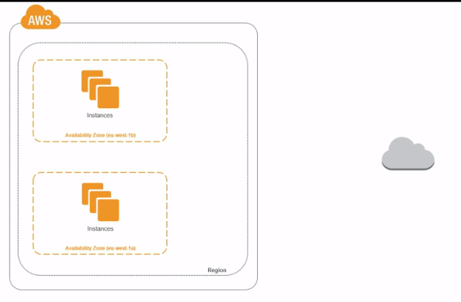 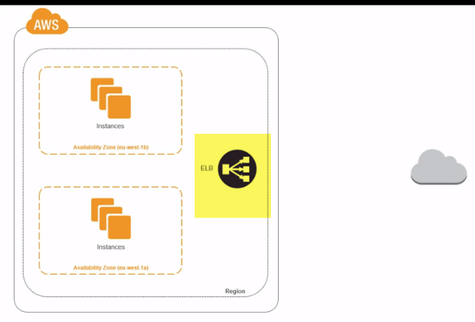

2.) Well, meet the elastic load balancer ..single point of contact for our farm of web front end servers that we've got. Then as such it knows about all of our web server instances behind it, so that as requests come in it balances those requests over all the instances it knows about.

EX:You know what? A bit like at airport security, yeah, where there's a bunch of lines queuing to go through the checkpoint and often there's someone there directing you to the shortest line, only they usually send you to the longest line, right, or at least they do with me. 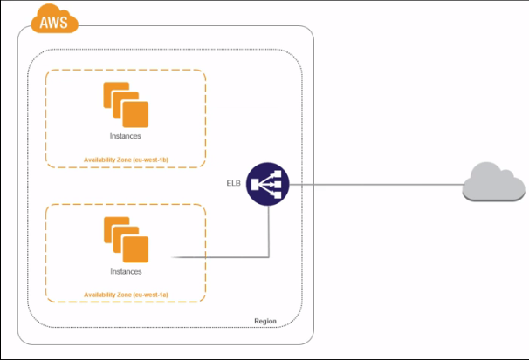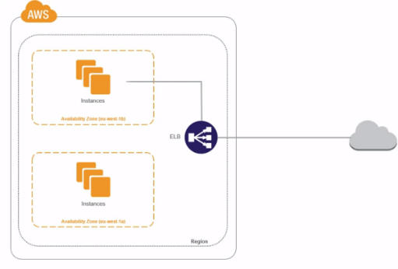

3.)Well, elastic load balancing works a bit like that. Directing and balancing incoming traffic over multiple instances behind it. And if we look closely enough, we can see that it's **load balancing across availability zones, so our instances don't need to be all in the same availability zone, though I should point out they do need to be in the same VPC.** 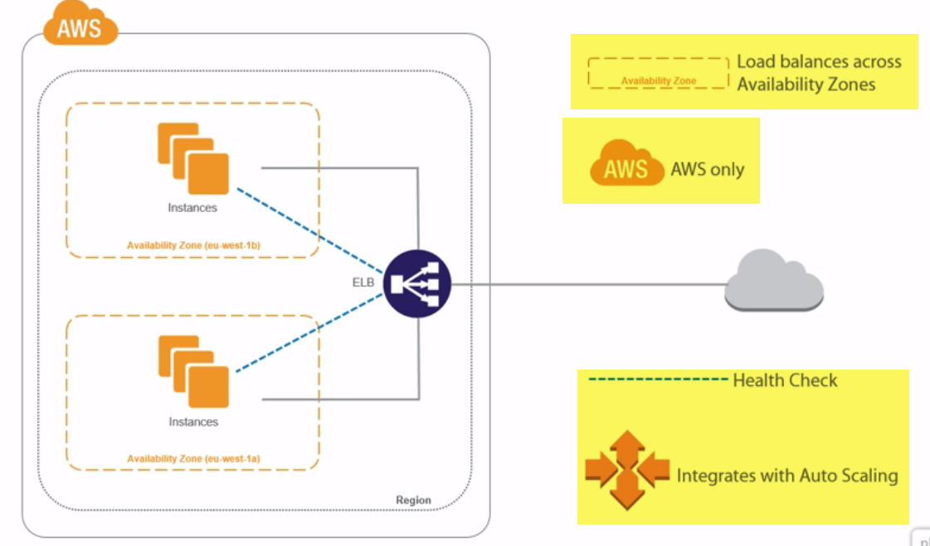

4.) So ELB right now is only for load balancing across infrastructure within a single VPC in the AWS cloud. And it can do health checks too. So, it keeps an eye on the instances that it knows about behind it so that if and when any of them stop responding, they get taken out of the load balancing config, though actually no, they don't really get taken out of the config, they just get marked as down and the ELB no longer sends requests to them. But because they're still in the config, once they're back up and running, they can automatically be brought back into play.

5.) What else? **Ah, yeah, it integrates with auto scaling as well.** So as in when auto scaling, as long as we've got it configured, yeah, decides that we need more web servers spinning up, they can all be added into the ELB config and start having traffic balanced over them as well.

6.) we’re going to introduce an elastic load balancer into our VPC and we're going to configure it to listen for incoming web traffic and balance those requests across instances in two public facing subnets, and that's magic...

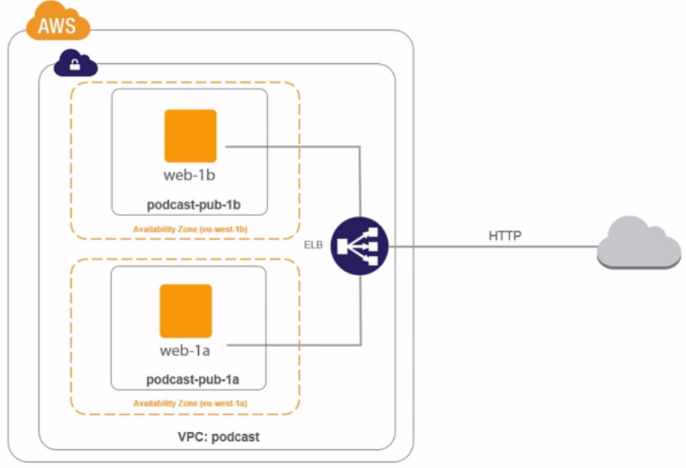

but we're only scratching the surface here. We can add a ton more to the mix. Maybe we could start load balancing internal traffic from our front end web servers to a distributed database back end in a couple of highly available private subnets.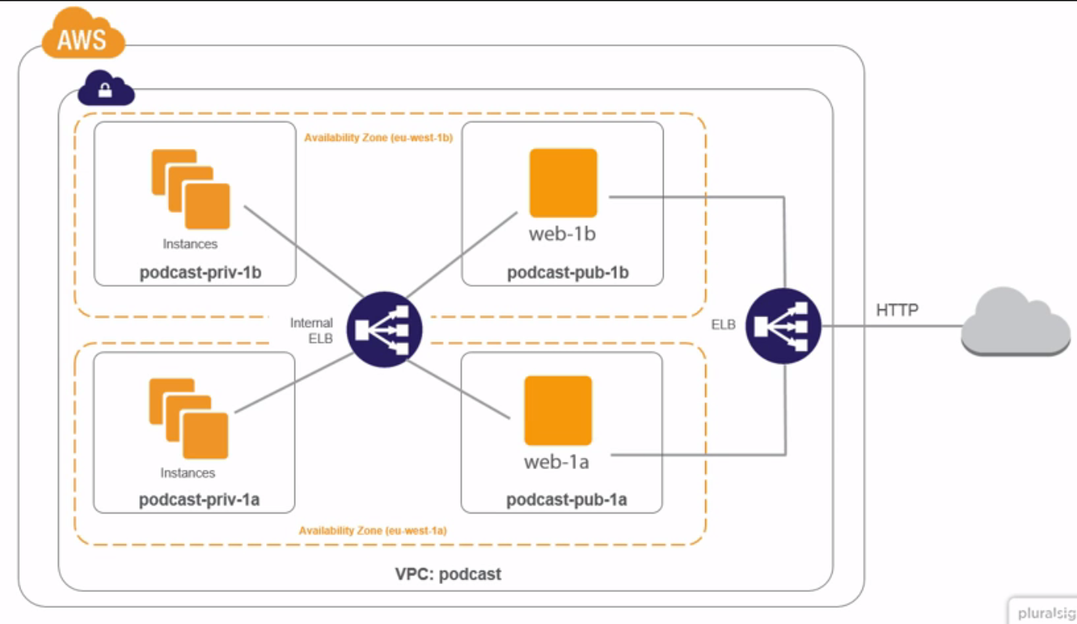

This way we could lose an entire availability zone or anything in it and keep on rocking. All this stuff down here that's not been effected, it just keeps ticking.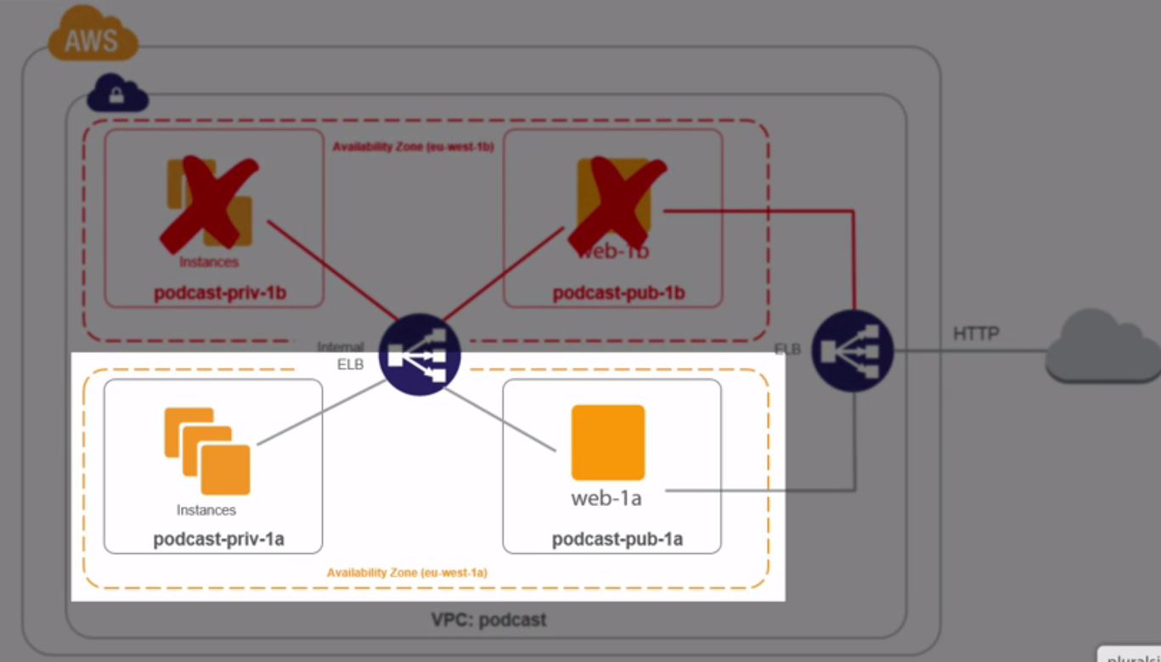

Because remember, availability zones don't effect or impact each other, or at least they shouldn't. So losing one is not such a massive deal, I mean it is a big deal, right, because your remaining infrastructure is probably going to struggle to manage the entire load on its own, but it's certainly not going to take your entire application or your entire business down with it, and that is a monster sized boon, right.

7.) So I reckon the things to grasp and learn, right, are elastic load balancers are resilient and they're not tied to an availability zone. So losing one, an availability zone, yeah, isn't going to take the elastic load balancer service out of play, and assuming we've got our app set up properly, we stay in business. And that there to me is a pretty sweet highly available design. Should we go and build it?

**Building Out Our Infrastructure**

1.) we've only got one public subnet and one private subnet 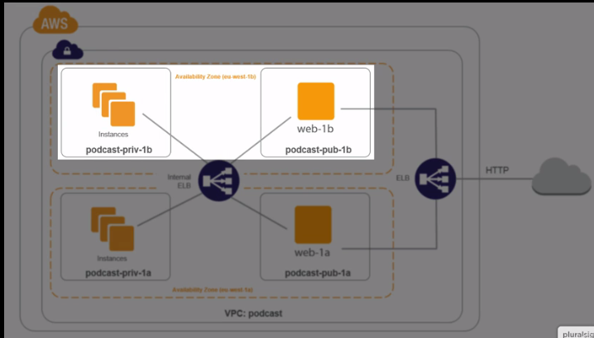

and we've not built any web servers yet either. So that's what we're going to do right now, build all of this missing stuff. 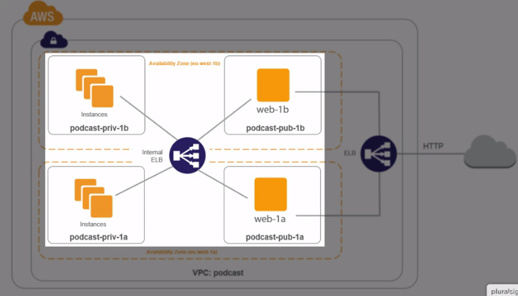

1. first up, I'm going to create a couple of security groups two new security groups, one for HTTP traffic, and another for SSH.

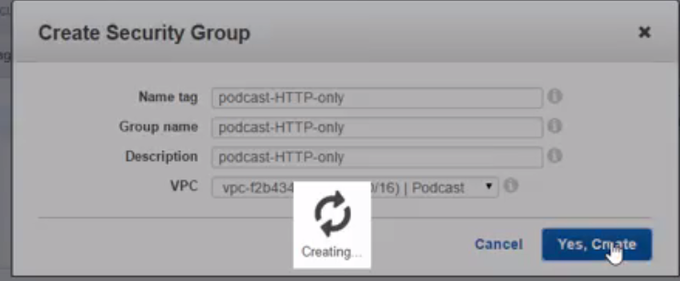 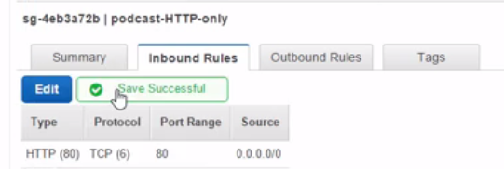

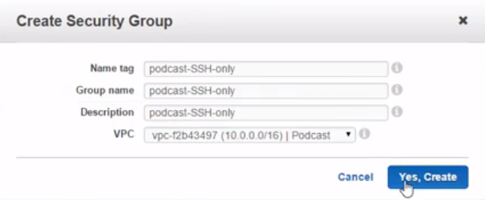 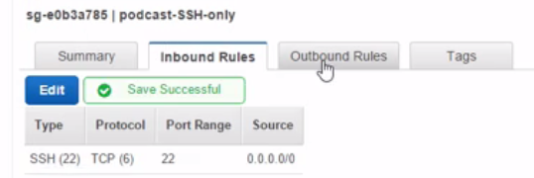

4.) Now we need a couple of subnets, but let's rename these first to tack on the availability zone, because that's going to become really important from now on.  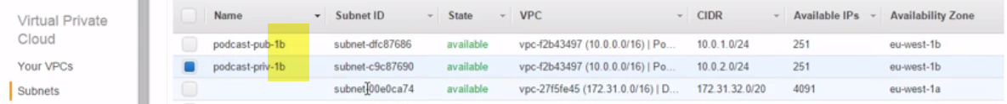

Now we want to know the public one, make sure it's got an internet gateway associated with the public NACL that ***we created before***, and I reckon that one's ready. 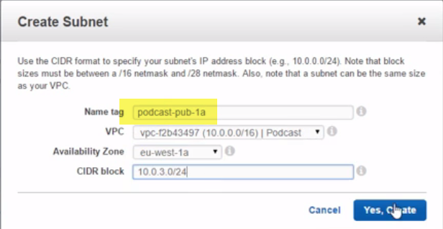 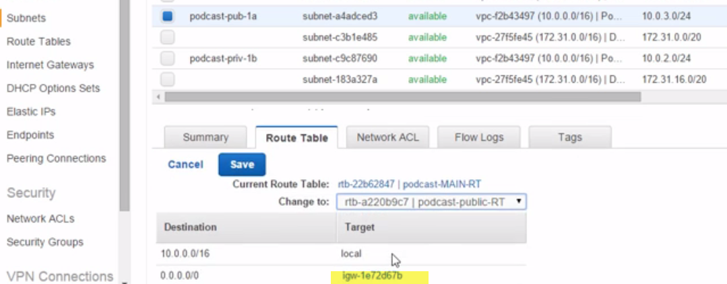 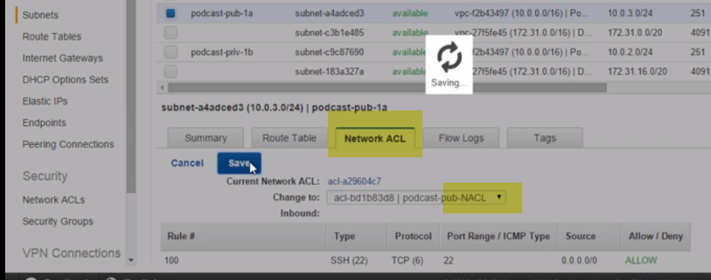

5.) Now under the private one, you keeping up? 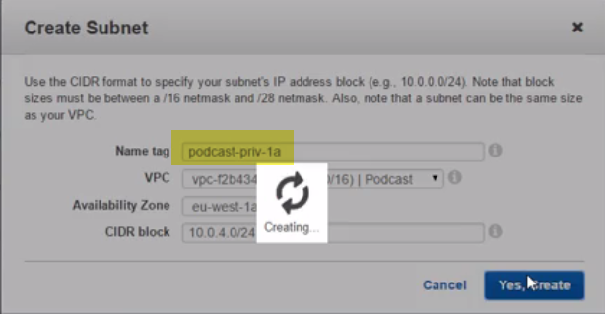

We'll make sure it's not connected to the internet, 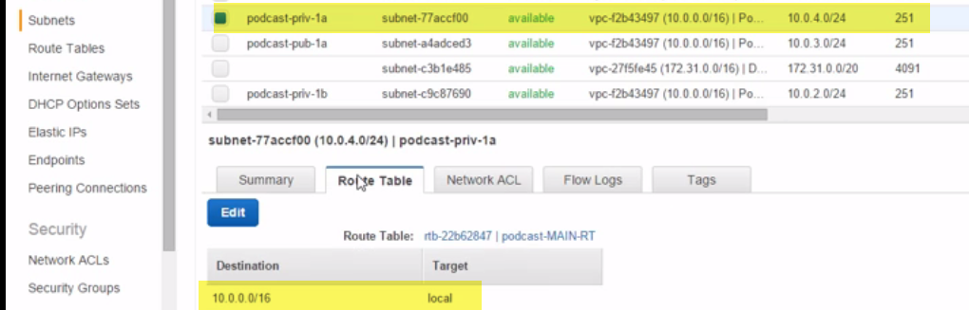

no, give it the wide open NACL **for now** 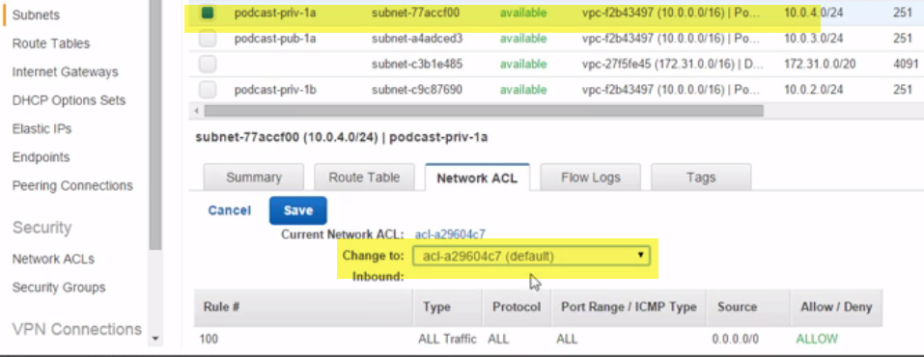, oh man, flying through it like this is good.

6.)We' ve already got our four subnets, two public, both in separate availability zones, and two private, also both in separate availability zones. 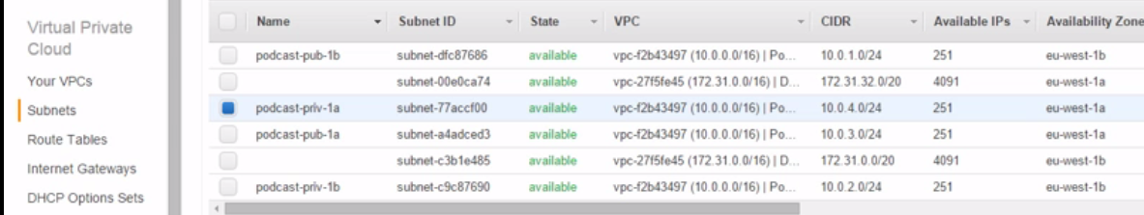

7.)So, if, let's say, I don't know, a fracture in the space time continuum opened up and swallowed up eu-west 1b, well, who cares about that, right, we've got our service, or we will have our services I should say, running in 1b and 1a, so we'd hardly even notice.

8.) Anyway, we need a couple of web servers now and this time I'm going to create those with the wave of my hand, and there they are. 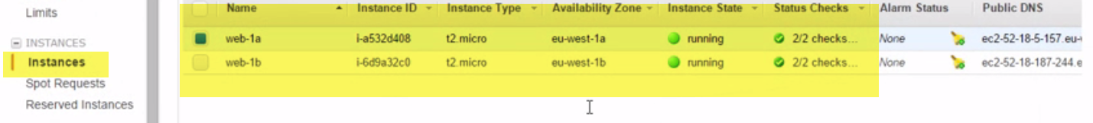

So two web servers, right, one in each of our public subnets, and they're essentially the same.

9.)Both of them have just got a single webpage that's almost identical except for the fact that each has got some individual text on there so we can tell which one it is, because we're going to need that when we start using the load balancer in a second.

10.) But before we use the load balancer, right, if I grab 1a's IP address and lash that into a browser session, there we go, Server 1a. And the same again for 1b, magic, same again, but with its own unique identifier. Cool. All of that done. Let's go and build ourselves an elastic load balancer. 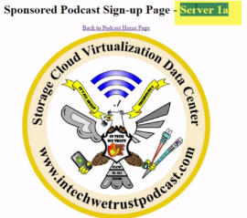 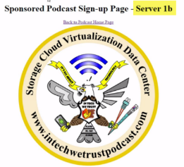

**Building and Elastic Load Balancer**

1.) Let's build this load balancer. Under Network and Security🡪LB🡪create a new one.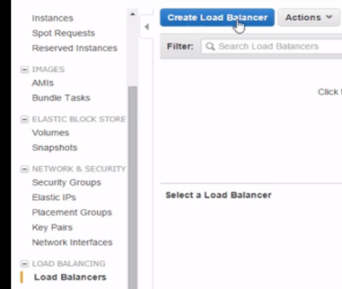

2.)Name: podcast-ELB-internet so that we know it's internet facing and not internal. Obviously we'll stick it in our podcast VPC, ah, right, see how the screen changed? Because we selected our podcast VPC, which is not a default VPC, yeah. 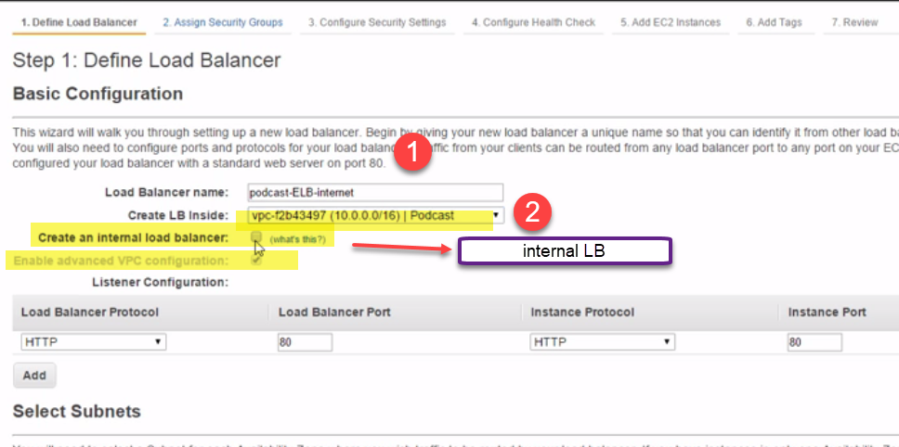

**3.)Well this advanced config box here got automatically checked.** Anyway, back up here, right, **if we wanted to create an internal load balancer, so for one that would load balance traffic from within our VPC instead of from the internet,** well we'd hit this. But we're going to go internet facing this time.(Don’t check it)..

4.)And then for the listener config. This is where we tell our load balancer which port to listen on and which port to forward to instances on. Now then, the current config of listening for incoming HTTP requests on port 80 here and then passing them on internally on the same port, this is actually exactly what we want. 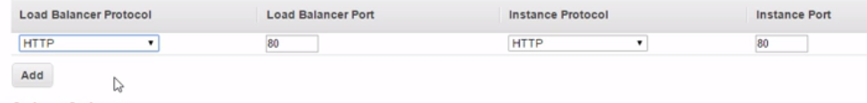

But a common and a pretty useful config, right, can be to listen here on HTTPS, so encrypted web traffic, and then pass on internally a straight HTTP. 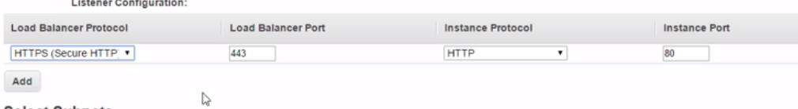

What this does, right, is it lets us use and abuse the load balancer to terminate our HTTPS sessions and as a result take some of the load off our instances. I don't know, it might be useful for you. But see as well, right, how we can't configure our elastic load balancer for that many protocols. Like I think we said earlier, while it is the absolute bizzo and all, it's not the most comprehensive load balancer that you can find.

5.) Other load balancers are available. Anyway this is good for us, okay. It's going to receive web traffic and then balance that traffic over the instances that we configure behind it.

6.) **Now for subnets,** see this nice little message here, **balance over multiple subnets where possible folks, that's where the app high availability comes from.** 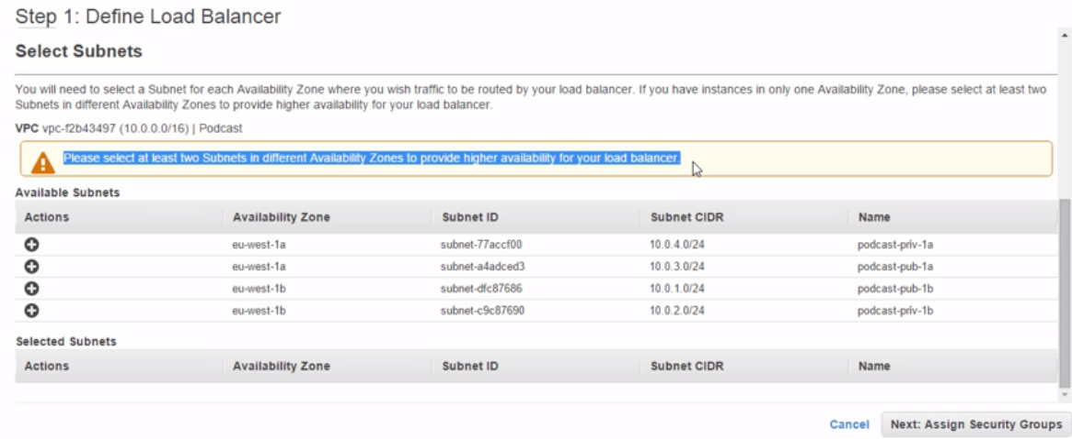

**Well, we'll pick both of our public facing subnets,** and you know what? The eu-west region has got three availability zones actually and there's absolutely nothing stopping us balancing over all three, obviously we need subnets in all three, right.

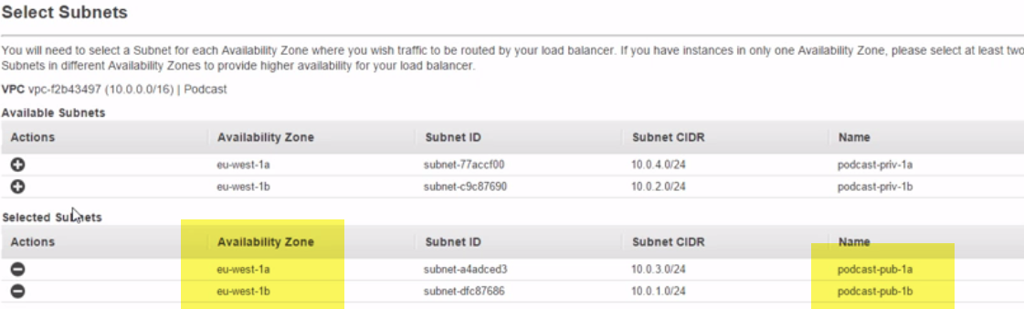

And you know? That would actually give us even better availability than just balancing over two.

7.) The only reason I'm not going to do that here is honestly, right, because the diagrams that I'm using on the slides they started to looking really busy when I started trying to fit three availability zones on them. So, two is no magic number or anything like that.

8.) Next, now then, for security group, we're going to go with this HTTP only one that we created a minute or two ago. We're not bothered about this message, we know that HTTP is just plain text. I do recommend HTTPS for production, of course. 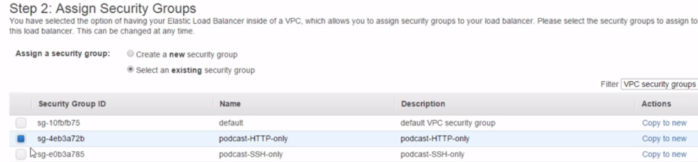9.)Now health checks, and these are the chiz-zing, right. These three bits up here, they form like the basics or the meat of our health check, yeah. So this particular one is going to send an HTTP request on port 80 and if index.html exists, then the health check is a pass. 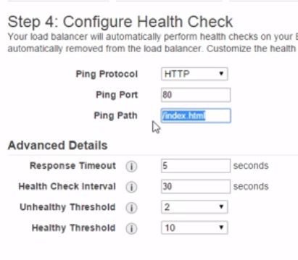If there's no response or index.html doesn't exist, it's going to fail. And we can edit these fields as well, right, though the top one here can only be one of these options.

But these old boys down here, well health check interval here, right, this is **how many seconds we wait between health checks**, so between the pings that we defined up here.

And then the healthy threshold down here, 10, well what we're going to need then is 10 successful pings or health checks before we consider the instance healthy, and you know what? Instances have got to be considered healthy before they get thrown into a load balancer config, which brings a good point actually, all of these health checks here apply to instances, right.

But you know what? 10 checks with a 30 second interval between each one, that's like 5 minutes, right, and not even counting the time it takes to perform the check.

Either way, right, that's an absolute age. 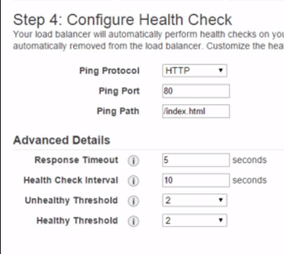

Meaning that any new instances that we add behind this load balancer, it's going to be a long and painful 5 minutes before they get added into the mix. So what I'm going to do is I'm going to make this 2 checks at 10 second intervals, which is better, for me at least, right. But you probably want to give this some thought because we probably don't want to be throwing recovering instances straight back into the mix, we probably want to give them a chance to see if they're going to stick around first before giving them work to do. And it's similar for marking instances as unhealthy, taking them out of the game, yeah. We're 2 checks here at a 10 second interval again, so 20 seconds before we say, you're out, on the sideline.

And last but not least, response time here, that's like how long do we wait to hear back before we consider the ping up there failed? And wowsers, 5 seconds is long, right? Not even in the days of 56K dial-up modems was like 5 seconds considered reasonable. But you know what, I'm going to leave it for now.

10.)Now to add some instances. Well we've got two and we'll have them both thanks. Basically here just telling a load balancer when you receive this web traffic, go and load balance it over these two instances. 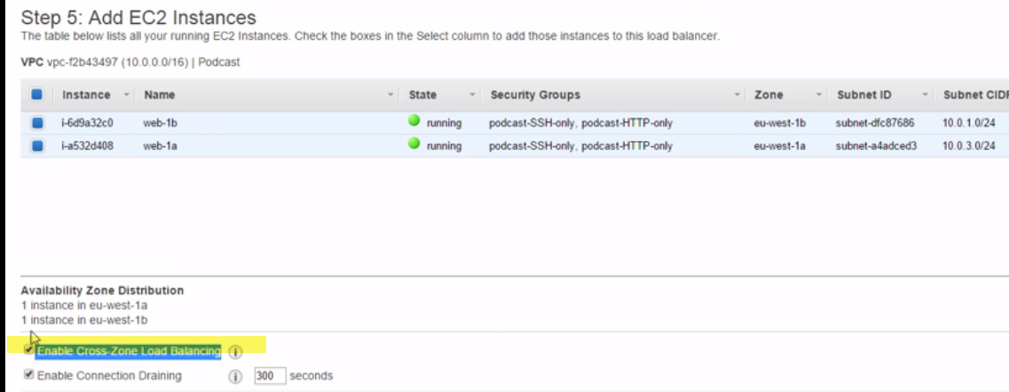

And yes thanks, we'd like cross-zone load balancing. What this does is, okay, it makes sure that all instances get a fair share of the work.

So imagine, right, if we had two instances in one availability zone, and only one instance in the other availability zone, well all three instances would get a third of the work if we've got this checkbox checked, checkbox checked.

And that's despite the fact, right, that there's only two availability zones. Effectively, what it's saying is, when it comes to load balancing, right, don't really worry about the availability zones, just think about the instances and balance evenly across the instances.

I'm a fan of this option anyway.

Last option, right, **enable connection draining** 300 seconds, so 5 minutes again. Well this is kind of an important little setting. It lets us say, hey when we come to take an instance out of the config, so maybe de-register it, yeah,well once we've done that, let it stick around a bit for this time here so that any potentially active sessions to it get a chance to finish and whether or not this number should be big or small is totally dependent on your application's requirements. So do your clients care if they get kicked off an active session? And you know what? Will the app have to start again if that happens?Who knows, right, it depends on your application. The point is, the option is there. We're not bothered about any tags, so let's create this thing. Right.

11.)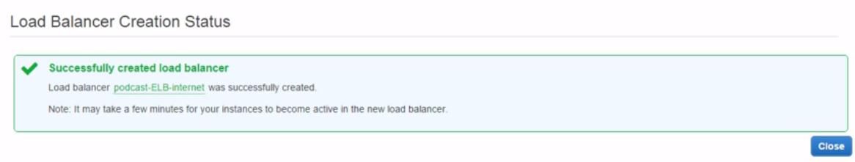

And there it is, okay. Status of our instances down here, remember they're having their health checks performed right now so it's going to be **something like about 20 seconds before** they're up and in the game. So if we come up and we refresh the browser here (Loading), nope still not in service yet. Let's give that another try. Right, both in service. And we can scroll down further and see other options. 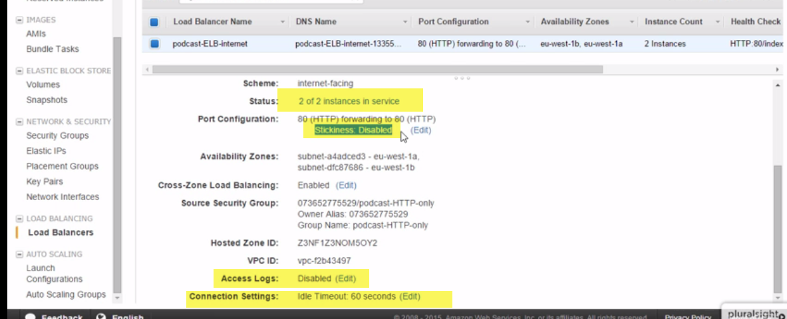

**Now stickiness here,** this one's new to us. But all it is is session affinity with cookies, if we enable it browser's are going to get a cookie that tells the load balancer to direct future sessions back to the same instance on the back end.

There's **more access logs and idle timeout as well.** We can go and configure those. But you know what? That's our elastic load balancer, honestly, all up and configured.

**Using an Elastic Load Balancer**

1.)Okay, so we've got our two web servers up and working. And we've configured our elastic load balancer to know all about them.

2.) So, now all that's done, we need to stop accessing our web service directly and start accessing them through the load balancer. Well, to do that, we're going to need either the IP address or the DNS name of the load balancer, which brings us to our first major point.

3.)Amazon doesn't expose the load balance's IP addresses, just its DNS name, and there's sound reasoningfor that. **You see, the elastic part of elastic load balancer means it's flexible, so the load balancer grows and shrinks based on how much traffic it's handling**, only we really need to think of it as a load balancing service and it's therefore the service that grows and shrinks.

4.)So, okay, behind the scenes, right, it's something like this

. 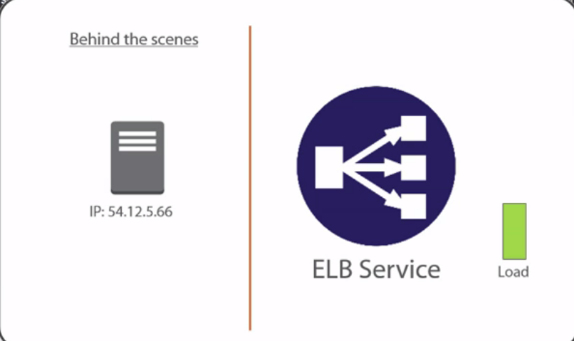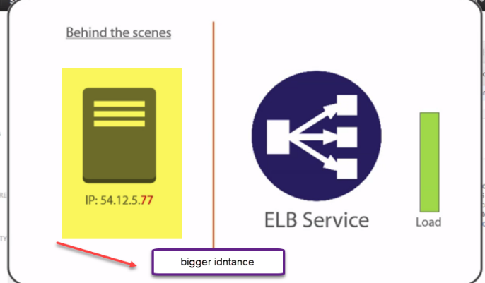

When we start out, our load balancer comes prepackaged as some standard size. And then let's say over time the amount of load that it's handling increases. Well, when that happens, the actual load balancer behind the scenes, so the nuts and bolts, yeah, well that might actually get swapped out for a bigger instance and that kind of switch makes the IP address or addresses behind the load balancer's DNS name, it makes them change. So the net effect, right, over time, the IP addresses servicing our load balancers are going to be changing.

5.)But the corollary, it's DNS name, doesn't, Amazon makes sure of that. But it can also happen that it scales out as well, so we end up with multiple IPs behind that DNS name. 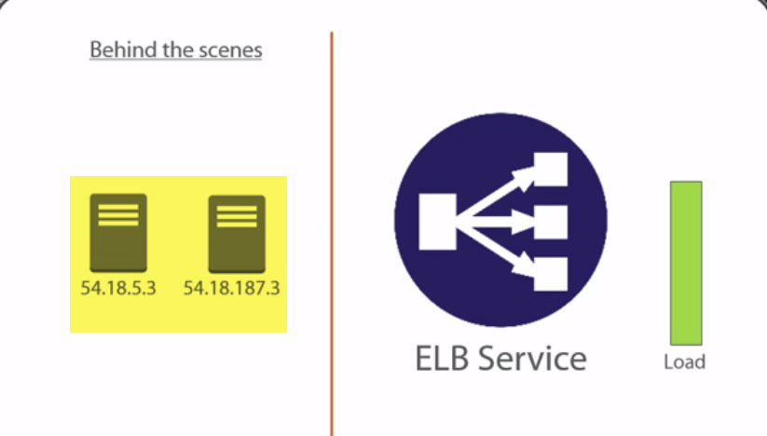

It really doesn't matter though, the point being, as the elastic load balancer flexes, so grows and shrinks based on demand and requirements, the IP addresses behind it are going to change, fluid yeah. Not to be trusted.

**Moral of the story, just always use the DNS name.**

6.)And of course, while that's no bad thing, it does have a few knock on effects that you're going to want to consider.

One of those, for example, being that you can't white list the load balancer's IP addresses because they change. 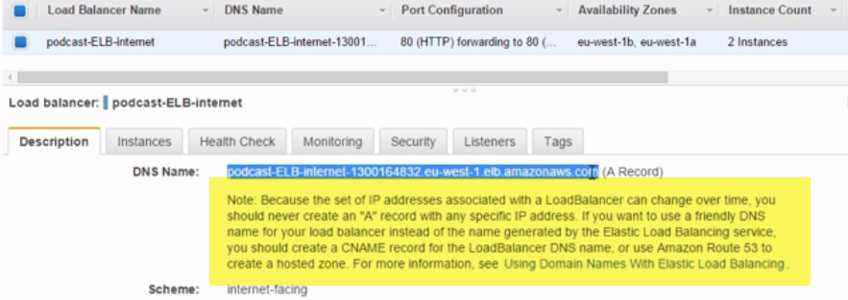

So for its DNS name that we can see here, yeah, we can just whack that into a browser session, that means our web traffic is going to go to the load balancer, which in turn is going to balance it over our two backend web servers. 

So 1b this time and if we hit refresh, 1a.  Refresh again and we how it's flipping between the two. Well I don't want this to be an anticlimax or anything, but that there is our elastic load balancer in all its glory or all its glory is a bit harsh, because that is a fairly mundane task we're asking it to do.

7.) Remember we said earlier, it can do things like accept HTTPS traffic and then pass that on internally as plain HTTP, effectively offloading our SSL connections, though I shouldn't really say SSL anymore, TLS, yeah. And you know what else? This is common as well, so the DNS name that it's been given by Amazon is a bit ugly, yeah.

8.) Well, if we jump over to GoDaddy over here or wherever your DNS servers are, yeah, well I've got this unuseddomain name here called tech-force-one.com, 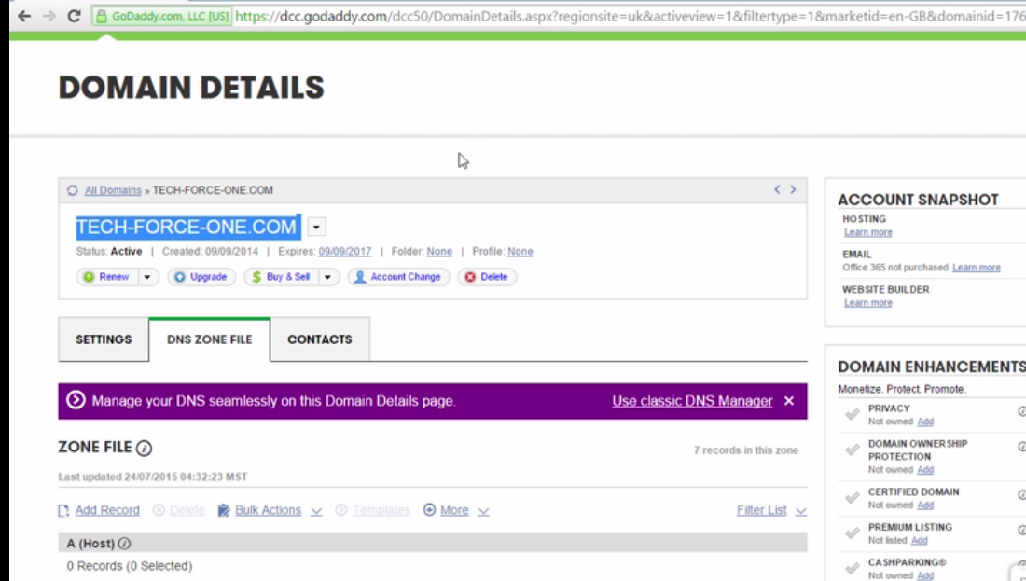

it's just from back when we were deciding on a name for the podcast that I co-host. I think we were deciding between In Tech We Trust and Tech Force One. 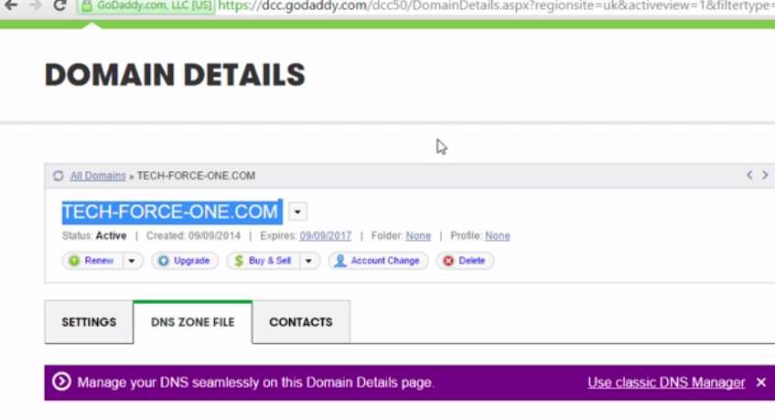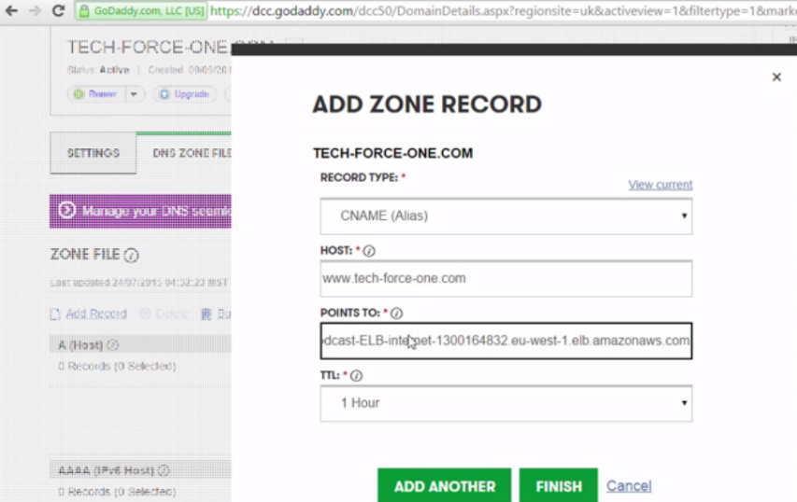

9.)Well at the time I just registered both domain names in case. Anyway, tech-force-one is unused, so if I add a record here, a CNAME, so an alias, and then say www.tech-force-one.com, we're going to point that to that heaviest long name that Amazon gave our elastic load balancer here, yep redirect that monstrosity, and a time to live of 1 hour is fine. So, save that, and what it's going to do is, right, it's going to let us use the friendly tech-force-one.com domain name to access our load balancers, which in turn gives us access to our web servers.

10.)And this is guaranteed to work, yeah, because that hideous long DNS name that our load balancer got given, Amazon guaranteed that that is not going to change.

11.)So, if we go to that browser session again, and change it to www.tech-force-one.com, bingo. And cycling through then, yeah, we flip-flop between both just as we'd expect.

Now then, I just want to point out one last thing before we go and do a recap of what we've learned. 12.) There's always going to be a lag when the elastic load balancer decides it needs to scale. So between the time that traffic increases, yeah, and the time that the load balancer responds by scaling to meet that increased demand and there definitely are corner cases or niche requirements, yeah, where this can be a challenge. So what I'd say is expect a minimum, right, of probably about 90 seconds before you see any scaling really start to happen. But that's just a minimum, it can be a bit more, and part of the reason for this, right, is that **there's a 60 second time to live**, or TTL, placed on the load balancer's DNS record, not the one we just created in GoDaddy, the one that Amazon maintains mapping that hideous long name to any IP addresses behind it.

13.)But what this means, right, is there's going to be 60 seconds before any changes to the IPs of the backend load balancing nuts and bolts services, yeah, actually getreflected in the real world. Remember, yeah, when scaling that load balancer, the newly scaled service has brand new IPs behind the DNS record and it's therefore going to be 60 seconds before those new IPs start getting used.

14.)And remember, there's also the health checks that we talked about before, so both are potential delays, right, to the overall time it takes your app to respond positively to changes in traffic patterns.

Anyway, it's still cracking stuff and if it doesn't totally meet your needs, go and pair it up with a third party load balancer too. Enough of that though, let's go quickly remind ourselves of the main things that we learned.

**Summary**

1.)First up, we've got to think in terms of **elastic load balancing as a service.** So, we get to configure the important stuff from the perspective of our apps, but we don't get involved in any of the dirty work that's going on behind the scenes. And that can be a good thing, right? I mean, we don't need to stress over how to make it highly available or scalable or reliable or any of that stuff, Amazon just does it for us, and as far as we should care the load balancer is just there and it just works.

2.) Though, for people who don't trust Amazon or actually that might be a bit unfair, for those of us who don't blindly trust Amazon and maybe need to understand a bit of how something works before they can trust it, well although you're not going to get a lot of detail other than what an NsLookup against the load balancer's domain name is going to give you, it is possible and it's moderately popular actually, to put multiple load balancers in your VPC.

3.)And when you do this, you give them all the same or a similar config and then use DNS in front of them to round robin or actually to load balance across them, so load balancing over our load balancers, highly available, high availability.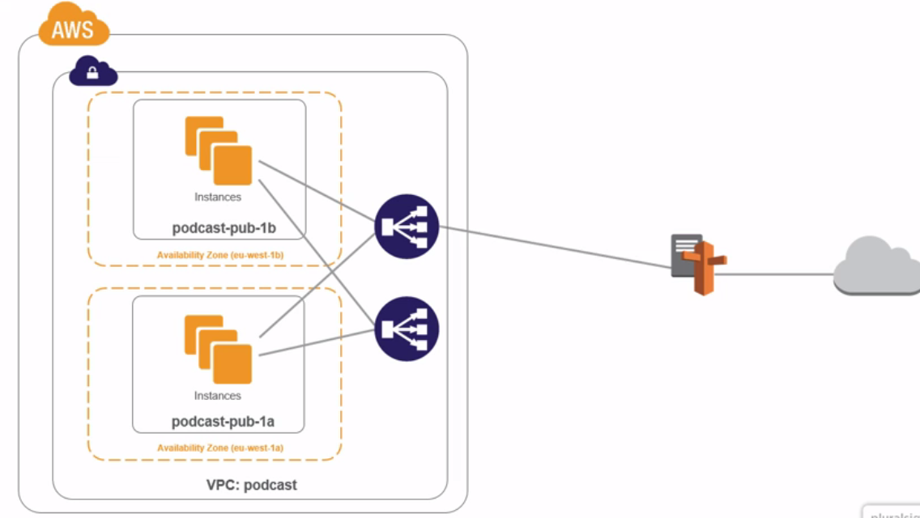

The thing is, if you really are paranoid about app availability, then that's an option.

4.)Anyway, so we built our load balancer and we told it about a couple of instances in our different subnets and availability zones. 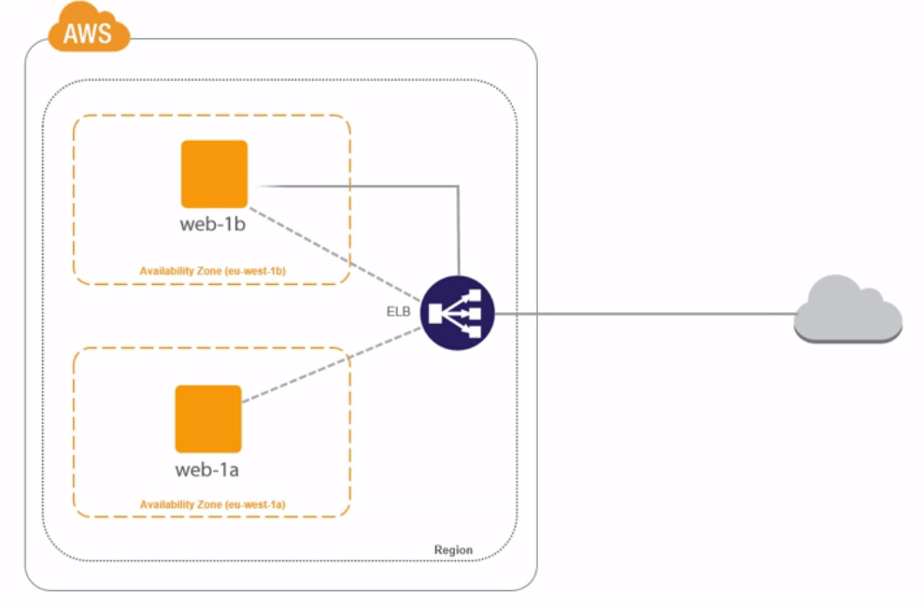

5.)Now, it didn't need to be just two hosts and subnets and two availability zones, it could totally have been more, it's just really, this kind of a diagram got really messy when I tried that. 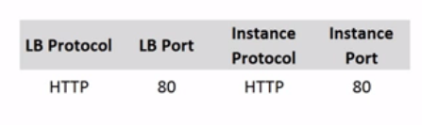

We also configured our listeners and we said, listen for web traffic on port 80 and forward it internally on the same to our two instances.

6.)And we said we wanted cross-zone load balancing, meaning that all instances would get an equal share of the load, no matter how many instances existed in each availability zone. 

But you know what? Generally speaking, it is a good idea to always maintain a semblance of balance acrossyour availability zones, so you probably don't want one availability zone with 10 servers in and the other with just 1.

It's up to you, right, but it's generally a good practice to keep them about the same

7.)And we left connection draining at its default of 5 minutes, making sure that if we were to de-register any of our web servers from the load balancer, they'd stick around for 5 more minutes servicing any existing connections, but they wouldn't take any new connections.

8.)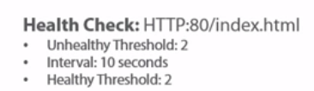

Also, we configured health checks. We said something like, keep checking each web server on TCP port 80 and make sure that index.hmtl is always there.If it's not, and it's not there for two consecutive checks, and we're going to be waiting I think we said 10 seconds between each check, then take it out of the game. But don't send it off for an early bath, right, don't write it off completely. Keep checking it every 10 seconds and if it comes back to life, and it's there for 2 consecutive checks, then bring it straight back into play. You know what? I reckon that's like the highlights of configuring the ELB, but we also said, right, that as it scales the IP addresses behind its unnaturally long DNS name, they're going to change, so don't ever trust the IP addresses. Always use the DNS name. Though, it is totally safe, right, and it's actually totally popular to use CNAME records to put friendly domain names in front of the load balancer. Oh, and we said scaling isn't instantaneous. I would take as a ballpark if I was here, right, something like 2 to 3 minutes as a realistic time before we see scaling come into effect. And that people is the basics of load balancing using Amazon Web Services elastic load balancers. Seriously good stuff. Next up, we're going to look at how to configure routing between multiple VPCs.

**Configure Routing Between VPCs**

Module Intro

1.)Alrightly then, so the way things stand at the moment, right, if we've got two VPCs, the only way for instances in one to connect to instances in the other is over the internet. But for that to work, right, we need a bunch of just stuff, yeah. So if the instances in question are in public subnets, so they've got public IPs and routes to the internet, then they can talk to each other straight over their respective internet gateways.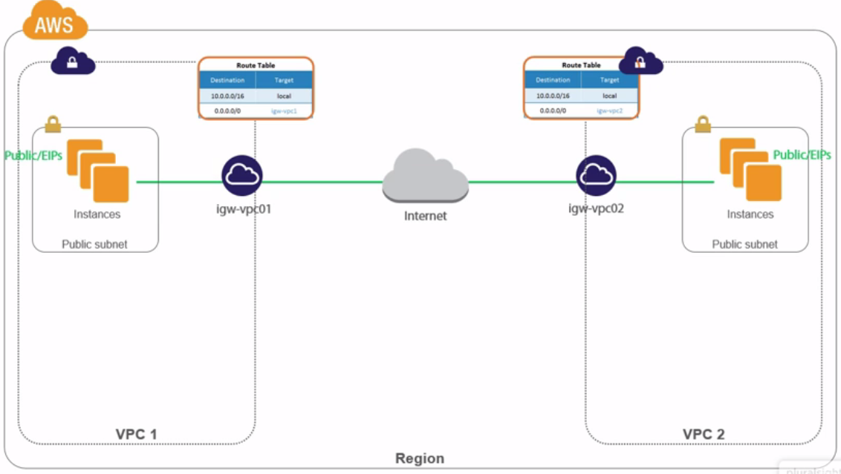

2.) But like we just said, this requires public IPs and if we want them to be reliable, they're going to need to be elastic IPs. Then, obviously all the chatter between the two has to traipse back and forth across the internet.

3.)A bit clunky and risky actually from a security perspective, at least for some kinds of traffic. But you know what? Just clunky, yeah, when you consider that all availability zones in a region have got these like shiny high speed network links between them. So why would we use the internet? Also though, it gets worse.

4.)If in one side of the equation instances initiating the communication are in private subnets, oh man, then there's the extra headache of traversing a NAT instance. Plus, yeah, the fact that only stateful responses are allowed back in in the opposite direction, who wants that? I mean it works okay, it's just a bit rubbish. Well, fortunately there is a better way. Ahhh, **and it's called VPC Peering.**

**5.)** Didn't know I could get my voice that high. Anyway, so at a mega high level, we lash up two VPCs so that instances in either can talk across VPC boundaries using private IPs and Amazon's ridiculously shiny and low latency network links. No internet and obviously there's more to it than we're letting on with that picture. 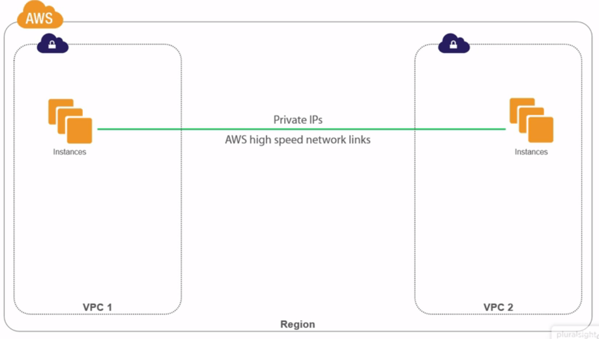

6.)But before we get started, here's how we're going to slice and dice this topic.I'm going to go through the basics up front, a quick bit of theory, yeah. Then I'm going to explain how we're going to rock and roll in the lab demo, just a couple of VPCs and some instances and we'll get these to talk to each other over a shiny new VPC peering connection. Then we're going to get to the fun bit and build the actual peering connection. And as we do that, we'll prove that the connection is working by setting up an instance on a continuous ping, which at first isn't going to work, but as soon as we bring the connection and routing up, it'll magically spring into life. Well, that's the plan. So, let's go get things all straight in our heads with a bit of basic theory.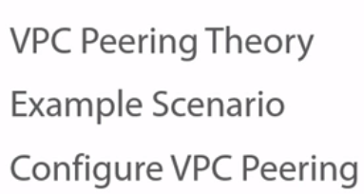

**VPC Peering Theory**

1.)So first up, right, I called the module configuring routing between VPCs. 

But the way we do this is via an AWS technology called VPC peering. 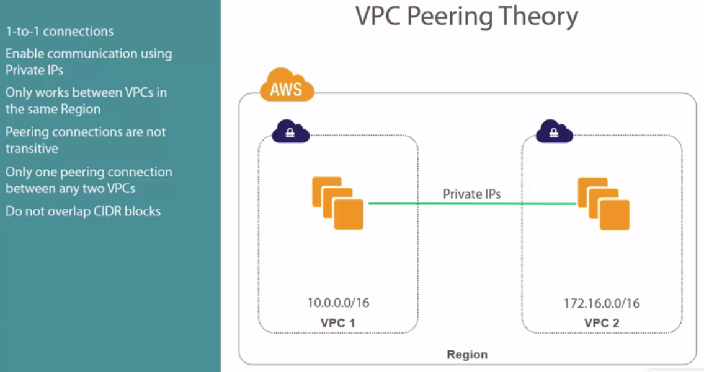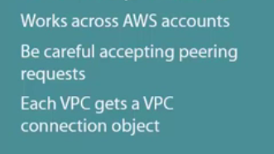

2.)So there are totally times, right, where we want to hook up a couple of VPCs, in a way though so that resources in either VPC can talk to the other VPC without having to cross the internet and I hate lists of bullet points, right, but I don't know, I can't really escape it here. Anyway, this, right, is where VPC peering comes into play. So, any two VPCs lashed together with a peering connection actually, that's our first point. These peering connections are 1 to 1. Sure, a VPC can be paired up with a whole bunch of other VPCs, but that requires a whole bunch of individual connections. Reason being, every connection requires its own connection object, it'll be crystal clear in a second. Anyway, this is all about private IPs, yeah, and this is the bizzo, I mean it means we don't have to worry about changeable public IPs or chargeable elastic IPs, and in general, it's just a bit more secure, yeah. Oh, peering is region specific, so the VPC's we want to lash together need to be in the same region.

We can't do this stuff across region yet. Hmm, okay, maybe I should have mentioned this when saying peering connections are 1 to 1, so as the slide says, right, peering connections are not transitive. This means if we've got three VPCs, 1, 2, and 3 here, and 1's connected to 2 and 2's connected to 3, this does not mean that 1 is connected to 3. It's not. There's none of this, don't mind me, I'm just passing through. No you're not. This old boy here, VPC 2 is not a transit point between 1 and 3.If 1 wants to talk to 3 as a peer, it needs its own connection. 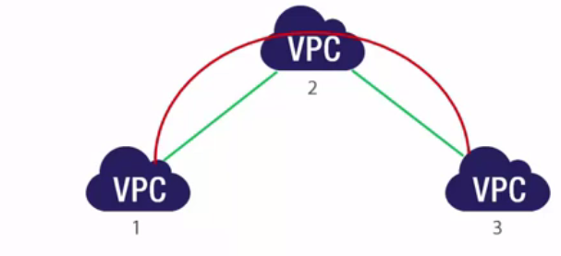

Oh yeah, kind of similar. We can only have one peering connection between any two VPCs. So no doubling up for performance or resiliency, yeah or no. But don't sweat about that, at least if you believe Amazon, because according to them, although they won't tell you how, VPC peering connections have no single point of failure and they're so bad ass, right, they're never going to be a choking point in your network.

Okay, well that's what they say. Ah, right, so this is like uber important okay. None of this is going to work if the network address space in one VPC, so the CIDR block that we configure it with, overlaps with the other VPC. They need to be on totally separate CIDR blocks and this runs through our VPC networking, right. If you want to connect any network up to a VPC, so maybe lash up a link between your corporate office and your VPC over a VPN or direct connect that we're going to talk about in the next module, or even what we're going here, connecting VPCs, we can never have overlapping CIDR blocks.

5.) 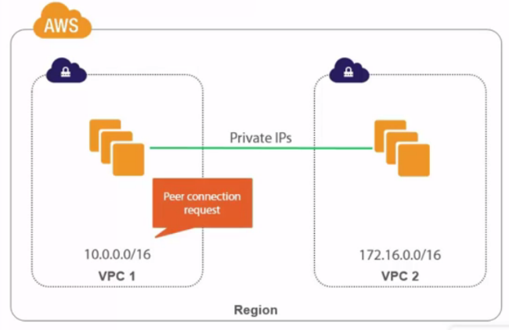 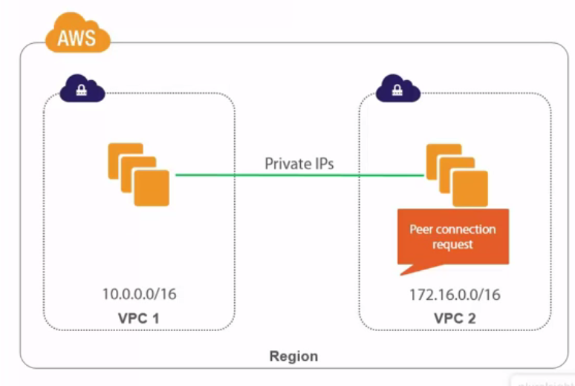Okay, so what happens is from within one VPC we create a connection request requesting a peer connection to another VPC. And that VPC, okay, can totally belong to another AWS account, in fact, we're going to do that later with two separate accounts, but we create this connection request from the source VPC, though there's no real concept of source and destination.

Anyway, that request, it then pops up in the VPC console of the destination VPC. Then the owner or the admin of that VPC has got like a week or something to accept it or reject it. And I totally advise you to be extremely carefully accepting peering requests. You don't want some evil dude spoofing a connection to you and you accepting it because bad things would almost certainly ensue.

5.)Anyway, once that's accepted each VPC gains a peering connection object, kind of like an internet gateway, yeah, and it's like totally uber remember, unbreakable and impossible to overrun. 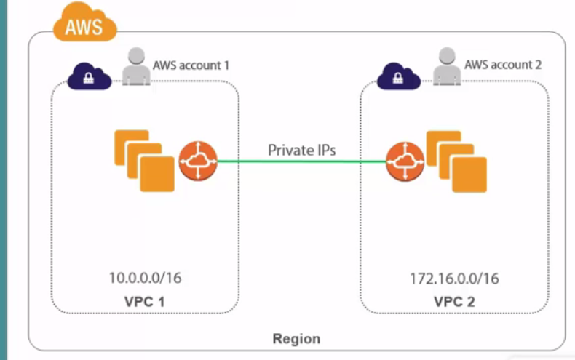

Then one last thing, we've got to update the routing tables associated with the subnets that we want using this connection. No doubt, right, some bits are probably still a bit vague, but I reckon, right, once we've run through our mock scenario and we've actually gone and configured it all, I reckon it will feel like you've known it forever, inside out and back to front. So let's go and look at our scenario.

**Lab Scenario**

1.)Okay, so we've got two VPCs, more actually, but for this demo we've got our podcast VPC that we've been using throughout the course, yeah, and I've created another one called blog. I don't know, blogs and podcasts, yeah, only our blog VPC here belongs to one of my other AWS accounts. One can never have too many AWS accounts, seriously. 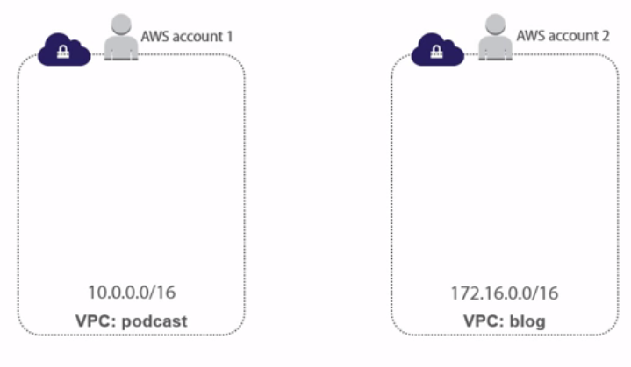

2.) So yeah, it's absolutely possible to configure peering connections between VPCs owned by different AWS accounts, they've just got to be in the same region, right. Now over here in the podcast VPC, we've got a Linux instance in a public subnet and at the start of the demo we're going to set it up pinging another instance over here in a private subnet in the blog VPC. 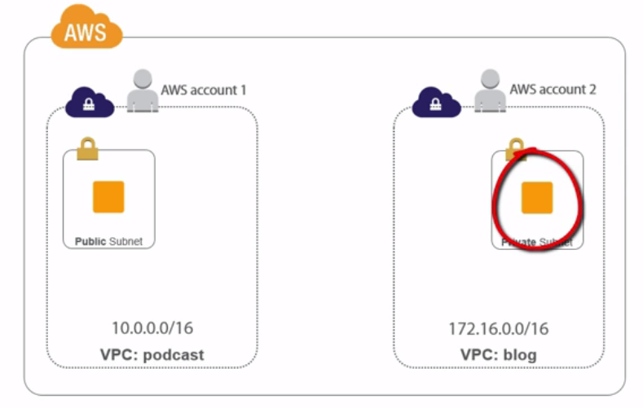

3.)And at first, right, because this old boy over here has only got a private IP, it's going to fail, get no replies.

4.)But then from over here, we're going to create a peering request and to do that we need the AWS account ID that owns the remote VPC plus the ID of the VPC that we want to peer up with. 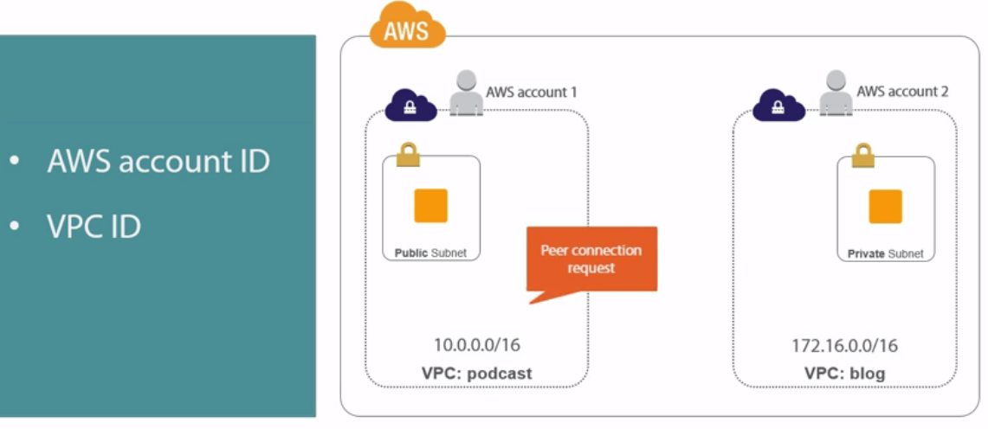

And of course, I've got things rigged up so that they're both in the eu-west region and I've got totally separate CIDR blocks. Anyway, once that connection request is made it's going to pop up in this VPC dashboard over here.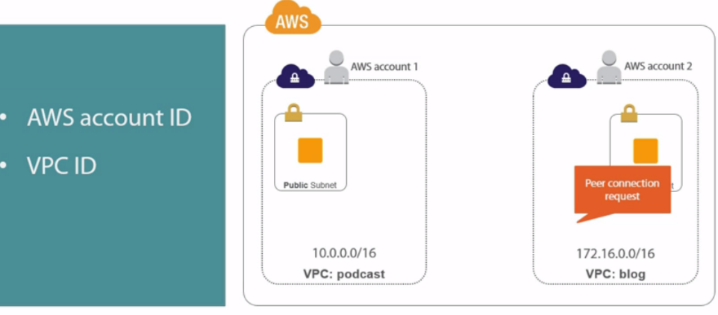

5.)Once we approve that, it'll trigger the creation of our peering connection objects. Then all we need to do is update our routing tables. Now then, this bit like totally depends on how you've got your routing set up. 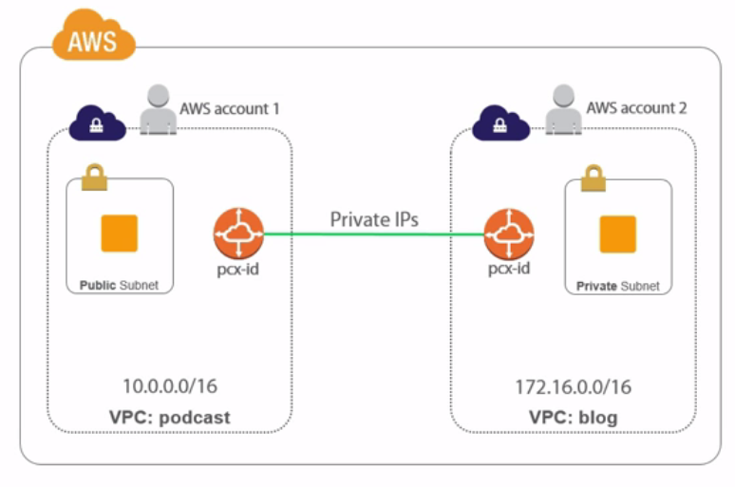We've got it set up so that each VPC has got a couple of custom routing tables, one of them is attached to all public subnets where the route to the internet and all and the other is attached to all the private subnets, no route to the internet.

6.)So what we're going to do in our podcast VPC is add a route to the route table attached to the public subnet and if you can see that, which oh my goodness if you can, hello superman vision, for the rest of us though it's basically the network of the remote blog VPC and a target of the new peering connection object. 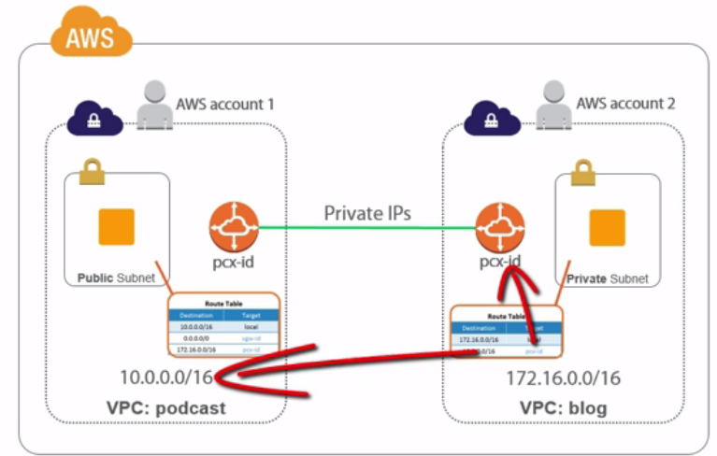Then over on this side we do the same, only this time for a private subnet, adding the network of the podcast VPC back over here and a target of the same connection object, which for the record is named the same on both ends. Then, if all goes to plan, we'll pull up that pinging Linux instance right before we save those final routing changes and we should see the ping springing to life. So that's the plan. Who's excited? I am. Let's go and do it.

**Configuring a Peering Connection**

1.)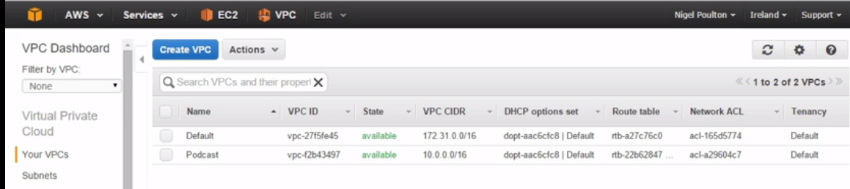 we've got two VPCs belonging to two different AWS accounts and the way that I normally roll with this is I open them in two separate browsers, one account in Chrome and the other in Firefox. It just means that Chrome saves my creds for one account and Firefox for the other. So, in Chrome first, we've got our podcast VPC, nice and familiar, yeah.

And we should have a single running instance (Loading), yeah, and with a public IP and DNS name.

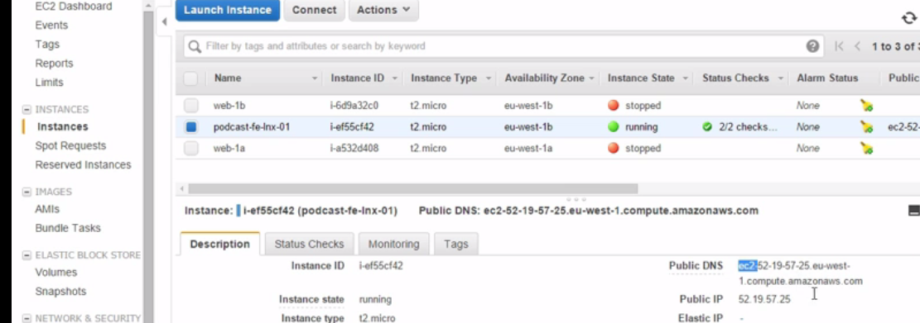In fact, let's grab that DNS name and I'll open up an SSH session to it, by magic, yeah.

Okay, so ip a, so 10.0.1.250 and yes, it's the right box. 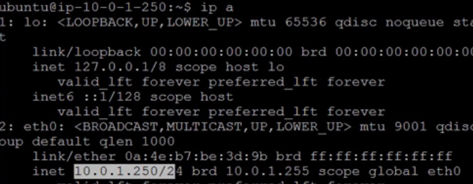Remember okay, instances don't know about their public IPs, that's all mapped in a table on the internet gateway.

1. if we scoot quickly over to Firefox to our other account, okay, two more VPCs. 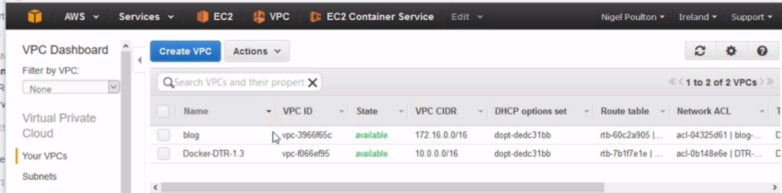And this blog one is the one that we care about. But for now, right, we want to grab the private IP of the instance that we're going to try and ping. Okay. And it's going to be this one here, blog and then in the private subnet and it's a Linux box. And this is it's private IP, so if we grab that, then go and try and ping it (Typing).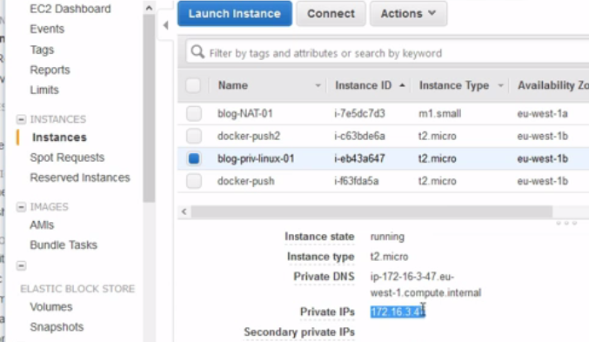 Yeah, not looking good.

Nope, definitely no replies coming back. 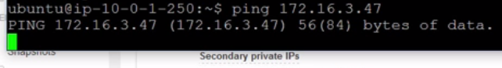3.)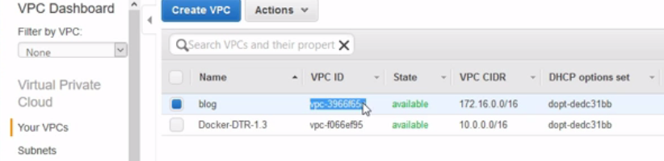Okay, back to Firefox. What we want now is some VPC ID stuff and the likes (Typing).So this is our blog VPC ID here, same again down here, and here, oh and notice it's CIDR block, yeah, in the 172 range.

4.)But we'll have a copy of this(VPCID) and we'll keep it in here. Remember, this is the ID of the VPC that we're going to request a connection to.

Also, right, we're going to want the ID of the account here that owns it and, by the way, don't be thinking because it says Nigel Poulton here and it's the same back here in Chrome, these are just display names, they are totally different accounts.

Anyway, if we click the dropdown and my account, this is what we want.

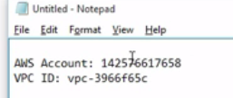

1. we're ready to rock and roll creating this peering request, …>back in our podcast VPC. And if we hit peering connections

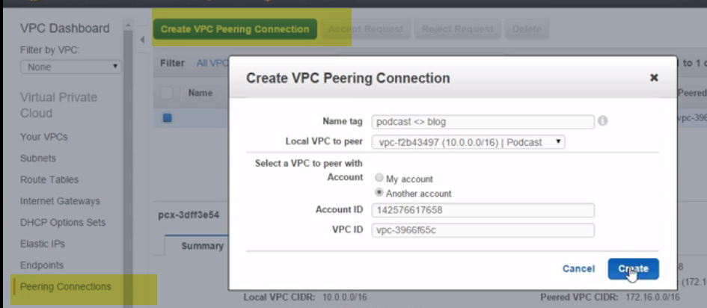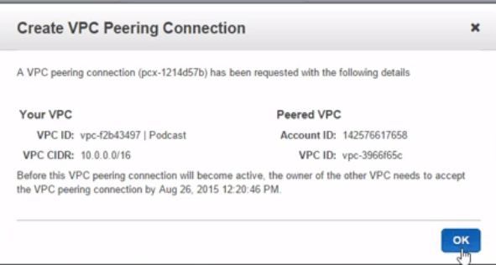

And by now, right, we know all about the importance of naming our stuff. So we'll call this I think podcast <> blog and pick our podcast VPC from here. Now then, we can obviously created a connection between two VPCs that our account here owns, or we can lash up a connection to a VPC owned by another account. Well, that's what we want. Okay, we'll grab the account ID (Typing) and the VPC ID (Typing). Alright then, so we've got a nice meaningful name. We're going to go from our podcast VPC here to this VPC ID here owned by this AWS account. Let's do it.

1. Now then, at this point it's probably important to remember that this is only going to work, right, if our two VPCs are in the same region and if they don't have overlapping CIDR blocks, right.

Anyway, take a note of the status here, pending, and that's acceptance, which is good, it means 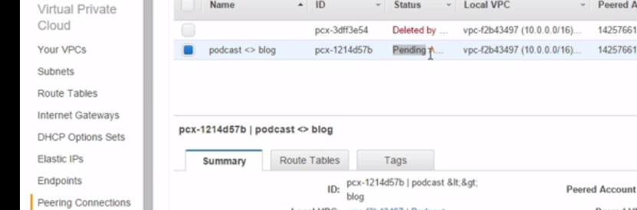

1. if we jump back over to our other account, navigate back to our VPC dashboard, peering connections, there we go. 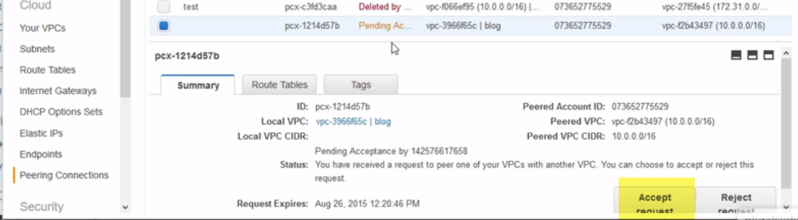

Now then, I'm expecting this, right, but you totally want to make sure, right, that all this stuff, like Account ID and maybe VPC ID, that they all match up with what you're expecting.

7.)Never just blinded accept peering requests. Then all we need to do now is hit Accept request down, one final chance to double check everything, and there we go, all established.

8.)And if we come back here, where is it? 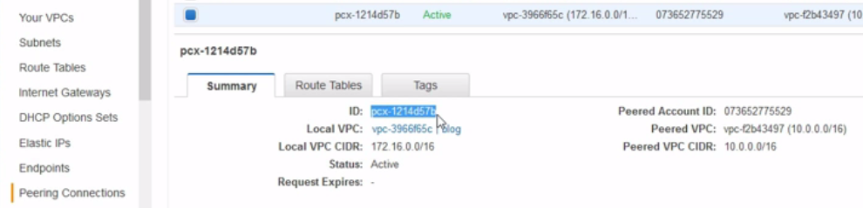Yeah, this ID here, this pcx object, this is our peering connection object, so like an internet gateway, yeah. This is going to be our target when we update our routing tables.

**Updating Your Routing Tables**

quick refresher1.) We've got our podcast VPC and in there we've got that Linux instance in a public subnet, you know, the one that's trying to ping another Linux instance over in a private subnet in the blog VPC.

And we've got things configured so that each VPC has got two custom route tables, one's for public subnets and the other i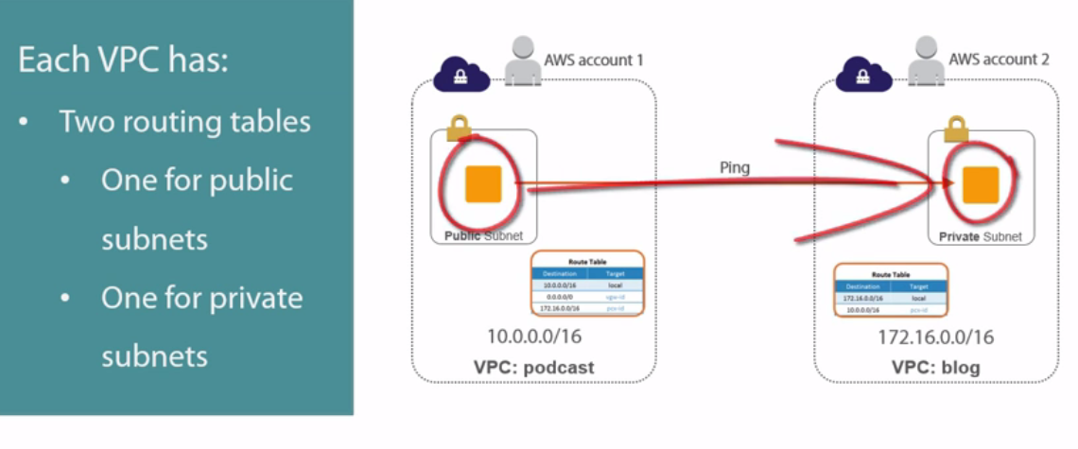s for private. So, because we want this public instance, if I can call it that, to talk to this private instance over here, we're going to need to update the publicrouting table on this side and the private routing table on that side. What this'll do is make sure that instances in the public subnet here know about the new route to the private subnet over here and a corresponding route back. Cool.

2.) And just in case we forget, I've got a mini version that I'm going to park up here, I'm going to keep my fingers crossed that it doesn't get in the way. So from Chrome here, so our podcast VPC, we want to hit Route Tables and according to our little picture up here we want the public one, so this one. Then hit Routes and add a new one. Now we want to be telling it about the blog VPC, again, a little pic at the top here tells us that that's 172.16.0.0/16. And well, as if by magic, there's our pcx object. Pcx standing for peering connection. Save that and why not, let's just make sure it's associated with our public subnets, which yes it is. So that's one side done. Our podcast public subnets now know how to get to our blog VPC. So if we jump to the blog side now and same again, Route Tables, all nicely name again, we want this one, blog route table local, Routes, and add a new one. This time our little picture is telling us we want 10.0.0.0/16 and our peer connection object again. Now interesting, okay, if we want to we can put in like a smaller range of IPs, we could put in just one of the subnets just back in our podcast VPC or we could even put a single IP address from that range. So there is flexibility. Anyway, here comes the moment of truth, and this better work,so let's, we'll move this over here a bit, bring our ping machine back. Nope still not pinging. Then if we hit Save, yes. There we go. Two instances in separate VPCs belonging to separate AWS accounts, not that that matters, but it sounds a bit better, having a polite conversation over private IPs. Marvelous. Let's go and wrap the module up.

Summary

Magic. Another cracking topic learned and tucked away under our belt. And this was all about, I suppose we could call it, inter-VPC rooting or routing, I've got to say it once like that, yeah. But it was basically stringing a couple of VPCs together so that resources on them can communicate using private IP addresses, oh, over Amazon's shiny like faster than light private network connections. Because if we remember, right, before we learned about this, if we wanted resources from two separate VPCs to talk to each other, we'd have been staring down the barrel of assigning public IPs or even worse, messing with NAT instances and then relying on the internet. So in my opinion, this has been huge, right. No need for public IPs and no need for the internet. I always said the internet was overrated. Anyway, to hook it all up, from one of the VPCs we want to connect, we go into the VPC dashboard and we create a new peering connection. If we're hooking up a connection between two VPCs that are part of the same AWS account, no sweat, we just pick the VPCs from a pair of drop down lists. But if we're connecting VPCs from different accounts, we need the AWS account ID and the VPC ID for the other VPC, the one that we're trying to hook up to. Then, a connection request gets sent over to the remote VPC and whoever is in charge of that needs to accept it.But, they need to do their due diligence, right. We don't want to be accepting peering connections from folks we don't know. Once that's all done, each VPC gets a peering connection object, which is basically a router or a router port, and we go and slap that into the relevant route tables. Now then, which route tables we update totally depends on how we've got routing configured in our VPCs. But when updating our route tables, we can either add a route to the entire remote VPC, just parts of it like maybe certain subnets, or if we want we can add routes for individual IPs. Yeah, this is magic, magic stuff. Very enterprise class or attractive to enterprises, yeah. I mean, let's say you acquire a company or maybe you just need to do more business with them and need to hook up dedicated private links between your VPC and theirs. What we've just seen, it's like a walk in the park, right, but there's a few prereqs and limitations, yeah. The biggest one I suppose is that this only works between VPCs in the same AWS region. That is definitely a biggie. Also, the two VPCs can't have overlapping network address spaces, those CIDR blocks have got to be distinct and separate. Oh yeah, then we've got to trust Amazon. There's no way for us to have multiple peering connections or connection objects between any two VPCs, we just can't do that. But according to Amazon, why would we want to anyway? I mean these things are like indestructible and are like grease lighting, though those are my words, yeah, but they definitely say that peering connection objects have no single points of failure and won't be a choking point, so there you go. Oh and finally, I try really hard to avoid conversations about costs, right. They just feel so open to change and potential variation by region. That all said though, charges do apply for passing data across VPC connections.Check Amazon for the latest charges. Okay, coming up next, a similar topic actually. Next we're going to talk about how VPNs and Direct Connect can be used to hook our VPCs up to non-AWS networks, so like hook it up to our corporate office or our data center or even your home office if you roll like that.

**Connecting Remote Locations with VPNs**

Module Intro

Okay then, so in this module we're going to rock and roll with VPNs, virtual private networks. But right off the bat, I want to take a sec to define a VPN and then outline how we're going to tackle things. So a VPN, okay, it's an acronym for virtual private network. And back in the day, right, so like when I was resetting passwords, changing backup tapes, and you know what, pretty much making coffees for my superiors, technical superiors yeah, well back then, VPNs were nasty things. I mean, I shutter just thinking about them. So the idea was, when people weren't in the office, but maybe needed access to company services, I don't know like email or maybe a database or whatever, well we needed a way to give them a connection from wherever they were back to the office and that connection had to be secure. So it was a bit like this, right? Well in fact, actually when I graduated into being trusted enough to be on the IT support on-call router it was exactly like this. So I don't know what it was, it was like once every 4 or 5 weeks I'd be anointed with the possession of the on-call mobile phone and a laptop, the likes of which would be almost unrecognizable these days, a proper honking piece of plastic, but you know what? Doubled as a pretty good weight for dead lifting. But it had a build in modem and then, right, whenever there was a problem with any of the company's server infrastructure outside of office hours, I'd fire up the laptop, then obviously I'd wait 5 minutes for it to boot, then I'd dial back to the office where we had a good old Nortel Contivity VPN concentrator. Now then, this combination of the laptop with the Nortel VPN Client, the internet, and let's just call it a VPN router here, this combo let us create what's called an encrypted tunnel from my laptop all the way through the internet to the corporate network, basically a secure, shall we call it, virtual private network. And while it was good in theory, right, in practice probably due to like the 56K modem speeds and the likes, it was a pig, seriously, it was absolutely pants. Now I don't want to waffle okay, so story time is over, but the principle is this, VPNs are all about tunneling a secure connection over the internet from one point to another. And back then when I was cutting my teeth in IT, it was from a laptop back to the office. Now these days, right, fast forward like, I don't know, 20 years or whatever and VPNs are a boatload more than just that. In fact, what we're going to be talking about in this module, while it's kind of like what I just talked about, it's different too. So we're going to be talking about hooking up two locations via the internet, so maybe a corporate office or an existing corporate data center, and hooking it up back to AWS via the internet using a VPN. And we're going to be configuring, right, what is an always up VPN, not like me on the on-call laptop, right, where I only fired it up like, I don't know what it was, maybe once a week or so when something information office broke. No, what we're going to be doing here is a totally different beast, an always up, reliable VPN connection. Anyway, okay, hopefully that does us like 1000 foot view primer on VPNs. Now how we're going to go about this is pretty much like this. We'll do a little bit more high level stuff, okay. Then we'll outline the major components that make up an AWS VPN. After that, we'll lash one up. Then we'll talk about something called direct connect, it's like a VPN, but it's also not like one. More of a full blown leased line DWDM type uber connection into AWS. I know, it probably makes no sense explained like that, but no sweat, right, on my honor I'll give it the full treatment later in the module. That's good for now though. Let's crack on.

**High Level VPN Stuff**

So here's the deal, right, so far we've configured this like uber network, our data center for ourselves, right, inside of Amazon Web Services and a module or two back we put a couple of public facing web servers in there and then we stuck a load balancer in front of them, all good stuff. Oh, and we've seen a few times as well how we can connect to our instances using SSH or if they're Windows, yeah that would be RDP, but the thing to note, right, all of this kind of access has come into our VPC through its internet gateway, so all using publically routable IPs and unless we use secure protocols like SSH or HTTPS, then it's all totally unencrypted. So, we're talking over the internet, right, and then wide open for anyone to look at. Now, okay, all we've done so far, right, is a bit of HTTP action to a static webpage or two with like 0 sensitive content, but there's like absolutely nothing stopping us from hosting, I don't know, mail servers or database servers or whatever in our VPC. In fact, we probably want to do stuff like that, but of course, as soon as we do, then the kind of traffic we're going to be sending is almost certainly going to be more sensitive. Well, if that's the case then we want to connect to those services from outside of AWS, so probably from our corporate office, yeah, well we've got a couple of options. We can either secure each and every connection type, so maybe configure our client so that they only talk to the mail servers over secure protocols or the same for our database servers, yeah, only allow clients to talk to them via secure protocols, or we can configure a secure virtual private network, a VPN, or a tunnel. So that would go from our corporate office all the way to our VPC. That way, right, everything that we send between our office and the VPC goes through this tunnel and is therefore automatically encrypted and nice and secure. And you know what? Of the two options, I don't know like 99. whatever % of the time, option 2 is going to be the oneand that's the deal with AWS VPNs. We take our office, so branch office, home office, corporate HQ, whatever, right, and we lash it up to our VPC over a VPN connection. And boom, right, in one fell swoop we've made all communications between the two secure. How come? Well like we just said, this connection between the two sites here, it's secure, IPsec secure, if that means anything to you. Basically, all traffic, so in both directions, is encrypted using IPsec. And I think we've hinted at this, but let's just be clear right now, we sometimes call this connection here the tunnel. I don't know, how's about this for an analogy, so we're connecting via the internet, yeah, and we know everyone's on the internet including the bad guys. Well, to keep the bad guys from spying on our chatter, we create this tunnel and then you can only get in and out of the tunnel from either end.But each end is already secure, right, or it should be, so in our VPC we'll be using things like NACLs and security groups and the likes, and then over in our remote office we'll be using similar stuff, or we should be. The point being, the bad guys out here are outside of our tunnel and from outside, you can't see or get in, so a bit like, and I did say we were going to get an analogy here, so I don't know, a bit like you know how famous people travel around in big old cars with blacked out windows so you can't see in from the outside? Well it's a bit like that. We're all using the same roads and the likes, but you can see straight into the likes of my car, right? So you can see who's inside, what the kids are watching on their iPads or DVD players, probably see my wife having a sleep in the passenger seat, but cars with blacked out windows, good luck seeing what's going on inside of them. Well a VPN tunnel it's a bit like that. We're all traveling about on the internet, yeah, but VPN tunnels are encrypted so if you're on the outside you can't see in. Okay, now in a way, right, the office location here, well it becomes almost like just another subnet within our VPC and that is massive, right? It literally means that resources in each network, so from either end of the tunnel, can access resources in the other network as if they were set right by each other, the key being using private IPs, yes. No more having to assign public IPs to resources that you only want to use internally. And also, this VPN, right, it's a permanent, always up, highly available, encrypted tunnel between the office here and our AWS VPC. Now that is a far cry, okay, from the flaky old VPN connections that I relied on as an IT support engineer all those years ago back in the early days of my career. The kind of VPNs we're working with here with AWS, they are rock solid, they're nothing like the VPNs of the bad old days. Anyway, that's the high level, okay. Now, let's go and drill down a bit to the actual bits and pieces that we need to get it all working.

**AWS VPN Components**

Well, first up, right, the obvious stuff. We need a working VPC and we need a remote office location. And I know that's totally obvious okay, but like we said in the previous module about VPC peering, these two locations, our office and our VPC, they absolutely must have totally separate networks. So that means zero overlapping of address spaces or CIDR blocks. For example, right, we can't have the 10.0 network over here and then use it again over here in our VPC, well I mean, we totally can and they'll work in isolation, but try and lash them together with a VPN, that's a whole different story. So like we said way, way back at the beginning of the course, right from day 0 you've got to treat your VPC just like a regular old corporate network, so that means give it its own documented IP range and make sure that you don't use that IP range anywhere else in the company.Sure our VPC is out in AWS and it kind of might not feel like it's part of the corporate network, but by lashing it up with a VPN or something, it totally can be. So treat it like any old site and any other network that you would on your corporate infrastructure. But to build this, right, we pretty need to configure three things. First we need to configure what AWS calls a customer gateway and for now, right, we can think of this as our end of the VPN, the bit of kit in our office that terminates the VPN tunnel and it's usually going to be a dedicated piece of hardware, like a firewall or a VPN router or something. Next, we need to configure a virtual private gateway. This is the other end of the tunnel, the end that terminates the connection inside of AWS. Then once we've got both ends, we need to configure the VPN itself, the tunnel, yeah. And this is basically just logically connecting the two, bringing the two together to form the tunnel. And go on, it's analogy time again, okay, so maybe think of the two ends of the tunnel, the customer gateway and the virtual private gateway, as being like, I don't know, rail terminals, yeah, at each end of a tunnel. Something like the channel tunnel that connects London to Paris, yeah. Well, the only way in and out of that tunnel is via those terminals, then this last bit that we configure here, the tunnel, is like all the config details needed to get the two ends of the tunnel talking to each other and ready to let trains through. I don't know, signaling and speed limits and stuff like that, yeah. Well the same goes for our VPN config, these two items here are like the rail terminals if you will, and then the VPN config itself is defining how the tunnel will work. I don't know it was probably a crappy analogy, okay, but we're talking about things like which customer gateway will be on our end and which virtual private gateway will be on the AWS end. Then we'll configure routing options, encryption, and stuff like that. And you know what? If we look over here at our VPC console, right, those three steps that we just mentioned, they correspond nicely to these threeoptions down here and literally in that order, one, two, three. The customer gateway, our end of the tunnel, the virtual private gateway, Amazon's end of the tunnel, and then the VPN config that brings the tunnel up and makes it operational. So that's the three steps okay. But before we dive in and do it, just a few quick points. First up, right, it's important to grok that this virtual private gateway here is a device of sorts, okay, and it kind of exists in our VPC. So, it can be addressed in our route tables, right, just like an internet gateway, but realize, right, that it's a totally different object to an internet gateway. So once we've got it up and working in our VPC, all traffic between our VPC and our remote office, which here is defined as the 10.1 network is going to go across the virtual private gateway and not the internet gateway. And like we hinted at before, this traversing of the VPN connection is what lets us use private IPs when communicating between the two networks rather than having to use internet routable public IPs, and that's good stuff. Also, right, the virtual private gateway, it's the cha-zing. So if we explode it out a bit, yeah, it really looks more like this. So two distinct end points IP addresses, yeah, in a highly available or a redundant design. Now I don't know the implementation specifics behind this, right, but I would expect it to be more than just a couple of ports on the same piece of hardware. I'd expect it to be more like two ports spread over two different devices, I don't know, probably in two different cabinets and maybe in two different holes or two different facilities. The whole idea being, right, it's highly available. So if one of those endpoints goes down, the other stands a pretty good chance of staying up.But this is one of those instances, right, where we've got to trust AWS as a platform. They're not going to give us the secret source behind how it all works and how it's all highly available, we've just got to trust that it's there and that it will be available and that's the big take away point, right. We totally want to think of this as a VPN concentrator service, yes, it's highly available, yes it's high performance, yeah, it's the bizzo. But we don't need to get bogged down by all of the detail. We just use it and it's there when we need it. But what we're looking at here is only half of the picture, yeah, we absolutely can and you know what, if we care at all about the availability of this tunnel then we absolutely should build a similar HA design at our end. So yeah, we totally can rig it up so that we've got two customer gateways on our end, hooked up, cross connected, multi-pathed, call it whatever you want, right, to each of those virtual private gateway endpoints on the AWS end. This way, right, when, and I say when on purpose, right, when any one individual component goes down, the surviving links here, they just kick in and take over. The VPN service, no sweat, right, remains up and working. Move along guys, nothing to see here, business as usual, yeah. Ah, and one more point, okay, you definitely want your own static IPs over here. And I know that's often par for the course, right, with office internet connections, but it's not always the case for home offices. So if you're trying to hook your home office up to your AWS VPC, you want a broadband package or an internet package or whatever, that guarantees you a static IP. Otherwise, right, anytime your IP changes, like maybe when you reboot your router or whatever, then you're going to need to reconfigure your whole tunnel again and that can be a royal pain in the rear. And on that note, right, I think we'll get off the slides and over to our AWS console.

**Configuring an AWS VPN**

So to rock and roll with VPN connections, we want to be over here in our VPC dashboard. And then down here under VPN Connections. And we'll just go through the three in order from top to bottom. So Customer Gateways here, this is our end of the tunnel, yeah, and we don't currently have any. But I want to point this out, okay, customer gateway config is really two things. There's the actual gateway itself, okay, so the piece of kit that we own on our office premises, that hardware device that we talked about that's our end of the tunnel. Well as well as that, then there's the corresponding object in AWS and that's what we're configuring here, okay. And this object, right, it's just a way for us to tell AWS a bit about our actual physical gateway. So if we take a look here, right, so name, routing, and IP address. The name's arbitrary, right, so we'll go with something that fits our loose standard, yeah. And then the routing and IP bits, they're just our way of telling AWS a little bit about the config on our end of the tunnel. The IP address at the bottom here, this is the public IP address of our router or our VPN endpoint, that static IP address that we were just talking about. So, if my office's public IP address is 94.119.64.23, then that's what I put in here. It's just the public interface of the piece of hardware I've got on my end of the tunnel. And remember, make it static, okay, because it's just not feasible to be changing this thing. Remember, we want this VPN connection to be always up and reliable. Anyway, then for the routing, okay, we've got a couple of options, static and dynamic. So, static is a bit like the cheap and cheerful option, it's nice and easy to configure, right, but it doesn't scale well. We've got to do things like manually add routes on both ends and it's great and all, but it becomes hard work at any kind of scale. Dynamic on the other hand, this is the more I suppose enterprise-y option. It uses BGP, the border gateway protocol, and it doesn't need static routes entering. Instead, both ends of the tunnel, so obviously both ends need to support it, yeah, but both ends they advertise routes to each other and it scales like a lizard. The downside being, you need to be a bit of a network ninja to configure it. Now I'm no networking ninja, so I'm all over the static option. Then we click Create. And that's our customer gateway object all configured. Next, we want the AWS and the virtual private gateway. Again, we've not got any, so we'll create one. And look at that. Just a single option to configure, name tag, talk about easy. Well, we'll be boring and go with podcast-vgw01 and there we go. So we've got our end of the tunnel here, podcast-cgw01, it's available, IPsec, it's IP address, and because we went with static routing we could ignore this BGP autonomous system number thing here. Back over here on the AWS end, and the same again, IPsec, but not attached to a VPC yet. So let's attach it (Typing) and there we go. With both ends configured, that means all we need to do now is stitch them together. So that'll be VPN connections and Create. Okay, so this time a little bit more to do. We'll go podcast-vpn for the name. Yes this is our virtual private gateway here, dead simple as we've only got one, but remember, right, naming stuff properly comes into its own when we've got like a boatload of everything. Oh and they can be useful for billing as well, yeah. We'll go with our existing customer gateway we just configured, though if we click New, yeah, we totally can create a new one right here right now, but we've already got one and we're definitely in the static camp here, yeah. Okay, now in this box we put in the networks that we want to be reachable over this connection. So, our office network, we said that was 10.1.0.0/16 and we're ready to go. Now in the real world, right, you might have a bunch of networks that you want to reach over this connection, well that's just fine. You can list pretty much as many as you want here, just separate them with commas, yeah like this. Anyway, we'll just go with the one. Create (Loading), okay that's having a good old think, come on Amazon, it's like we're installing Windows for work groups with like 14 floppies or whatever it was, we don't expect this kind of hanging around in the cloud area now. Maybe I'll pause the video here, okay, it's back, there it is, right. Though it's not available just yet. Now, here's the config down here, so both ends of the connection, yeah, the type and the networking wimp's option of static routing. If we hit Tunnel Details, we can see both endpoints.Remember we said earlier that we automatically get this highly available design, so two tunnels, each with its own IP, and each currently down. But the point being, if we connect our end up to both of these, if one goes down the tunnel itself stays up. Good stuff, it's just down right now, okay, because we haven't configured the actual router on our end. So to configure our router, we hit the Download Config up here, then depending on our router make and model, yeah, I mean who even knew that Yamaha made routers? I thought they made like pianos and motorbikes. Anyway, if your kit is on the list here, just select the model and then the software version and hit Download and what you'll get is a nice text file with all the commands and config stuff that you need to put into your router. It's really simple actually, but if your kit ain't on the list, then you're going to want to go with generic here and what that's going to give you is a nice little file that explains all the settings that you need to set, you just don't get the actual commands this time around, you're going to have to work them out for yourself, but it's pretty easy.Now then, here's where like I totally, totally let you know. Wait, no. What? Don't press Cancel. You just pressed Cancel, why? Okay, so I'm like kicking back in the home office here, yeah, and not being a networking guy, sorry, I don't have a router here at my end of the tunnel. So sorry folks, I can't complete the demo for you, but you know what, don't hate me. That part of the config is totally like non-AWS stuff, it's proper Cisco or Juniper or even Yamaha, yeah. Seriously we've done all the AWS config and learning, the only thing left to do is configure your router with the config that you downloaded from the previous step. Once that's done your tunnel is going to come up and as long as you configure keep-alives or you keep traffic going across it, it's going to stay up. Pretty cool stuff. Oh, to bring it up in the first place as well, actually, you need to send traffic from your end, so it is actually our end of the tunnel, right, that's responsible for bringing it up and sending any necessary keep-alives that might be needed to keep it up and healthy. But that's how we configure a site to site VPN in AWS. Time for one more VPN related topic before we wrap up the module.

**Direct Connect**

So, there is another way of hooking your corporate network up to your AWS VPCs and it's like, well certainly in my opinion at least, it's the more enterprise class way to do it, the posh way, you know, like VPNs are maybe connections for the common man or woman, whereas this, this is for the serious customer. So it's like more reliable, gives you better and more consistent throughput, lower latency, just an all around better, more high grade option. Oh, and it's called Direct Connect. Maybe I should have left that off the slide and given like a drum roll or something. And it's called Direct Connect. Anyway, the name's like a total gimme. So it tells us pretty much exactly what it does, which is instead of using the internet as the network in between our office over here and our VPC, we string a dedicated cable between the two. Now that's like the mega high level, of course, and we'll look into the detail in uno momento. But to grasp the big picture, that's pretty much what we need. So, get rid of the internet here, we don't need that, I mean like it's totally overrated, right? Who needs the internet? Anyway, we replace it with a dedicated cable and as simple as that, right, we've got ourselves a nice little connection into AWS, but one without all the baggage that comes with the internet, so you know, without all the bad guys lurking around every corner trying to nick your data and without all of the internet traffic jams at rush hour that give us that like totally random performance. Well, Direct Connect makes pretty much all of that go away. But, and there's always a but, for me at least, okay, that but lies in the fact that lashing the piece of string or the network circuit between ourselves and AWS, ah it's not quite as simple as that diagram makes out. I mean it's not mega hard or anything, but you've got to go through a third party, so you can't just run a cable from one of your own routers directly into AWS. No. You've got to go through like an AWS Direct Connect access point of sorts or a point of presence or POP, but all that basically is is a colo data center that's got dedicated network pipes into AWS. So for example, right, I'm in the UK, yeah, meaning a bunch of people that I work with run their AWS stuff in the Ireland region, eu-west 1. So, when they need a Direct Connect connection, a Direct Connect connection, yeah, try saying that 10 times while chewing on a sweet, but anyway, they tend to use the TeleCity data centers in the London Docklands. The reason being, right, TeleCity, who's got a handful of data centers in the Docklands area, have got high speed dedicated pipes directly from their own data centers into the AWS Ireland region. Now, I know maybe all of you don't have infrastructure backgrounds, so I don't want to assume that you just know what all of that stuff is. So, stick with me, right, while I back up just a second. A colo data center, right, it's basically a data center facility with space to rent. So, a company like TeleCity or Equinix or whoever, right, there's tons of them, yeah. Well they build like a mahoosive data center with top notch facilities, all the bells and whistles, yeah,and then they rent space out. So maybe they rent out a whole or a room or a cabinet or a caged area, right. Each of those being like a mini data center, but each one being sold or rented out to different customers. What we end up with is a big old data center with a bunch of different companies using it. Anyway, a select group of these colo data centers, and colo is just short for collocation because we have multiple companies using them, yeah, well a select group of those have got dedicated network connections from their data centers directly into AWS. Magic. So, I guess it's pretty easy to get your head around this,right, if you're already in one of those select few colos, in fact actually, if we jump quickly over to our AWS console here, we go into Direct Connect down here. Look here, we're in Ireland, right? So there's only two colos to choose from, TeleCity and Eircom, I hope I pronounced that right. But if we jump over here to US West Oregon, right, oh good option. So there's Euqinix and SUPERNAP. Now I say it's a good option, right, because as a geek I've kind of drooled over SUPERNAP facilities in the past, proper like, I don't know, uber data centers. Very cool to Google and research some time if you're into data centers, SUPERNAP, I'm telling you. Anyway, you're usually going to find like a couple of colo options, so those AWS Direct Connectpoints of presence, yeah, a couple per region is normal. I don't know, maybe they'll be more in the future, but for now it's usually a couple per region. Anyway, what I was going to say was, if you're already located in one of those, so you've got your infrastructure and your kit and your servers and stuff in there, then you kind of sort it or so it would seem. I mean, surely it can't be that hard to string up some fiber between some of your kit, already in the colo, yeah, over to one of the routers with access to AWS that the colo provides. And that's ideal, right? It's basically a fiber cross connect. So not wickedly hard. Yeah it's going to cost you and you're going to need some networking know how to be able to do it. Because you're already on site, it's pretty simple. Cool and all, but what if you're not already in one of those sites? I don't know, maybe you are in a colo, just not one that's been blessed with connectivity to AWS. Well, no massive issue actually, it's still totally doable. All you've got to do is work with a Telco provider, so like Colt or AT&T or Verizon or whoever's in your area and on the list of AWS approved partners,then what can happen is, these guys can hook you up from your facility or colo into one of those Direct Connect POPs. So here's you over her in your colo, right, with no access to Direct Connect. But let's say Colt, right, and substitute those guys with whoever's relevant in your area, these guys are on the AWS list and have got connectivity into your colo and connectivity into the Direct Connect point of presence, meaning they can basically act like a middle man, getting you access over herewhere you need it. Now obviously there's more to it than that, okay, but conceptually, so long as I did a half decent job at least, you should pretty grasp the idea of Direct Connect. Now, I think we did say that it's an alternative way of getting your office access to your VPC, so instead of using a VPN. Meaning, as a result, all access to resources is done via private IPs again. So you totally need to make sure that the network addresses of your office and your VPC don't overlap, because it ain't using the internet, we're on private IPs again here. I just can't stress this enough, right, when you're getting started with VPCs, treat them like regular corporate networks, make sure they've got their own documented and separate IP ranges. Anyway, right, it can also work alongside a VPN, sort of, right. It's just got to be in an active passive formation. This means that while your Direct Connect link is up that's going to get used and your VPN, your secure connection over the internet, it's going to be ignored.But then as soon as your Direct Connect link goes down, your VPN connection kicks in and takes over. So the two can work together for high availability. But, right, speaking of Direct Connect links going down, they're like totally not redundant by design, okay. So if you want some sort of high redundancy within Direct Connect, you're going to need two of them, each with their own dedicated fiber cross connect. Now then, to do it, right, Direct Connect has got its own icon and its own link from here in the AWS console. Then, under Connections here, we go to Create Connection. Now we give our connection a name (Typing) and that'll do for us. Then we get to choose which POP we use, we're in Ireland, so it's either TeleCity or Eircom and if they're not an option, then we can hit this link here, but we'll go with TeleCity and we'll have a 10Gbps connection please, I mean, 1Gbps it's like so last year, in fact where's the 100Gbps connections, Amazon? Anyway, we'll create that. Okay so there it is and it's details. State, requested. Now then, in the real world, right, like as opposed to the alternative reality that I'm creating this course from, well we'd need to go and get the cross connect in place now. And that's going to look something like this, okay. We're going to need to speak to our colo or network provider and we'll give them the authorization email that we'll get from Amazon. Because yeah, we get an authorization email from them now that we're created that connection request. And then once we given them that, we go through the motions of physically cabling it all up, yeah. Once that's done, that state there is going to change from requested and this Create Virtual Interface spot in here, that's going to light up. Then you're going to create a virtual interface for every VPC that you want to be reachable over your Direct Connect link. So if you've got four VPCs, you might want to create four virtual interfaces, assuming you want all four to be reachable over Direct Connect.But I'm going to let you down again, that's beyond the scope of this course, because as awesome as my consulting company is, yeah, I'm not yet on the Fortune 100 list. So I've not bothered to get myself kit in the Direct Connect POP yet and plus, from here on in, right, it's all networking mumbo jumbo like VLANs and BGP ASNs and router configs and the likes. But I reckon, right, that's enough to make us cool with Direct Connect, a rich man or woman's VPN, if you will. I don't know, you want a direct connection into AWS? You're too important for the internet? Then Direct Connect is the option for you. But, charges to apply. And on that note, I think we'll go and summarize what we've learned in this module.

**Summary**

Okay, what did we learn in this module? Well two things basically, first up VPNs. A cost effective and convenient way to lash our existing sites and networks up to our AWS VPC. But, using the internet to string the two together. Though that's like not the end of the world, right, these are proper site to site IPsec VPNs, so they're robust, reliable, and secure. But seeing as how they use the internet in the middle, they also object to the kind of latency and throughput challenges that we all love about the internet. But you know what? Don't let that put you off totally. They really can be the bizzo. We also pointed out, right, that once these VPN connections are up and working, we can then connect to our instances in AWS from our office networks using private IPs. And this is cracking, right? It makes them look and feel like regular old services that are on our corporate network rather than distant cloud services that we need to access over the internet. It's really a good thing. Then, we looked at Direct Connect, kind of like the VPN's big brother. These, right, allow us to run dedicated fiber connections directly from our infrastructure into AWS or actually via an approved partner. But the point being, we're on dedicated fiber links now and we're not shifting traffic over the internet. As a result, right, these are going to give us much more reliable and consistent network performance and most importantly, at least in most cloud computing use cases, higher throughput. Now of the two big networking measurements, right, latency and throughput, I'd say in the majority of cases, throughput is the killer for cloud computing. Because I figure, right, in most cases, high latency is a given, yeah. I mean even using Direct Connect, you're not going to get the kind of low latencies that you can get if everything's in your own data center. So on your own layer 2 network or your own fiber channel SAN or whatever, you're not going to get those kind of latencies. It really is throughput that's the killer. I mean, you want to maybe backing up and restoring to S3 or Glacier or something or doing data analytics on large data stores that you've got in AWS. Latency is usually not even part of the conversation. It's all about how much data you can shift back and forth between yourself and AWS. Well, if that's the case, Direct Connect can be a proper golden ticket to the cloud for you. Anyway, we said we can have both, so Direct Connect and VPNs, but if we do that, the Direct Connect links are going to be the preferred ones as long as they're up and then if and when they're down, the VPN connection kicks in and saves the day. Well, all good stuff, right? Next up, well a change of gears actually. We're going to wrap the course up with a bit of a quick Q and A with me, me asking the questions and me giving the answers, how's about that for a rigged set up, yeah? A bit like a dictatorship. I'll answer any question, so long as I get to see it first and allow only the easy ones. In fact, what am I talking about? I even wrote the questions and I get to edit the video, talk about an easy ride. Anyway, see you there in the next module.

Q&A: Common Questions About AWS VPCs

**What Is the Most Common Mistake People Make with AWS VPCs?**

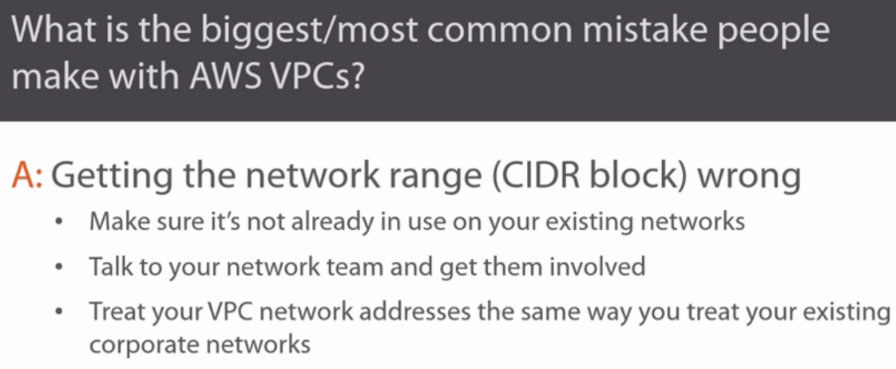

1.)Nice easy one to start off with. Thanks for that. Yeah, this is a bit weird. Anyway, seriously right. I reckon it's VPC CIDR blocks, so choosing the IP address space to use in your VPC. If you've watched the course we use the 10.0.0.0/16 network and I feel like I blabbered on about this quite a lot in the course. But network planning it's just huge and it's so easy not to bother with or to get wrong. Probably because it's one of the first things that you do when creating your VPC.

2.)But seriously, get those CIDR blocks wrong and you can find yourself in a deep hole with no ladder to help you out, you really, really, really want to make sure you're not using the same network addresses in your VPC that you've already got in use somewhere else on your corporate network. So for instance, if you're going to go with a 10.0 network for your VPC, make absolutely sure that it's not the network you're already using in the office or your on-prem data center or anything. And if you're at a company with a dedicated network team or multiple network teams, you're definitely going to want to talk to them about this kind of thing. Get them involved and get them on your side from the start because in IT infrastructure, right, in my experience, the network is where most of the complexity is. I mean, did you ever wonder why just about every outage is blamed on the network? Yeah, I know a bunch of the time we use the term network issue or network incident when it's not really the network, but in all of my years of infrastructure experience, more often than not it is the network. And I'm not slamming networks or network people here, right?

3.)The reason it's usually the network at the core of the problem is because networking is so freaking complex. So get in early with your network team and plan out your subnets and stuff with those guys before you start tearing into your VPC. And as well, don't let the network guys fob you off because your VPC networks are out there in the cloud and not yet considered part of your network proper. Treat your VPC networks just like any other corporate network, at least from a planning and an address space perspective, because I can almost guarantee that the day will come when you're going to want to hook yourcorporate networks up with your VPCs and we saw that actually earlier in the course using VPNs and Direct Connect. So, a bit of a long winded answer, but I reckon the biggest mistake and probably one of the easiest to make is getting your VPC networking wrong.

4.)So yeah, networking, get it right from the start because unpicking a fundamental problem like duplicate CIDR blocks, it's about as much fun as, I don't know waxing your armpit hair, not that I've ever done that, obviously. Really I haven't. But you get the message, right? Unpicking network problems is not fun.

**What Is the Most Misunderstood AWS VPC Concept?**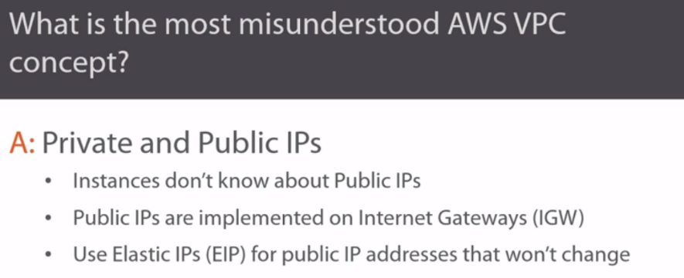

I'd probably say some of the auto scaling stuff, but that's not directly VPC related or at least auto scaling is not configured from the VPC console, so it's not included in the course. I guess then I'd better choose something that we did cover in the course.

1.)Maybe private and public IPs. So you know when we launch instances into our VPCs? Those instances automatically get private IPs, but obviously we can't talk directly to instances using those private IPs unless we're connecting over a VPN or Direct Connect, which by the way, is why VPNs and Direct Connect are so cool.

2.)But when we do assign public IPs to instances, the instance itself, so Linux or whatever iOS you're using, well it's got zero knowledge of that public IP. It knows absolutely nothing about it. So I mean if you log on and run host based IP commands like ifconfig and IP and the likes, you're only going to see private IPs. Public IPs are totally abstracted from instances. No, not abstracted, decoupled.

3.)The internet gateway in your VPC is what makes the magic of public IPs work. So, the internet gateway, right, it keeps a table that maps public IP addresses to instances or to network interfaces on instances.

4.)Basically, right routing any traffic that comes inbound for those public IP addresses to the private IPs of the instances. So I guess for all practical intents and purposes, our instances do have public IPs, it's just that behind the scenes AWS does a bunch of smoke and mirror stuff on the internet gateway to make it all happen. And while we're on public IPs actually, it's really common for folks to forget or you know what, maybe not even know, that normal public IPs in AWS, they change every time you reboot an instance.

5.)So, they're cool, but they're totally unreliable. For reliable public IPs, ones that are going to stick with our instance, even after reboots, we need elastic IPs, and last I checked, every AWS account is limited to five elastic IPs per region. And they cost money, another reason, right, for using VPNs and Direct Connect. Anyway, I'm blabbering again, but I think the main points to note are that normal public IPs in AWS change when you reboot an instance and elastic IPs don't. But you pay for elastic IPs and you're initially limited to five per region per account, though you can request more. Hope that answered your question.

**Should Multiple Environments Use a Single VPC?**

when it comes to VPCs, should I put all of my different environments in a single VPC? So like, dev, test, UAT, and production, all in the same VPC? Okay, pretty simple.

No. It really is as simple as that. No. **Separate environments like that totally belong in their own VPCs. Life will just be so much easier that way.**

**Should I Use Network ACLs or Security Groups?**

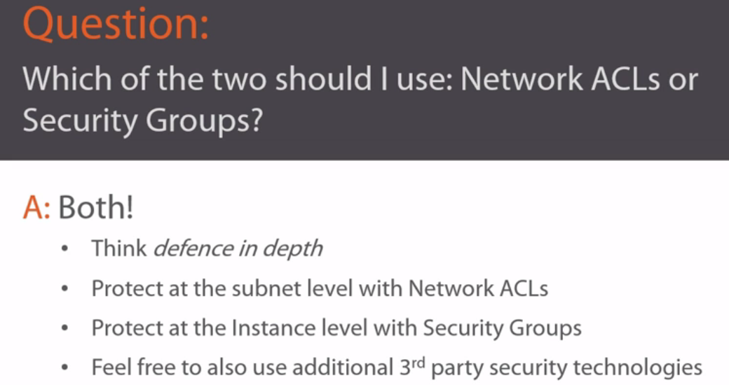

These security groups and network access control lists, they sound a bit similar, mate. Which of the two should I be using?

1.)Hi Brad. Just real quick actually, did you by any chance see England play Australia in the Ashes recently? That's cricket for anyone out there who doesn't know. Anyway, the answer to that question is simple. Both. You should definitely use both. And more, right.

2.)The idea being, there's no single technology that on its own is going to keep your infrastructure safe. We really do need to deploy multiple layers of security, defense in-depth, yeah. **So we protected the subnet level with NACLs and we've protected the instance level with security groups**. Yeah, they might take a bit of learning and yeah, no doubt, they're going to be a bit of a pain at first, in fact you're probably going to find yourself tripping over them from time to time, you know, like you're going to be wondering something's not working or why you can't connect to an instance or something, yeah. And it's going to turn out to be because of a NACL rule or a security group rule.

3.)And you might even be tempted to turn the blasted things off. But don't. Honestly, don't. They are proper insurance policies. And you know Murphy's law says that the day that you cancel your home insurance your house is going to burn to the ground? Well don't let the equivalent happen to your VPC. Get to know NACLs and get to know security groups and use them properly.

4.)And this is a good idea s well, right, have some standards, yeah, and maybe document them and who knows, even stick to them, yeah. Just so that you've got a bit of a pattern to how you use them, and I'm talking simple things like what's your strategy for applying security groups, yeah? Is it one per instance or one per instance type like web servers or one security group per application tier or whatever, yeah? Just do it, right. I can't stress this enough.

5.) Security is not optional anymore and NACLs and security groups really do complement each other. So don't cheat and just try to use one. You know what, right, these are just the basics, the minimum, yeah. You can totally use like third party tools as well, intrusion prevention systems, you can encrypt bits and pieces, you might want to run antivirus, SC Linus, AppArmor. There's tons of stuff. Take security seriously. But yeah, of the two major things that we've covered in the course, NACLs and security groups, use them both and use them wisely.

**How Do I Mitigate Against AWS Outages?**

how do I plan against AWS going down? Whoa, okay. So we're talking about disaster recovery here. Sometimes we call it business continuity. 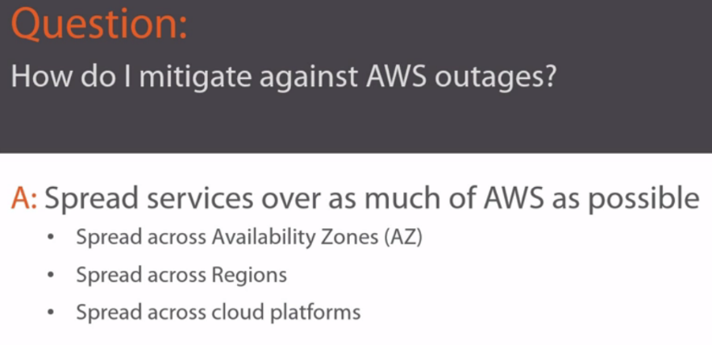

1.)build your apps okay, and design your infrastructure so that you spread your services across as much of AWS as possible. I mean, we've talked in the course about things like using multiple availability zones.

2.)So if you've got two front end web servers doing the same thing, stick them both in separate availability zones. That way if one zone goes down, the other web server is going to survive. But you know what? You might need to take things even further, so like in all the enterprise environments I've worked in, we've had two data centers, sometimes more.

3.)But they've always been geographically dispersed, so at least 20 or 25 miles apart. So, in AWS terms, you might want to run services out of like EU-West 1 in Ireland as well as EU-Central in Frankfurt. Or maybe some of your services in an EU region and some in a US region. And all of this takes planning, obviously. Usually day 1 planning with the app guys and the infa guys actually talking to each other. But this really is the only way to protect your business against an entire region going down and this has happened and it will happen again. So if you're running mission critical stuff and you take your business seriously, like who doesn't? Then spread your risk as widely as possible. Don't stick all of your eggs into like US-East and then feel a grief when US-East goes belly up, right.

4.)And to mitigate against the whole of AWS going away, I suppose it's feasible to spread your risk over multiple cloud providers, so maybe AWS and Google Cloud platform or AWS and Microsoft Azure. Though I'd say, at least at the time of recording, that's like uber bleeding edge stuff, but I imagine it's going to get more and more common and easier to do in the future. So keep your eye out for things like that. Whatever you're doing though, yeah, make sure your CIDR blocks don't overlap with your on-prem corporate networks, yeah.

**What Is the Simplest Thing to Do with the Biggest Benefit?**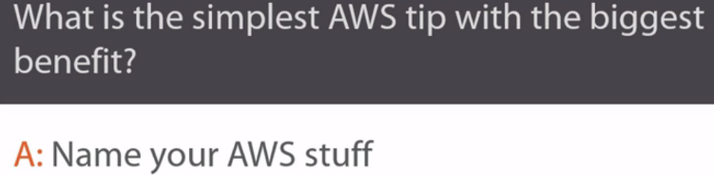

1.)That's pretty easy actually. Naming your stuff.

2.) Just name everything, right. Your instances, your security groups, your subnets, your VPN gateways, the whole shebang, and do it sensibly, right.

3.)Have a naming convention so that the names you use make sense, it'll make day to day management so much easier and definitely troubleshooting, man

**When Should I Use Public Subnets and Private Subnets?**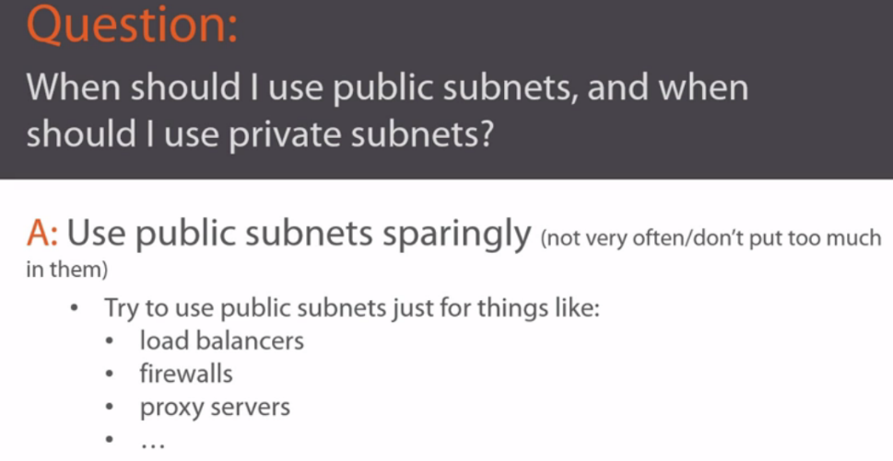

1.)a good general rule is to use public subnets sparingly. Basically, right, anything you put in a public subnet has a route to the internet and it's often going to have a public IP, and that combination is going to make it more open to attacks.

2.)If you can, right, maybe try and rig things up so that you only stick like elastic load balancers, firewall instances, proxy servers, that kind of stuff in public subnets. Maybe web servers if you need to, yeah.

3.)Then, stick everything else into private subnets, where there's no route to the internet and they don't have public IPs. I don't know if that's a good answer or not, but I do reckon it's a pretty good rule of thumb, you won't go far wrong by sticking to it.



 